|  |  |  |
| --- | --- | --- |
|  |  |  |

Helwan University

Faculty of Computers and Artificial Intelligence

Software Engineering Program

**MediBooki Healthcare and Pneumonia Detection System**

|  |  |
| --- | --- |
| 1. **Mohamed Ali GadAlhak Hassan** | **ID: 20201871** |
| 1. **Assem Mohamed AhmedSamy Mohamed** | **ID: 20201836** |
| 1. **Pola Osama Aziz** | **ID: 20201823** |
| 1. **Ahmed Salah Mohammed** | **ID: 20201803** |
| 1. **Ahmed Waleed Abdullah Ahmed** | **ID: 20201815** |
| 1. **Eslam Sabry Hassan** | **ID: 20201849** |

**Team Members: -**

**Supervised by: -**

**1st Assc. Prof. Mohamed Marie.**

**2nd Dr. Ahmed El Sayed.**

June 2023

Table Of Contents

Table Of Contents 2

Table Of Figures 8

Abstract 10

Chapter 1: Introduction 10

1.1. Overview 10

1.2. Objectives 11

1.3. Purpose 11

1.4. Scope 11

1.4.1 Introduction: 11

1.4.2 Features: 12

1.5. General constraints 13

❖ Time constraints: 13

❖ Spatial constraints: 13

❖ Operating requirements: 13

❖ Users Constraints: 13

Chapter 2: Project “Planning and analysis” 14

2.1. Project planning (Feasibility Study) 14

2.1.1. Technical Feasibility 14

2.1.2. Economic Feasibility 15

2.1.3. Operational Feasibility 15

2.2. Analysis and Limitation of existing system 16

2.3. Need for the new system 16

2.4. Analysis of the new system 17

2.4.1. Identification of key stakeholders and End-Users 17

a. Internal-Operational: 17

b. External-Operational 19

c. Internal-Executive 19

2.4.2. User requirements 19

1. Administrator: 19

2. Hospital Manager: 20

3. Doctor: 20

4. Pharmacist: 21

5. Analytics specialist: 21

6. Radiology doctor: 21

7. Accountant: 21

8. Patient: 22

2.4.3. System Requirements 22

2.4.4. Domain Requirements 22

2.4.5. Functional Requirements 23

➢ Login Function: - 23

➢ View Profile: - 23

➢ Edit Profile: - 24

➢ Add Doctor: - 25

➢ View Doctor: - 25

➢ Delete Doctor: - 26

➢ Add Patient: - 27

➢ View Patient: - 27

➢ Delete Patient: - 28

➢ Add Analytics Specialist: - 29

➢ View Analytics Specialists: - 30

➢ Delete Analytics Specialist: - 30

➢ Add Pharmacist: - 31

➢ View Pharmacist: - 32

➢ Delete Pharmacist: - 32

➢ Add Radiology Doctor: - 33

➢ View Radiology Doctor: - 34

➢ Delete Radiology Doctor: - 35

➢ Add Accountant: - 35

➢ View Accountant: - 36

➢ Delete Accountant: - 37

➢ Accept Join Requests: - 37

➢ Reject Join Requests: - 38

➢ Add Specialization: - 39

➢ View Specialization 39

➢ Update Specialization 40

➢ Delete Specialization 41

➢ Add Articles 41

➢ View Articles 42

➢ Update Articles 42

➢ Delete Article 43

➢ Add Ambulance: - 44

➢ View Ambulance 44

➢ Update Ambulance 45

➢ Delete Ambulance 45

➢ Add Insurance: - 46

➢ View Insurance 46

➢ Update Insurance 47

➢ Delete Insurance 48

➢ Reset Insurance Due 48

➢ View medical Analysis 49

➢ View X-rays 49

➢ Add Medicine: - 50

➢ Update Medicine: - 50

➢ Delete Medicine: - 51

➢ Upload Medical Analysis: - 52

➢ Upload X-Rays: - 52

➢ Add User: - 53

➢ View User: - 53

➢ Update User: - 54

➢ Delete User: - 55

➢ Add Role: - 55

➢ View Role: - 56

➢ Update Role: - 56

➢ Delete Role: - 57

➢ Add Tenant: - 58

➢ View Tenant: - 58

➢ Update Tenant: - 59

➢ Delete Tenant: - 59

➢ Add Invoice: - 60

➢ Request to join hospital: - 61

➢ Diagnose Patient: - 61

➢ Create Patient Prescription: - 62

➢ Add Service: - 62

➢ Update Service: - 63

➢ Delete Services: - 64

➢ View Services: - 64

➢ Add Appointments: 65

➢ Update Appointments: 65

➢ View Appointments: 66

➢ Delete Appointments: 67

➢ View Patient History: - 67

➢ Pneumonia Detection: - 68

➢ Register function: 68

➢ Book a doctor: 69

➢ View Doctors 70

➢ View medicines 70

➢ Buy medicines 71

➢ View Specialization: 71

➢ Use medical Insurance: 72

➢ Talk to chatbot: 72

➢ Review Doctor:- 73

➢ View Invoices:- 73

2.4.6. Non- Functional Requirements 74

➢ Usability & Humanity. 74

➢ Performance. 74

➢ Maintainability & Support. 75

➢ Security. 75

➢ Availability. 75

➢ Software Quality. 75

➢ Reusability. 75

2.5. Advantages of the new system 75

2.6. Use Case: - 77

2.7.1. Use Case Diagram: 77

2.7.2. Use Case Scenarios: 78

Use case: Login 78

Use case: Edit profile 79

Use case: Add Doctor 79

Use case:  Delete Doctor 80

Use case:  Accept Join Requests 81

Use case:  Add Specialization 82

Use case:  Add Ambulance 82

Use case:  Add Insurance 83

Use case:  View Appointments 84

Use case:  Add Medicine 85

Use case:  Upload Medical Analysis 85

Use case:  Upload X-Rays 86

Use case:  Add Role 87

Use case:  Add User 88

Use case:  Add Invoice 88

Use case:  Patient Diagnosis 89

Use case:  Create Prescription 90

Use case:  Add Service 91

Use case:  View Patient History 91

Use case:  View Specialization 92

Use case:  Register 93

Use case:  Book a doctor 94

Use case:  View Doctors 94

Use case:  Use medical Insurance 95

Use case:  Talk to chatbot 96

Use case: View medical Analysis 96

Use case: Add Tenant 97

2.7. Activity Diagrams 98

Chapter 3: Software Design 104

3.1. Design of database (Class Diagram) 104

3.1.1. Version 1: - 104

3.1.2. Version 2: 105

3.2. Sequence Diagram 106

3.3. System architecture 136

Chapter 4: Implementation 137

4.1. Description of Implementation 137

4.2. Programming language and technology 137

4.2.1. The factors that influenced the choice of Angular 138

4.2.2. The factors that influenced the choice of PHP 138

4.2.3. Why MySql database was chosen? 139

4.2.4. Why did we use Flutter in Mobile App 139

4.3. Part of Implementation 140

Chapter 5: Testing 141

5.1. Unit Testing 141

5.2. Integrated Testing 141

5.3. Additional Testing 141

Chapter 6: Conclusion & Future Work 141

6.1. Conclusion 141

6.2. Future Work 142

Table Of Figures

Figure 1: Use Case Diagram 77

Figure 2: Hospital Manager Activity Diagram 98

Figure 3: Hospital Manager Activity Diagram 98

Figure 4: Doctor Activity Diagram 99

Figure 5: Admin Activity Diagram 100

Figure 6: Patient Activity Diagram 101

Figure 7: Analysis Specialist Activity Diagram 102

Figure 8: Radiology Doctor Activity Diagram 102

Figure 9: Pharmacy Activity Diagram 103

Figure 10: Accountant Activity Diagram 103

Figure 11: Class Diagram V1 104

Figure 12: Class Diagram V2 105

Figure 13: Employee Login 106

Figure 14: Patient Registration 106

Figure 15: Update Employee Profile 107

Figure 16: Patient Login 107

Figure 17: Hospital Manager Remove User 108

Figure 18: Hospital Manager Add User 108

Figure 19: Hospital Manager View Users 109

Figure 20:Hospital Manager Update User 109

Figure 21: Hospital Manager Remove Role 110

Figure 22: Hospital Manager Add Role 110

Figure 23: Hospital Manager View Role 111

Figure 24: Hospital Manager Update Role 111

Figure 25: Hospital Manager Remove Tenant 112

Figure 26: Hospital Manager Add Tenant 112

Figure 27: Hospital Manager View Tenant 113

Figure 28: Hospital Manager Update Tenant 113

Figure 29: Admin Add Specialization / Ambulance / Article 114

Figure 30: Admin Add User ( Doctor , Patient , Pharmacist , Specialist , Accountant , Radiology ) 114

Figure 31: Admin Remove Specialization / Ambulance / Article 115

Figure 32: Admin Remove User ( Doctor , Patient , Pharmacist , Specialist , Accountant , Radiology ) 115

Figure 33: Admin View User ( Doctor , Patient , Pharmacist , Specialist , Accountant , Radiology ) 116

Figure 34: Admin Update Specialization / Ambulance / Article 116

Figure 35: Admin View Something 117

Figure 36: Admin Accept/Reject Request 117

Figure 37: Doctor Add New Appointment 118

Figure 38: Doctor Add New Service 118

Figure 39: Doctor Delete Appointment 119

Figure 40: Doctor Delete Service 119

Figure 41: Doctor Diagnose Patient 120

Figure 42: Doctor Create Prescription 121

Figure 43: Doctor Join Request 121

Figure 44: Doctor Update Appointment 122

Figure 45: Doctor Update Service 122

Figure 46: Doctor View Patient History 123

Figure 47: Doctor View Services 123

Figure 48: Doctor View Appointments 123

Figure 49: Patient Update Profile 124

Figure 50: Patient talk to chatbot 124

Figure 51: Patient Buy Medicine 125

Figure 52: Patient View Doctor_Specialization_Medicine 126

Figure 53: Patient Book Doctor 127

Figure 54: Patient Review Doctor 127

Figure 55: Pharmacist Add Medicine 128

Figure 56: Patient use Medical Insurance 128

Figure 57: Pharmacist Update Medicine 129

Figure 58: Pharmacist Delete Medicine 129

Figure 59: Accountant View Invoices 130

Figure 60: Pharmacist View Medicines 130

Figure 61: Accountant Update Invoice 131

Figure 62: Accountant Add New Invoice 131

Figure 63: Accountant Delete Insurance 132

Figure 64: Accountant Add Insurance 132

Figure 65: Accountant View Insurances 133

Figure 66: Accountant Update Insurance 133

Figure 67: Analytics specialist upload medical analysis 134

Figure 68: Accountant Reset Insurance Due 134

Figure 69: Radiology use Pneumonia Detection Service 135

Figure 70: Radiology Upload X-Ray 135

Figure 71: System Architecture 136

Abstract

We discuss medical booking system and its social benefits to fulfill patients’ needs by connecting them to the appropriate doctor and we discuss the technical requirements for booking doctors in the easiest way. the presentation is not totally completed, but it aims to give an idea of the system-level issues to be considered for real applications. The technology in this area is rapidly developing, and without doubt we will evidence emergence of these applications in the coming years in the market.

1. Introduction
   1. Overview

Our project is a medical information system for hospital which helps patients in their medical needs such as booking doctors, buying medicines online and track orders to know shipping status and providing pneumonia prediction service for doctors.

* 1. Objectives

Project’s objective is building a powerful system which provides services to patients to fulfill their requirements digitally such as booking doctors and buying medical supplies online using medical insurance; and provides services to admins such as managing users digitally without using hard copy papers by building ease-use dashboard.

* Now we can say that the most affected by the current system in hospitals are patients who find it difficult to seek medical advice, so they turn to search via the Internet. In a study conducted, it proved that websites and applications for examining symptoms are accurate about 34% of the time, while doctors, when given the same information, diagnosing the condition correctly 72% of the time.
* Doctors also, because their task is made difficult in the current system because there are no ways to facilitate the matter of meeting patients, for example, or knowing their medical history in asking each patient. Those related to the health system in Egypt, so by making it easier for them, they are more attracted to work in Egypt.
  1. Purpose
* managing patients and their related information.
* Improving patients care by helping them in booking doctors easily and digitally.
* helping radiology doctors in detecting pneumonia using service.
* Helping doctors in managing their appointments.
* Helping admins in accessing users’ information.
* Improving efficiency via taken care of processes automatically.
* Increasing data security & retrieve-ability.
* Accounting, laboratory, and pharmacy management.
* Buying medical supplies from pharmacy page online using electronic payment system allowing them to use medical insurance.
* Serving patients from multiple regions using multitenancy (Software as a Service).
  1. Scope
     1. Introduction:

The scope of the project is to develop a comprehensive Hospital Management System (HMS) that includes a pneumonia prediction service. The system aims to streamline and automate various hospital management tasks while providing an advanced prediction model to assist healthcare professionals in diagnosing and managing pneumonia cases.

* + 1. Features:
* Patient Management: The system will allow hospital staff to efficiently manage patient records, including registration, medical history, and current symptoms. It will enable easy tracking of patient admissions, discharges, and transfers.
* Appointment Scheduling: A centralized appointment scheduling module will be implemented to facilitate the efficient allocation of resources and minimize waiting times. Patients can book appointments online.
* Pneumonia Prediction Service: The system will integrate a pneumonia prediction model based on machine learning algorithms. It will analyze patient symptoms, vital signs, and relevant medical data to assess the likelihood of pneumonia. The prediction service will provide healthcare professionals with insights to aid in early detection and treatment decisions.
* Electronic Health Records (EHR): The HMS will maintain comprehensive electronic health records for each patient, ensuring easy access to medical history, test results, prescribed medications, and treatment plans. This will enhance data accuracy, reduce paperwork, and improve overall patient care.
* Laboratory and Radiology Integration: The system will integrate with laboratory and radiology departments, enabling seamless communication of test orders, results, and interpretations. This integration will optimize the diagnostic process and allow physicians to make informed decisions based on accurate and timely information.
* Inventory and Pharmacy Management: The HMS will include modules to manage hospital inventory, including medical supplies, drugs, and equipment. It will track stock levels, automate reordering, and manage pharmacy operations efficiently.
* Billing and Insurance: The system will facilitate accurate billing and insurance claims processing, reducing errors and improving financial management. It will generate itemized bills, track payments, and integrate with insurance providers' systems for seamless claims submission.
* Reporting and Analytics: The HMS will provide comprehensive reporting and analytics capabilities, allowing hospital administrators to monitor key performance indicators, resource utilization, patient outcomes, and the effectiveness of the pneumonia prediction service. These insights will support data-driven decision-making and continuous improvement.
* Security and Privacy: The system will adhere to strict security protocols and comply with healthcare data privacy regulations such as HIPAA. Patient data will be encrypted, access controls will be implemented, and regular backups will be performed to ensure data integrity and confidentiality.
* Mobile Access: The HMS will have a mobile-friendly interface or a dedicated mobile app, while also allowing patients to conveniently order prescribed medications through the application. This feature enhances the efficiency and flexibility of healthcare delivery, providing a seamless process for patients to purchase their medicines.
  1. General constraints
* Time constraints:

Our system is only used in the modern era due to our use of modern technologies such as artificial intelligence and due to the presence of computers in all hospitals now so they can use our system.

* Spatial constraints:

Since our system is a medical system, this system is used only in hospitals because it serves medical institutions. We also added multitenancy technology to our system, so according to the use of each hospital, the countries in which its branches are located are determined. The system can only be used by the user in these countries specified by the hospital.

* Operating requirements:

The user can use our system from three things, namely the mobile app, as it is not required except for the Android or iOS operating system. As for the Dashboard and Web App, the user can run them from any operating system only when it has a good and fast browser and a good internet connectin, then he can run it .

* Users Constraints:

Our system can be used by users who want to go to the hospital or buy medicines, as well as doctors, all hospital workers and those involved in the health field.

1. Project “Planning and analysis”
2. 1. Project planning (Feasibility Study)

In this section we will know everything about the project and study its aspects to understand it very well to start building the system.



A feasibility study is conducted to find out whether the proposed system is possible, affordable, and acceptable for organization. The financial, political, social and time constraints must be considered during this study.

* Possible: to build it with the given technology and resources
* Affordable: given the time and cost constraints of the organization
* Acceptable: for use by the eventual users of the system.
  + 1. Technical Feasibility

The primary technical requirement includes the availability of a good version of operating system installed in the network. To develop programs, any good Integrated Development Environment is needed, which can be easily acquired after deciding. Reliability, access, power and data security are also available.

* Hardware Requirements:

➔ Computer Systems: 3 (Available)

➔ Processor: Core i3 Processor (minimum)

➔ RAM: Minimum 8 GB. (1 GB extra RAM is required to use Android emulator and Vs code)

➔ Disk Space: Using an SSD would be a wise decision, but 256GB SSD can be a good choice.

➔ Works on graphic card 4GB to 8GB

* Software Requirements:

1. Web apps can be developed using a number of different alternative languages and IDEs.

➔ Back-End

1. Xampp local host and Vs code “IDE”
2. Php V 7.4 “language”

➔ Front-End

1. HTML, CSS “tools”
2. Local host and Vs code “IDE”
3. Angular “frame work”
4. Android or IOS apps can be developed using a number of different alternative languages and IDEs.

➔Java Development Kit (JDK) and Android studio “IDE”

➔Git.

➔Dart “language”

➔ Flutter “frame work”

AI feature:

➔Anaconda environment

* + 1. Economic Feasibility

Whether the MediBooki is cost effective or not? The benefits in the form of reduced cost?

MediBooki is economically Feasible. As the hardware cost on the project is low. Similarly. it’s cost is also under the budget. Moreover, some of the technical requirements are already available and some can be obtained by using a reasonable amount and effort.

* + 1. Operational Feasibility

MediBooki is operationally feasible. it provides the necessary information to the user as how to enter the information, how to register, selecting the interests, giving permissions to the apps. Some prior knowledge is required for the management to go through the various operations. But for the user basic knowledge of computers is enough.

* 1. Analysis and Limitation of existing system
* At the beginning of our study of the project, we found that the current manual medical system is difficult for the patient these days, so we decided to try to make it easier for patients and doctors as well by making an electronic system that would be an intermediary between them and also between them and the hospital. **We found the following:**
* There are many medical systems, but we did not find one of them that contains all the needs of the three categories patients, doctors and the hospital.
* The patient has to go to the hospital to book his doctor, and he finds it difficult because he sits and waits for a lot of time.
* The patient is forced to go to the hospital to book his doctor, and he finds it difficult because he sits and waits for a lot of time and also book the work of x-rays and medical tests and also receive them.
* We also found that the proportion of patients with pneumonia affects about 15% of children under the age of five around the world, according to the World Health Organization. <https://www.who.int/ar/news-room/fact-sheets/detail/pneumonia>.
* Under the spread of the Corona virus, the patient, if he suspects that he has the disease, tends to make Lung x-ray, where pneumonia appears.
* We found that these days, the state is working to reduce the circulation of currencies and dealing with them and towards electronic payment.
* We also found it difficult to organize between doctor's and patients' appointments.
* We also found that the doctor does not see the patient’s medical history, so the doctor is forced to ask each patient about his medical history and his details, but the medical history is not recorded in order to be preserved if the same patient goes again in follow-up.
* We also found administrative and accounting problems in hospitals.
* We also found that there is a difficulty in dispensing medicines to patients and that they do not reach those who deserve them.
  1. Need for the new system

To overcome problems found in existing system as mentioned above; then we will build new system that contains the following points: -

* Optimize, manage, and track personal and financial hospital resources.
* **No** chance for **duplicated** patient files and data.
* Manage **lab tests**, and **consultation** of different specialties like cardiology and more.
* Build actionable treatment plans with reminders and targets for patients, staff, and doctors to enhance adherence.
* Manage appointment time slots and timings by lab, clinic, and doctor.
* Access to your portal through our mobile apps.
* You will find support in how to use our website in **Chatbot**.
* Fast **detection** of pneumonia disease.
* Cost effective and easily manageable.
* Easy access to patient data with correct patient history.
* Support Multilingual.
* Support multitenancy.
* Billing and Insurance Management.
  1. Analysis of the new system

In this section we know who are stakeholders and collect all requirements they want in new system.

2. 4. 1. Identification of key stakeholders and End-Users

In this chapter we identify all persons who have an interest in the successful implementation of the system either they are inside or outside the organization. Stakeholders are consisting of 3 types: -

1. Internal-Operational:

persons within the organization and regularly interact with the system.

* **Doctor** is the person who examines and diagnoses the patient's condition, determines the optimal treatment, and follows up on his condition and treatment results. He also performs first aid for patients and injured people. He also trains and directs instructions to the nursing staff.
* **Analytics specialist** is the person who receives various samples of blood and other body fluids, marking and sorting and classifying blood samples. he also organizes and stores all chemicals, liquids and compressed gases in accordance with safety instructions. Designs and implements laboratory tests according to standard procedures and takes explanatory notes on the results. He also presents the results of tests and medical examinations to patients and providing specialized doctors with the necessary knowledge for treatment, taking into account the confidentiality of medical laboratory information related to patients.
* **Radiology doctor** is the person who makes sure that the x-ray examination is requested from the treating doctor and determines what part to be photographed and what conditions are required. He also informs patients or department nurses of all the necessary instructions for any examination, such as attending the patient without breakfast or taking a specific tablet. He also adjusts the x-ray tube and determines the x-ray package and the necessary imaging factors. For each patient’s required situation, he chooses the appropriate film size and quality for each examination, puts the patient’s letter and identification number on the clipboard, and prints the patient’s name and examination date on the film, if possible, and his technical number, or write that on the x-ray film. He also develops the films from him or from other radiology assistants according to the order of the work schedule in the radiology department, prepares the chemicals for acidification and daily and periodic cleaning of the acidifying device, and then delivers the x-rays to the patient.
* **Accountant** is the person who Follow up the financial procedures of patients, whether cash payment patients or receivable patients, collecting them, settling the fund, and following up on closing outstanding bills. He also restricts cash payment patients’ bills on the system, collects cash from cash payment patients, restricts health insurance patients’ bills on the system, follows up on cash payment patients’ bills, and follows up pending bills with doctors and administration. Also, organizes the patient’s file upon discharge from the hospital and completes financial exit procedures. Also send invoices to public accounting and accounting insurance companies. Also participate in the annual or periodic inventory work in the hospital.
* **Pharmacist** is the person who Dispensing the patient’s medication via the doctor’s prescription only, as well as dispensing the medication through the health insurance. Educating the patient about the side effects of the drug, writing insurance forms, and communicating with insurance companies to verify that patients get the drugs they want. Also answer patients' inquiries about prescriptions for medicines. Also, organize the pharmacy and its medications in an effective and organized manner, and continuously monitor the expiration dates of the medications. Also, follow-up invoices for purchases and sales of medicines and medical supplies as well. Follow the correct means of storing medicines and try as much as possible to prevent problems of poor storage.
* **Administrator** He is the person responsible for the administrative things in the hospital such as organizing departments, appointing employees, adding departments and things like that.

1. External-Operational

persons outside the organization and regularly interact with the system.

* **Patients** They are the clients who come to the hospital in order to receive the services they request.
* **Pharmaceutical suppliers** They are the people who supply all medicines to the hospital pharmacy as well as all medical supplies.

1. Internal-Executive

persons within the organization and don’t directly interact, but use the information or have financial interest.

* **hospital managers** They are the people who have financial interests and who take the highest decisions in the management of the hospital and follow up on all activities in the hospital.
  + 1. User requirements

Requirements of stakeholders and end-users identified in section 2.4.1.

1. Administrator:
2. **Login:** Admin can login to his personal account.
3. **View/Edit Profile:** Admin can see and edit his profile.
4. **Add/View/Delete Doctor:** Admin can Add, view doctor, or delete him from system.
5. **Add/View/Delete Patient:** Admin can Add, view patient, or delete him from system.
6. **Add/View/Delete Pharmacist:** Admin can Add, view pharmacist, or delete him from system.
7. **Add/View/Delete Analytics Specialist:** Admin can Add, view analytics specialist, or delete him from system.
8. **Add/View/Delete Radiology Doctor:** Admin can Add, view radiology doctor, or delete him from system.
9. **Add/View/Delete Accountant:** Admin can Add, view accountant, or delete him from system.
10. **Accept/Reject Join Request:** Admin can accept or reject doctor join request from database.
11. **Add/View/Update/Delete Specialization:** Admin can Add, view specialization, or update its information, or delete it from system.
12. **Add/View/Update/Delete Ambulance:** Admin can Add, view ambulance, or update its information, or delete it from system.
13. **View Appointments:** Admin can see all appointments detail from database.
14. **View Medicines:** Admin can see all medicines detail from database.
15. **View Medical Analysis:** Admin can see all medical analysis detail from database.
16. **View X-Rays:** Admin can see all X-Rays detail from database.
17. **View Invoices:** Admin can see all invoices detail from database.
18. **Add/View/Update/Delete Articles:** Admin can Add, view Article, or update its information, or delete it from system.
19. Hospital Manager:
20. **Login:** Hospital Manager can login to his personal account.
21. **View/Edit Profile:** Hospital Manager can see and edit his profile.
22. **Add/View/Update/Delete Administrator:** Hospital Manager can add, view administrator, or update his information, or delete him from system.
23. **Add/View/Update/Delete Role:** Hospital Manager can add, view User Role, or update user’s role, or delete this role from user.
24. **Add/View/Update/Delete Tenant:** Hospital Manager can add new branch of hospital, view, update or delete it.
25. Doctor:
26. **Login:** Doctor can login to his personal account.
27. **View/Edit Profile:** Doctor can see and edit his profile.
28. **Request to Join Hospital:** Doctor can Request to join hospital team through ‘Join Us’ form from UI.
29. **Diagnose patients:** Doctor can diagnose patients or transfer patient to radiology/analysis department when needed.
30. **Create Patient Prescription:** Doctor can create patient prescription after diagnosing him.
31. **Add/View/Update/Delete Service:** Doctor can Add, view services he will do, or update them, or delete them from system.
32. **View Patient history:** Doctor can view patient history from dashboard.
33. **Add/view/update/delete Appointments:** Doctor can Add, view appointments dates he will make, or update them, or delete them from system.
34. Pharmacist:
35. **Login:** Pharmacist can login to his personal account.
36. **View/Edit Profile:** Pharmacist can see and edit his profile.
37. **Add/View/Update/Delete Medicine:** Pharmacist can Add, view medicine, or update its information, or delete it from system.
38. Analytics specialist:
39. **Login:** Analytics Specialist can login to his personal account.
40. **View/Edit Profile:** Analytics Specialist can see and edit his profile.
41. **Upload medical analysis:** Analytics Specialist can upload medical analysis through dashboard.
42. Radiology doctor:
43. **Login:** Radiology Doctor can login to his personal account.
44. **View/Edit Profile:** Radiology Doctor can see and edit his profile.
45. **Upload X-Rays:** Radiology Doctor can upload X-Rays through dashboard.
46. **Use pneumonia detection service:** Radiology Doctor can upload patient’s X-Ray to predict pneumonia.
47. Accountant:
48. **Login:** Accountant can login to his personal account.
49. **View/Edit Profile:** Accountant can see and edit his profile.
50. **Add/View/Update Invoice:** Accountant can add new invoice, or view or update its details.
51. **Add/View/Update/Delete/Reset Due of Insurance:** Admin can Add, view insurance, or update its information, or delete it from system; Admin can also update Due of insurance company.
52. Patient:
53. **Login:** Patient can login to his personal account.
54. **Register:** Patient can register to the system for the first time.
55. **View/Edit Profile:** Patient can see and edit his profile.
56. **Book a doctor:** Patient can make an appointment with doctor based on his services.
57. **Use Medical Insurance:** Patient can use his medical insurance when dispensing a medicine.
58. **Talk to Chatbot:** Patient can talk to a chatbot to guide him where to go.
59. **View Medicines:** Patient can see all medicines detail to buy them online.
60. **Buy Medicines:** Patient can buy medicines using credit card or cash on delivery.
61. **View Doctors:** Patient can see all doctors’ details to book an appointment.
62. **Review Doctors:** Patient can review doctor after visiting him in hospital.
63. **View Specializations:** Patient can see all specializations detail to reach doctors in specific specialization.
    * 1. System Requirements

System needs Cloud-based to

* Put it in a specific domain to work properly.
* Allows recording of medical data for eventual use.
* Allows data retrieval in real time.
* Allows patients to access and monitor their medical data.
* Does not allow patients to provide their health conditions.
* Supports data sharing only within the same hospital.
  + 1. Domain Requirements

Based on the medical field, we found that the medical system should contains some sub-systems related to its field like pharmacy management system; So, our system contains many integrated sub-systems such as pharmacy management system, reservation management system and online billing system.

* + 1. Functional Requirements

They describe what the system/software must do; functionality or services (a function is a useful capability provided by one or more components of a system). Therefore, they specify an action that a system must be able to perform.

* Login Function: -
* **Function:**

Login

* **Actors:**

Administrator, Hospital Manager, Doctor, Pharmacist, Analytics Specialist, Radiology doctor, Accountant, Patient

* **Priority:**

High

* **Description:**

When the actor login, he can manage the system based on his roles.

* **Inputs:**

The actor should write the email and password in the right way and correct data for a successful login

* **Outputs:**

The actor can manage many functions based on roles that assign to him

* **Requirements:**

Write the right data to can login

* **Pre-condition:**

The actor already has an account

* **Post-condition:**

The actor entered his account successfully

* View Profile: -
* **Function:**

View profile

* **Actors:**

Administrator, Hospital Manager, Doctor, Pharmacist, Analytics Specialist, Radiology doctor, Accountant, Patient

* **Priority:**

Medium

* **Description:**

An actor profile is a collection of settings and information associated with a user. It contains critical information that is used to identify an individual, such as their name, age, profile picture, email, and password

* **Inputs:**

His account must be verified on the site after logging in.

* **Outputs:**

View personal information successfully.

* **Requirements:**

Actor information must be added by logging in to the site before viewing his profile.

* **Pre-condition:**

The actor must be logged in to the system and has permission.

* **Post-condition:**

The actor can view this profile.

* Edit Profile: -
* **Function:**

Edit profile

* **Actors:**

Administrator, Hospital Manager, Doctor, Pharmacist, Analytics Specialist, Radiology doctor, Accountant, Patient

* **Priority:**

High

* **Description:**

An actor profile is a collection of settings and information associated with a user. It contains critical information that is used to identify an individual, such as their name, age, profile picture, email, and password, and can edit this information based on this role

* **Inputs:**

His account must be verified on the site after logging in.

* **Outputs:**

edit personal information successfully.

* **Requirements:**

Actor information must be added by logging in to the site before viewing his profile.

* **Pre-condition:**

The actor must be logged in to the system and has permission.

* **Post-condition:**

The actor can edit this profile.

* Add Doctor: -
* **Function:**

Add Doctor

* **Actors:**

Administrator

* **Priority:**

High

* **Description:**

When the administrator login, he can add the Doctor to the website database and give him an account to make the doctor can do many functions

* **Inputs:**

Admin should write first name, last name, age, id, username, and password in the right way and correct data to add successfully;

* **Outputs:**

The administrator adds doctors to the system and makes accounts for the doctors and gives them some permeations.

* **Requirements:**

The data about a required doctor will be added.

* **Pre-condition:**

The administrator had signed in to his profile (system), has permeation and the doctor give his data to the administrator

* **Post-condition:**

The doctor is added and has an account.

* View Doctor: -
* **Function:**

View Doctor

* **Actors:**

Administrator

* **Priority:**

Medium

* **Description:**

When the administrator login, he can add the Doctor to the website database and give him an account to make the doctor can do many functions, and he can view doctor details like "see his appointments, personal information, and the number of patients who have examined him.”.

* **Inputs:**

Admin should write first name, last name, age, id, username, and password in the right way and correct data to add doctor first; can view the details by clicking “view info”.

* **Outputs:**

The administrator adds doctors to the system and makes accounts for the doctors and gives them some permeations, views doctors’ details from the system.

* **Requirements:**

The data about a required doctor will be added.

* **Pre-condition:**

The administrator had signed in to his profile (system), has permeation and the doctor give his data to the administrator

* **Post-condition:**

The administrator views details about all the doctors.

* Delete Doctor: -
* **Function:**

Delete Doctor

* **Actors:**

Administrator

* **Priority:**

High

* **Description:**

When the administrator login, he can add the Doctor to the website database and give him an account to make the doctor can do many functions, and he can delete the doctor.

* **Inputs:**

Admin should write first name, last name, age, id, username, and password in the right way and correct data to add successfully, and can delete the doctor by clicking “delete doctor”

* **Outputs:**

The administrator adds doctors to the system and makes accounts for the doctors and gives them some permeations, and can delete doctors’ details from the system

* **Requirements:**

The data about a required doctor will be added.

* **Pre-condition:**

The administrator had signed in to his profile (system), has permeation and the doctor give his data to the administrator

* **Post-condition:**

The administrator deletes all the doctors.

* Add Patient: -
* **Function:**

Add Patient

* **Actors:**

Administrator

* **Priority:**
* High
* **Description:**

When the administrator login, he can add the patient to the website database and give him an account to make the patient can do many functions.

* **Inputs:**

Admin should write first name, last name, age, id, username, and password in the right way and correct data to add successfully;

* **Outputs:**

The administrator adds patients to the system and makes accounts for the patients and gives them some permeations.

* **Requirements:**

The data about a required patient will be added.

* **Pre-condition:**

The administrator had signed in to his profile (system), has permeation and the patient give his data to the administrator

* **Post-condition:**

The patient is added and has an account.

* View Patient: -
* **Function:**

View Patient

* **Actors:**

Administrator

* **Priority:**

Medium

* **Description:**

When the administrator login, he can add the patient to the website database and give him an account to make the patient can do many functions, and he can view patient details like " Viewing the dates he booked, personal information”.

* **Inputs:**

Admin should write first name, last name, age, id, username, and password in the right way and correct data to add patient first; can view the details by clicking “view info”.

* **Outputs:**

The administrator adds patients to the system and makes accounts for the patients and gives them some permeations, views patients’ details from the system.

* **Requirements:**

The data about a required patient will be added.

* **Pre-condition:**

The administrator had signed in to his profile (system), has permeation and the patient give his data to the administrator

* **Post-condition:**

The administrator views details about all the patients.

* Delete Patient: -
* **Function:**

Delete Patient

* **Actors:**

Administrator

* **Priority:**

High

* **Description:**

When the administrator login, he can add the patient to the website database and give him an account to make the patient can do many functions, and he can delete the patient.

* **Inputs:**

Admin should write first name, last name, age, id, username, and password in the right way and correct data to add successfully, and can delete the patient by clicking “delete patient”

* **Outputs:**

The administrator adds patients to the system and makes accounts for the patients and gives them some permeations, and deletes patients’ details from the system

* **Requirements:**

The data about a required patient will be added.

* **Pre-condition:**

The administrator had signed in to his profile (system), has permeation and the patient give his data to the administrator.

* **Post-condition:**

The administrator deletes all the patients.

* Add Analytics Specialist: -
* **Function:**

Add Analytics Specialist

* **Actors:**

Administrator

* **Priority:**

High

* **Description:**

When the administrator login, he can add the analytics specialist to the website database and give him an account to make the analytics specialist can do many functions.

* **Inputs:**

Admin should write first name, last name, age, id, username, and password in the right way and correct data to add successfully;

* **Outputs:**

The administrator adds analytics specialists to the system and makes accounts for the analytics specialists and gives them some permeations.

* **Requirements:**

The data about a required analytics specialist will be added.

* **Pre-condition:**

The administrator had signed in to his profile (system), has permeation and the analytics specialists give his data to the administrator

* **Post-condition:**

The analytics specialist is added and has an account.

* View Analytics Specialists: -
* **Function:**

View analytics specialists

* **Actors:**

Administrator

* **Priority:**

Medium

* **Description:**

When the administrator login, he can add the analytics specialist to the website database and give him an account to make the analytics specialist can do many functions, and he can view analytics specialist details like " Viewing the personal information”.

* **Inputs:**

Admin should write first name, last name, age, id, username, and password in the right way and correct data to add specialist first; can view the details by clicking “view info”.

* **Outputs:**

The administrator adds an analytics specialist to the system and makes accounts for the analytics specialists and gives them some permeations, views analytics specialist details from the system.

* **Requirements:**

The data about a required analytics specialist will be added.

* **Pre-condition:**

The administrator had signed in to his profile (system), has permeation and the analytics specialist give his data to the administrator

* **Post-condition:**

The administrator views details about all the analytics specialists.

* Delete Analytics Specialist: -
* **Function:**

Delete analytics specialist

* **Actors:**

Administrator

* **Priority:**

High

* **Description:**

When the administrator login, he can add the analytics specialist to the website database and give him an account to make the analytics specialist can do many functions, and he can delete the analytics specialist.

* **Inputs:**

Admin should write first name, last name, age, id, username, and password in the right way and correct data to add successfully, and can delete the analytics specialist by clicking “delete pharmacist”

* **Outputs:**

The administrator adds analytics specialists to the system and makes accounts for the analytics specialists and gives them some permeations, and deletes the analytics specialist’ details from the system

* **Requirements:**

The data about a required analytics specialist will be added.

* **Pre-condition:**

The administrator had signed in to his profile (system), has permeation and the analytics specialist give his data to the administrator

* **Post-condition:**

The administrator deletes all the analytics specialists.

* Add Pharmacist: -
* **Function:**

Add Pharmacist

* **Actors:**

Administrator

* **Priority:**

High

* **Description:**

When the administrator login, he can add the Pharmacist to the website database and give him an account to make the Pharmacist can do many functions.

* **Inputs:**

Admin should write first name, last name, age, id, username, and password in the right way and correct data to add successfully.

* **Outputs:**

The administrator adds Pharmacists to the system and makes accounts for the Pharmacists and gives them some permeations.

* **Requirements:**

The data about a required pharmacist will be added.

* **Pre-condition:**

The administrator had signed in to his profile (system), has permeation and the Pharmacist give his data to the administrator.

* **Post-condition:**

The Pharmacist is added and has an account.

* View Pharmacist: -
* **Function:**

View Pharmacists

* **Actors:**

Administrator

* **Priority:**

Medium

* **Description:**

When the administrator login, he can add the Pharmacist to the website database and give him an account to make the Pharmacist can do many functions, and he can view Pharmacist details like " Viewing the personal information”.

* **Inputs:**

Admin should write first name, last name, age, id, username, and password in the right way and correct data to add pharmacist first; can view the details by clicking “view info”.

* **Outputs:**

The administrator adds Pharmacists to the system and makes accounts for the Pharmacists and gives them some permeations, views Pharmacist details from the system.

* **Requirements:**

The data about a required Pharmacist will be added.

* **Pre-condition:**

The administrator had signed in to his profile (system), has permeation and the Pharmacist give his data to the administrator.

* **Post-condition:**

The administrator views details about all the pharmacists.

* Delete Pharmacist: -
* **Function:**

Delete Pharmacist

* **Actors:**

Administrator

* **Priority:**

High

* **Description:**

When the administrator login, he can add the Pharmacist to the website database and give him an account to make the Pharmacist can do many functions, and he can delete the pharmacist.

* **Inputs:**

Admin should write first name, last name, age, id, username, and password in the right way and correct data to add successfully, and can delete the pharmacist by clicking “delete pharmacist”

* **Outputs:**

The administrator adds pharmacists to the system and makes accounts for the pharmacists and gives them some permeations, and deletes the pharmacist’ details from the system

* **Requirements:**

The data about a required Pharmacist will be added.

* **Pre-condition:**

The administrator had signed in to his profile (system), has permeation and the pharmacist give his data to the administrator

* **Post-condition:**

The administrator deletes all the pharmacists.

* Add Radiology Doctor: -
* **Function:**

Add Radiology Doctor

* **Actors:**

Administrator

* **Priority:**

High

* **Description:**

When the administrator login, he can add the Radiology Doctor to the website database and give him an account to make the Radiology Doctor can do many functions.

* **Inputs:**

Admin should write first name, last name, age, id, username, and password in the right way and correct data to add successfully.

* **Outputs:**

The administrator adds Radiology Doctors to the system and makes accounts for the Radiology Doctors and gives them some permeations.

* **Requirements:**

The data about a required Radiology Doctor will be added.

* **Pre-condition:**

The administrator had signed in to his profile (system), has permeation and the Radiology Doctor give his data to the administrator.

* **Post-condition:**

The Radiology Doctor is added and has an account.

* View Radiology Doctor: -
* **Function:**

View Radiology Doctor

* **Actors:**

Administrator

* **Priority:**

Medium

* **Description:**

When the administrator login, he can add the Radiology Doctor to the website database and give him an account to make the Radiology Doctor can do many functions, and he can view Radiology Doctor details like " Viewing the personal information”.

* **Inputs:**

Admin should write first name, last name, age, id, username, and password in the right way and correct data to add radiology doctor first; can view the details by clicking “view info”.

* **Outputs:**

The administrator adds Radiology Doctors to the system and makes accounts for the Radiology Doctors and gives them some permeations, views Radiology Doctors’ details from the system.

* **Requirements:**

The data about a required Radiology Doctor will be added.

* **Pre-condition:**

The administrator had signed in to his profile (system), has permeation and the Radiology Doctor give his data to the administrator

* **Post-condition:**

The administrator views details about all the Radiology Doctors.

* Delete Radiology Doctor: -
* **Function:**

Delete Radiology Doctor

* **Actors:**

Administrator

* **Priority:**

High

* **Description:**

When the administrator login, he can add the Radiology Doctor to the website database and give him an account to make the Radiology Doctor can do many functions, and he can delete the Radiology Doctor.

* **Inputs:**

Admin should write first name, last name, age, id, username, and password in the right way and correct data to add successfully, and can delete the radiology doctor by clicking “delete radiology doctor”

* **Outputs:**

The administrator adds radiology doctors to the system and makes accounts for the radiology doctors and gives them some permeations, and deletes the radiology doctor’ details from the system

* **Requirements:**

The data about a required Radiology Doctor will be added.

* **Pre-condition:**

The administrator had signed in to his profile (system), has permeation and the radiology doctor give his data to the administrator.

* **Post-condition:**

The administrator deletes all the radiology doctors.

* Add Accountant: -
* **Function:**

Add Accountant

* **Actors:**

Administrator

* **Priority:**

High

* **Description:**

When the administrator login, he can add the Accountant to the website database and give him an account to make the Accountant can do many functions.

* **Inputs:**

Admin should write first name, last name, age, id, username, and password in the right way and correct data to add successfully.

* **Outputs:**

The administrator adds Accountants to the system and makes accounts for the Accountants and gives them some permeations.

* **Requirements:**

The data about a required Accountant will be added.

* **Pre-condition:**

The administrator had signed in to his profile (system), has permeation and the Accountant give his data to the administrator

* **Post-condition:**

The Accountant is added and has an account.

* View Accountant: -
* **Function:**

View Accountant

* **Actors:**

Administrator

* **Priority:**

Medium

* **Description:**

When the administrator login, he can add the Accountant to the website database and give him an account to make the Accountant can do many functions, and he can view Accountant details like " Viewing the personal information”.

* **Inputs:**

Admin should write first name, last name, age, id, username, and password in the right way and correct data to add accountant first; can view the details by clicking “view info”.

* **Outputs:**

The administrator adds Accountants to the system and makes accounts for the Accountants and gives them some permeations, views the Accountant’ details from the system.

* **Requirements:**

The data about a required Accountant will be added.

* **Pre-condition:**

The administrator had signed in to his profile (system), has permeation and the Accountant give his data to the administrator

* **Post-condition:**

The administrator views details about all the Accountants.

* Delete Accountant: -
* **Function:**

Delete Accountant

* **Actors:**

Administrator

* **Priority:**

High

* **Description:**

When the administrator login, he can add the Accountant to the website database and give him an account to make the Accountant can do many functions, and he can delete the Accountant.

* **Inputs:**

Admin should write first name, last name, age, id, username, and password in the right way and correct data to add successfully, and can delete the Accountant by clicking “delete Accountant”

* **Outputs:**

The administrator adds Accountants to the system and makes accounts for the Accountants and gives them some permeations, and deletes the Accountant’ details from the system

* **Requirements:**

The data about a required Accountant will be added.

* **Pre-condition:**

The administrator had signed in to his profile (system), has permeation and the radiology doctor give his data to the administrator.

* **Post-condition:**

The administrator deletes all the Accountants.

* Accept Join Requests: -
* **Function:**

admin accepts Join requests.

* **Actors:**

Administrator

* **Priority:**

High

* **Description:**

The system is available to accept doctors' requests by the admin, and requests for the doctor to join the site to work on it.

* **Input:**

**Click on the “accept” button on the requested doctor**

* **Output:**

Admin accepts doctor join request.

* **Requirements:**

**Central database to store all doctor join request information.**

* **Pre-condition:**

The system is allowed to accept doctor join request.

The admin must be log in system.

The admin has permission to do this.

* **Post-condition:**

Admin accepts doctor join request.

* Reject Join Requests: -
* **Function:**

admin rejects Join requests.

* **Actors:**

Administrator

* **Priority:**

High

* **Description:**

The system is available to reject doctors' requests by the admin, and requests for the doctor to join the site to work on it.

* **Input:**

**Click on the “Reject” button on the requested doctor**

* **Output:**

Admin rejects doctor join request

* **Requirements:**

**Central database to store all doctor join request information.**

* **Pre-condition:**

The system is allowed to reject doctor join request.

The admin must be log in system.

The admin has permission to do this.

* **Post-condition:**

Admin rejects doctor join request.

* Add Specialization: -
* **Function:**

Add Specialization

* **Actors:**

Administrator

* **Priority:**

High

* **Description:**

When the admin login, he can add a specialization to the website database, and make patient can access to view it

* **Inputs:**

Admin should write name, id, and some information about the specialization in the right way and correct data to add successfully

* **Outputs:**

Admin adds specializations to system and patient can access to view it

* **Requirements:**

The data about a required specialization will be added

* **Pre-condition:**

Admin had signed into his profile (system) and has a permeation

* **Post-condition:**

specialization is added.

* View Specialization
* **Function:**

View specialization

* **Actors:**

Administrator

* **Priority:**

Medium

* **Description:**

When the admin logins, he can view specialization details like “name and some other info”

* **Inputs:**

Click on ‘specialization’ button to show all specializations details.

**Outputs:**

Admin views specializations details from the system

* **Requirements:**

The data about a required specialization that System User wants to view

* **Pre-condition:**

Admin had signed into his profile (system) and has a permeation

* **Post-condition:**

Admin view details about all the specializations.

* Update Specialization
* **Function:**

Update specialization

* **Actors:**

Administrator

* **Priority:**

Medium

* **Description:**

Updating Specialization is a behavior done by an Administrator. When the Administrator updates a specialization, the old information of the specialization will be changed to new information.

* **Inputs:**

The Administrator chooses specialization to make updates on him.

* **Outputs:**

The specialization will be successfully updated.

* **Requirements:**

Only the administrator can update the specialization that exists in the system.

* **Pre-condition:**

The administrator must log in system and verified to update the specialization is existing in the system

* **Post-condition:**

The specialization will be updated in the database.

* Delete Specialization
* **Function:**

Delete specialization

* **Actors:**

Administrator

* **Priority:**

Medium

* **Description:**

The admin is available to delete a Specialization with his information

* **Inputs:**

The admin must enter the information about the Specialization system with everything the Specialization contains and with more accurate details.

* **Outputs:**

The specialization will be deleted successfully.

* **Requirements:**

Only the administrator can delete this existing specialization from the system.

* **Pre-condition:**

The administrator must log in system and verify to delete the specialization is existing in the system

* **Post-condition:**

The specialization will be deleted from the database.

* Add Articles
* **Function:**

Add Articles

* **Actors:**

Administrator

* **Priority:**

Medium

* **Description:**

When the admin login, he can add an article to the website database, and make patient can access to view it.

* **Inputs:**

Admin should write title, section, and some information about the article in the right way and correct data to add article successfully.

* **Outputs:**

Admin adds articles to system and patient can access to view it

* **Requirements:**

The data about the required article will be added.

* **Pre-condition:**

Admin had signed into his profile (system) and has a permeation.

* **Post-condition:**

article is added.

* View Articles
* **Function:**

View Article

* **Actors:**

Administrator

* **Priority:**

Medium

* **Description:**

When the admin login, he can view article details like “title, section and some other info.”

* **Inputs:**

Click on ‘articles’ button to show all articles details.

* **Outputs:**

Admin views articles details from the system

* **Requirements:**

The data about a required article that admin wants to view.

* **Pre-condition:**

Admin had signed into his profile (system) and has a permeation.

* **Post-condition:**

Admin view details about all the articles.

* Update Articles
* **Function:**

Update articles

* **Actors:**

Administrator

* **Priority:**

Medium

* **Description:**

Updating Articles is a behavior done by an Administrator. When the Administrator updates an article, the old information of the article will be changed to new information.

* **Inputs:**

The Administrator chooses an article to make updates on him.

* **Outputs:**

The article will be successfully updated.

* **Requirements:**

Only the administrator can update the article that exists in the system.

* **Pre-condition:**

The administrator must log in system and verified to update the article is existing in the system.

* **Post-condition:**

The article will be updated in the database.

* Delete Article
* **Function:**

Delete Article

* **Actors:**

Administrator

* **Priority:**

Medium

* **Description:**

The admin is available to delete an article with his information.

* **Inputs:**

The admin must enter the information about the article with everything the article contains and with more accurate details.

* **Outputs:**

The article will be deleted successfully.

* **Requirements:**

Only the administrator can delete this existing article from the system.

* **Pre-condition:**

The administrator must log in system and verify to delete the article is existing in the system.

* **Post-condition:**

The article will be deleted from the database.

* Add Ambulance: -
* **Function:**

Add Ambulance

* **Actors:**

Administrator

* **Priority:**

High

* **Description:**

When the admin login, he can add an Ambulance to the website database, and make patient can access to view it

* **Inputs:**

Admin should write name, id, and some information about the Ambulance in the right way and correct data to add successfully

* **Outputs:**

Admin adds Ambulances to the system and patients can access to view it

* **Requirements:**

The data about a required Ambulance will be added

* **Pre-condition:**

Admin had signed into his profile (system) and has a permeation

* **Post-condition:**

Ambulance is added.

* View Ambulance
* **Function:**

View Ambulance

* **Actors:**

Administrator

* **Priority:**

Medium

* **Description:**

When admin login, he can view Ambulance details

* **Inputs:**

Click on ‘ambulance’ button to show all ambulance details.

* **Outputs:**

admin views ambulances detail from the system

* **Requirements:**

The data about a required Ambulance that System wants to view

* **Pre-condition:**

Admin had signed into his profile (system) and has a permeation

* **Post-condition:**

Admin view details about all the Ambulances.

* Update Ambulance
* **Function:**

Update ambulance

* **Actors:**

Administrator

* **Priority:**

Medium

* **Description:**

Updating an ambulance is a behavior done by an Administrator. When the Administrator updates an ambulance, the old information about the ambulance will be changed to new information.

* **Inputs:**

The Administrator chooses an ambulance to make updates on him.

* **Outputs:**

The specialization will be successfully updated.

* **Requirements:**

Only the administrator can update the ambulance that exists in the system.

* **Pre-condition:**

The administrator must log in system and verified to update the ambulance is existing in the system

* **Post-condition:**

The ambulance will be updated in the database.

* Delete Ambulance
* **Function:**

Delete ambulance

* **Actors:**

Administrator

* **Priority:**

Medium

* **Description:**

The admin is available to delete an ambulance with his information

* **Inputs:**

The admin must enter the information about the ambulance system with everything the ambulance contains and with more accurate details.

* **Outputs:**

The ambulance will be deleted successfully.

* **Requirements:**

Only the administrator can delete this existing ambulance from the system.

* **Pre-condition:**

The administrator must log in system and verify to delete the ambulance is existing in the system

* **Post-condition:**

The ambulance will be deleted from the database.

* Add Insurance: -
* **Function:**

Add Insurance

* **Actors:**

Accountant

* **Priority:**

High

* **Description:**

When the accountant login, he can add Insurance to the website database, and make patient can access to view it

* **Inputs:**

Accountant should write name, id, and some information about the Insurance in the right way and correct data to add successfully

* **Outputs:**

Accountant adds Insurance to the system and patients can access to view it

* **Requirements:**

The data about a required Ambulance will be added

* **Pre-condition:**

Accountant had signed into his profile (system) and has a permeation

* **Post-condition:**

Insurance is added.

* View Insurance
* **Function:**

View Insurance

* **Actors:**

Accountant & Admin

* **Priority:**

Medium

* **Description:**

When the accountant or admin login, they can view Insurance details

* **Inputs:**

Click on ‘insurance’ button to show all insurances details.”

* **Outputs:**

accountant or admin view Insurance detail from the system

* **Requirements:**

The data about required Insurance that System wants to view

* **Pre-condition:**

Accountant or Admin had signed into them profile (system) and have a permeation

* **Post-condition:**

Accountant or Admin view details about all the Insurance.

* Update Insurance
* **Function:**

Update Insurance

* **Actors:**

Accountant

* **Priority:**

Medium

* **Description:**

Updating Insurance is a behavior done by an accountant. When the accountant update Insurance, the old information about the Insurance will be changed to new information.

* **Inputs:**

The accountant chooses an insurance to make updates on him.

* **Outputs:**

The Insurance will be successfully updated.

* **Requirements:**

Only accountant can update the Insurance that exists in the system.

* **Pre-condition:**

The accountant must log in system and verify to update the Insurance is existing in the system

* **Post-condition:**

The Insurance will be updated in the database.

* Delete Insurance
* **Function:**

Delete Insurance

* **Actors:**

Accountant

* **Priority:**

Medium

* **Description:**

The accountant is available to delete an Insurance with his information

* **Inputs:**

The accountant must enter the information about the Insurance system with everything the Insurance contains and with more accurate details.

* **Outputs:**

The Insurance will be deleted successfully.

* **Requirements:**

Only the accountant can delete this existing Insurance from the system.

* **Pre-condition:**

The accountant must log in system and verify to delete the Insurance is existing in the system

* **Post-condition:**

The Insurance will be deleted from the database.

* Reset Insurance Due
* **Function:**

Reset Insurance Due

* **Actors:**

Accountant

* **Priority:**

Medium

* **Description:**

The accountant is available to reset an insurance due.

* **Inputs:**

Click on ‘insurance’ button to show all insurance info.

* **Outputs:**

The insurance due will be reset successfully.

* **Requirements:**

Only the accountant can reset due of this existing Insurance from the system.

* **Pre-condition:**

The accountant must log in to the system and verify to reset the insurance due which is existing in the system

* **Post-condition:**

The insurance due will be reset.

* View medical Analysis
* **Function:**

View medical analysis

* **Actors:**

Administrator

* **Priority:**

medium

* **Description:**

When admin login, he can view medical analysis details

* **Inputs:**

Click on ‘medical analysis’ button to show all analysis details.

* **Outputs:**

Admin views medical analysis details from the system

* **Requirements:**

The data about required medical analysis that admin wants to view

* **Pre-condition:**

Admin had login into his profile (system) and has permission

* **Post-condition:**

Admin view details about all filtered the medical analysis.

* View X-rays
* **Function:**

View x-rays

* **Actors:**

Administrator

* **Priority:**

medium

* **Description:**

When admin login, he can view the details of the x-ray

* **Inputs:**

Click on ‘X-Ray’ button to show all rays details.

* **Outputs:**

Admin views x-ray details from the system

* **Requirements:**

The data about required x-rays that admin wants to view

* **Pre-condition:**

Admin had login into his profile (system) and has permission

* **Post-condition:**

Admin view details about all filtered the x-rays.

* Add Medicine: -
* **Function:**

Add Medicine

* **Actors:**

Pharmacist.

* **Priority:**

High

* **Description:**

Adding Medicineis behavior done by a pharmacist. When the pharmacist adds a medicine, He’ll add details for the medicine such as the name and image etc.

* **Input:**

The pharmacist chooses category he wants to put the medicine in.

* **Output:**

The medicine will be successfully added.

* **Requirements:**

Only the pharmacist can add the medicine.

* **Pre-condition:**

The pharmacist must log in system and verified to add pharmacist.

* **Post-condition:**

The medicine will be saved to database.

* Update Medicine: -
* **Function:**

Update Medicine

* **Actors:**

Pharmacist.

* **Priority:**

medium

* **Description:**

Updating Medicineis behavior done by a pharmacist. When the pharmacist Update a medicine, the old information of medicine will be changed to new information.

* **Input:**

The pharmacist chooses medicine to make update on him.

* **Output:**

The medicine will be successfully updated.

* **Requirements:**

This medicine exists in system and only the pharmacist can update it.

* **Pre-condition:**

The pharmacist must log in system and verified to update pharmacist and medicine is exist in system.

* **Post-condition:**

The medicine will be updated in database.

* Delete Medicine: -
* **Function:**

Delete Medicine

* **Actors:**

Pharmacist.

* **Priority:**

high

* **Description:**

Delete Medicineis behavior done by a pharmacist. When the pharmacist delete a medicine, the medicine will be deleted from the medicine list.

* **Input:**

The pharmacist chooses medicine to delete.

* **Output:**

The medicine will be successfully deleted.

* **Requirements:**

This medicine exists in system and only the pharmacist can delete it.

* **Pre-condition:**

The pharmacist must log in system and verified to delete medicine and medicine is exist in system.

* **Post-condition:**

The medicine will be deleted from database.

* Upload Medical Analysis: -
* **Function:**

Upload medical analysis.

* **Actors:**

Analytics specialist.

* **Priority:**

medium

* **Description:**

After Analytics specialist finish medical analysis, he uploads result of medical analysis as file on system.

* **Input:**

The doctor must send prescription about what type of medical analysis that he does.

* **Output:**

The medical analysis result will be successfully Added.

* **Requirements:**

Only the Analytics specialist can Add the result of medical analysis.

* **Pre-condition:**

The Analytics specialist must log in system and type of medical analysis is exist.

* **Post-condition:**

The medical analysis result will be saved to database.

* Upload X-Rays: -
* **Function:**

Upload x-ray.

* **Actors:**

Radiology doctor.

* **Priority:**

medium

* **Description:**

After Radiology doctor finish x-ray, he uploads result of x-ray as file on system.

* **Input:**

The doctor must send prescription about what type of x-ray that he does.

* **Output:**

The x-ray result will be successfully Added.

* **Requirements:**

Only the Radiology doctor can Add the result of medical analysis.

* **Pre-condition:**

The Radiology doctor must log in system and type of x-ray is exist.

* **Post-condition:**

The x-ray result will be saved to database.

* Add User: -
* **Function:**

Add User.

* **Actor:**

The Hospital Manager

* **Priority:**

Critical

* **Description:**

The Hospital Manager is available to add any user and describe his privileges.

* **Input:**

Enter User Information

* **Output:**

The Hospital Manager adds user

* **Requirements:**

The Hospital Manager **must add users.**

* **Pre-condition:**

The system is allowed to add users

The Hospital Manager must be logged in the system

Users hasn’t been created yet.

* **Post-condition:**

User is added successfully.

* View User: -
* **Function:**

View User.

* **Actor:**

The Hospital Manager

* **Priority:**

Critical

* **Description:**

The Hospital Manager can view the users he created.

* **Input:**

Click on ‘users’ button to show all users details..

* **Output:**

The Hospital Manager views list of users.

* **Requirements:**

The Hospital Manager **must view users list.**

* **Pre-condition:**

The system is allowed to view users.

The Hospital Manager must be logged in the system.

User has been created.

* **Post-condition:**

User is viewed successfully.

* Update User: -
* **Function:**

Update User.

* **Actor:**

The Hospital Manager

* **Priority:**

Critical

* **Description:**

The Hospital Manager can update users he created.

* **Input:**

**Click on specific user to update his details.**

* **Output:**

The Hospital Manager updates user.

* **Requirements:**

The Hospital Manager **can update user description and privileges.**

* **Pre-condition:**

The system is allowed to update user.

The Hospital Manager must be logged in the system.

User has been created.

* **Post-condition:**

User is updated successfully.

* Delete User: -
* **Function:**

Delete User.

* **Actor:**

The Hospital Manager

* **Priority:**

Critical

* **Description:**

The Hospital Manager can delete users he created.

* **Input:**

**Click on specific user to delete him from system**.

* **Output:**

The Hospital Manager deletes users.

* **Requirements:**

The Hospital Manager **can delete users.**

* **Pre-condition:**

The system is allowed to delete users.

The Hospital Manager must be logged in the system.

User have been created.

* **Post-condition:**

User is deleted successfully.

* Add Role: -
* **Function:**

Add Role.

* **Actor:**

The Hospital Manager

* **Priority:**

Critical

* **Description:**

The Hospital Manager is available to add roles and describe the privilege for each user. The role is the validities that the user takes, whoever (Admin, Pharmacist, Doctor, Analytics Specialist, Radiology Doctor, Accountant or Patient) to perform certain tasks.

* **Input :**

The Hospital Manager **create roles and describe privileges for each role**

* **Output :**

The Hospital Manager adds the roles

* **Requirements :**

The Hospital Manager **must add roles and describe their privileges**

* **Pre-condition :**

The system is allowed to add roles

The Hospital Manager must be logged in the system

Role hasn’t been created yet.

* **Post-condition:**

Role is created successfully.

* View Role: -
* **Function:**

ViewRole.

* **Actor:**

The Hospital Manager

* **Priority:**

Critical

* **Description:**

The Hospital Manager can view roles he created.

* **Input:**

Click on ‘roles’ button to show all roles details**.**

* **Output:**

The Hospital Manager view role page.

* **Requirements:**

The Hospital Manager **can view roles and privileges.**

* **Pre-condition:**

The system is allowed to view roles.

The Hospital Manager must be logged in the system.

Role has been created.

* **Post-condition:**

Role is viewed successfully.

* Update Role: -
* **Function:**

Update Role.

* **Actor:**

The Hospital Manager

* **Priority:**

Critical

* **Description:**

The Hospital Manager can update roles he created.

* **Input:**

**Role name and Role ID**

* **Output:**

The Hospital Manager updates role

* **Requirements:**

The Hospital Manager **can update roles and privileges**

* **Pre-condition:**

The system is allowed to update roles

The Hospital Manager must be logged in the system

Role has been created.

* **Post-condition:**

Role is updated successfully.

* Delete Role: -
* **Function:**

Delete Role.

* **Actor:**

The Hospital Manager

* **Priority:**

Critical

* **Description:**

The Hospital Manager can delete roles he created.

* **Input:**

Enter Role ID or Role Name

* **Output:**

The Hospital Manager deletes roles

* **Requirements:**

The Hospital Manager **can delete roles**

* **Pre-condition:**

The system is allowed to delete roles

The Hospital Manager must be logged in the system

Roles have been created.

* **Post-condition:**

Roles deleted successfully.

* Add Tenant: -
* **Function:**

Add Tenant.

* **Actor:**

The Hospital Manager

* **Priority:**

Critical

* **Description:**

The Hospital Manager is available to add tenant to the system to be available to use the system in many tenant like (UAE, OMAN, etc ,…… ).

* **Input :**

The Hospital Manager **create tenants and describe its community and the where is it**

* **Output :**

The Hospital Manager adds the tenants

* **Requirements :**

The Hospital Manager **must know tenants and its community or information about it**

* **Pre-condition :**

The system is allowed to add tenants

The Hospital Manager must be logged in the system

Tenant hasn’t been created yet.

* **Post-condition:**

Tenant is created successfully.

* View Tenant: -
* **Function:**

ViewTenant.

* **Actor:**

The Hospital Manager

* **Priority:**

Critical

* **Description:**

The Hospital Manager can view tenants he created.

* **Input:**

Click on ‘tenants’ button to show all tenants details**.**

* **Output:**

The Hospital Manager view tenant page and its details.

* **Requirements:**

The Hospital Manager **can view tenants.**

* **Pre-condition:**

The system is allowed to view tenants.

The Hospital Manager must be logged in the system.

Role has been created.

* **Post-condition:**

Tenant is viewed successfully.

* Update Tenant: -
* **Function:**

Update Tenant.

* **Actor:**

The Hospital Manager

* **Priority:**

Critical

* **Description:**

The Hospital Manager can update tenants he created.

* **Input:**

**Tenant name and Tenant ID**

* **Output:**

The Hospital Manager updates Tenant

* **Requirements:**

The Hospital Manager **can update tenants**

* **Pre-condition:**

The system is allowed to update tenants

The Hospital Manager must be logged in the system

Tenant has been created.

* **Post-condition:**

Tenant is updated successfully.

* Delete Tenant: -
* **Function:**

Delete Tenant.

* **Actor:**

The Hospital Manager

* **Priority:**

Critical

* **Description:**

The Hospital Manager can delete tenants he created.

* **Input:**

Enter Tenant ID or Tenant Name

* **Output:**

The Hospital Manager deletes tenants

* **Requirements:**

The Hospital Manager **can delete** tenants

* **Pre-condition:**

The system is allowed to delete tenants

The Hospital Manager must be logged in the system

Tenant have been created.

* **Post-condition:**

Tenant deleted successfully.

* Add Invoice: -
* **Function:**

Add Invoice.

* **Actor:**

Accountant

* **Priority:**

High

* **Description:**

Accountant must add invoices and manage the financial part of the hospital.

* **Input:**

Add Invoice details and for whom this invoice belong to.

* **Output:**

Accountant creates invoice

* **Requirements:**

Accountant **should write the** invoice **details**

* **Pre-condition:**

The system is allowed to create invoices

The Accountant must be logged in the system

Patients and Doctors have been created.

* **Post-condition:**

Invoice is added successfully.

* Request to join hospital: -
* **Function:**

Join doctor.

* **Actor:**

Doctor

* **Priority:**

Medium.

* **Description:**

When doctor register by filling his information, he/she will wait until Request will be Accepted then he/she can login into the system.

* **Input:**

Add doctor`s information.

* **Output:**

The Doctor`s information saved successfully in database.

* **Requirements:**

Doctor must write the right data can register.

* **Pre-condition:**

Doctor don’t have an account.

* **Post-condition:**

Doctor register successfully and can login into the system.

* Diagnose Patient: -
* **Function:**

Diagnose Patient.

* + **Actor:**

Doctor

* **Priority:**

High

* **Description:**

Doctor must add patient diagnosis and can send them to the specialist.

* **Input:**

Add patient details and his/her diagnosis.

* **Output:**

The Doctor adds patient diagnosis

* **Requirements:**

Doctor **must diagnose patient and write the diagnosis details , send patient to specialist if needed**

* **Pre-condition:**

The system is allowed to add diagnosis

The Doctor must be logged in the system

Patient, Radiology Doctor, Analytics Specialist and Doctors have been created.

The Doctor should view patient history.

* **Post-condition:**

Diagnosis is added successfully.

* Create Patient Prescription: -
* **Function:**

Create prescription

* **Actor:**

Doctor

* **Priority:**

High

* **Description:**

Doctor must create prescription after diagnose patient.

* **Input:**

Add patient details, date and medicines needed.

* **Output:**

The Doctor adds prescription.

* **Requirements:**

Doctor **must diagnose patient and write the diagnosis first and then write the prescription**

* **Pre-condition:**

The system is allowed to add prescription

The Doctor must be logged in the system

Patients and Doctors have been created.

Patient Diagnosis has been created

* **Post-condition:**

Prescription is added successfully

* Add Service: -
* **Function:**

Add service

* **Actor:**

Doctor

* **Priority:**

Medium

* **Description:**

Doctor must add service. Service is what the doctor will do when the patient books him.

* **Input:**

Add service details.

* **Output:**

The Doctor adds service.

* **Requirements:**

Doctor **must add service so patient books him**

* **Pre-condition:**

The system is allowed to add service.

The Doctor must be logged in the system

The Doctor has been created.

* **Post-condition:**

Service is added successfully.

* Update Service: -
* **Function:**

Update service

* **Actor:**

Doctor

* **Priority:**

Medium

* **Description:**

Doctor can update the service which were added.

* **Input:**

Write service ID. Add service details want to be updated.

* **Output:**

The Doctor updates service.

* **Requirements:**

Doctor **must has created service so he could update it.**

* **Pre-condition:**

The system is allowed to update service.

The Doctor must be logged in the system

The Doctor has been created.

The Service has been created

* **Post-condition:**

Service is updated successfully.

* Delete Services: -
* **Function:**

Update services

* **Actor:**

Doctor

* **Priority:**

Medium

* **Description:**

Doctor can delete the added services.

* **Input:**

Write service ID. Delete service.

* **Output:**

The Doctor deletes the service.

* **Requirements:**

Doctor **must has created service so he could delete it.**

* **Pre-condition:**

The system is allowed to delete service.

The Doctor must be logged in the system

The Doctor has been created.

The Service has been created.

* **Post-condition:**

Service deleted successfully.

* View Services: -
* **Function:**

View services

* **Actor:**

Doctor

* **Priority:**

Medium

* **Description:**

Doctor can view services which were added.

* **Input:**

Click on button service list

* **Output:**

The Doctor’s services view.

* **Requirements:**

Doctor **must has created service so he could view it.**

* **Pre-condition:**

The system is allowed to view service.

The Doctor must be logged in the system

The Doctor has been created.

The Service has been created.

* **Post-condition:**

Service is viewed successfully.

* Add Appointments:
  + **Function:**

Add appointments

* + **Actors:**

Doctor

* + **Priority:**

Medium

* + **Description:**

The doctor must add appointments. Appointments are the time that the patient books with the doctor for the examination to take place.

* + **Inputs:**

Add appointments details.

* + **Outputs:**

The Doctor adds appointments, user views appointment details from the system

* + **Requirements:**

The doctor must add appointments so the patient books him

* + **Pre-condition:**

The system is allowed to add appointments.

The Doctor must be logged in to the system

The Doctor has been created.

* + **Post-condition:**

Appointments are added successfully.

* Update Appointments:
  + **Function:**

Update appointments

* + **Actors:**

Doctor

* + **Priority:**

Medium

* + **Description:**

Doctor can update the appointments which were added.

* + **Inputs:**

Write appointments ID. Add appointments details want to be updated.

* + **Outputs:**

The Doctor updates appointments.

* + **Requirements:**

Doctor **must has created** appointments **so he could update it.**

* + **Pre-condition:**

The system is allowed to update appointments.

The Doctor must be logged in the system

The Doctor has been created.

The appointments have been created

* + **Post-condition:**

Appointments are updated successfully.

* View Appointments:
  + **Function:**

View appointments

* + **Actors:**

Doctor

* + **Priority:**

Medium

* + **Description:**

When Admin login, he can view appointment details like “name, date and some another info”

* + **Inputs:**

Click on ‘appointments’ button to show all appointments details.”

* + **Outputs:**

Admin views appointment details from the system

* + **Requirements:**

The data about required appointment that admin wants to view and has permission

* + **Pre-condition:**

Admin had login into his profile (system) and has permission

* + **Post-condition:**

Admin view details about all filtered the appointment

* Delete Appointments:
  + **Function:**

Delete appointments

* + **Actors:**

Doctor

* + **Priority:**

Medium

* + **Description:**

Doctor can delete the appointments which were added.

* + **Inputs:**

Write appointments ID. Delete appointment.

* + **Outputs:**

The Doctor deletes appointments.

* + **Requirements:**

Doctor **must has created** appointments **so he could** delete **it.**

* + **Pre-condition:**

The system is allowed to update appointments.

The Doctor must be logged in the system

The Doctor has been created.

The appointments have been created

* + **Post-condition:**

Appointments are deleted successfully.

* View Patient History: -
* **Function:**

View Patient History

* **Actor:**

Doctor

* **Priority:**

High

* **Description:**

Doctor can view patient history to help doctor in diagnoses.

* **Input:**

**Click on specific patient from patient list to get his details and history**.

* **Output:**

The medical history of patient.

* **Requirements:**

Doctor must view **patient history to help in diagnosis.**

* **Pre-condition:**

The system is allowed to view patient history.

The Doctor must be logged in the system

The Doctor and patient have been created.

* **Post-condition:**

List of patient’s history is viewed successfully.

* Pneumonia Detection: -
* **Function:**

Detect Pneumonia

* **Actor:**

Radiology Doctor

* **Priority:**

High

* **Description:**

Radiology Doctor can upload patient lung`s x-ray to help doctor in pneumonia diagnoses.

* **Input:**

upload lung`s x-ray.

* **Output:**

The pneumonia Positive or Negative.

* **Requirements:**

The Radiology Specialist did the X-ray to the patient so it can be uploaded.

* **Pre-condition:**

The Radiology Doctor must be logged in the system.

The X-ray is existed and uploaded.

* **Post-condition:**

pneumonia diagnoses result and diagnoses x-ray saved in database.

* Register function:
  + **Function:**

Register

* + **Actors:**

Patient

* + **Priority:**

High

* + **Description:**

When user register by filling his information, he can login into the system, use its services in system and user`s information is added to the database

* + **Inputs:**

User should write first name, last name, phone number, user name (E-mail) and password in right way and correct data for successfully register

* + **Outputs:**

User can login into system

* + **Requirements:**

Write the right data to can register

* + **Pre-condition:**

User don’t have an account

* + **Post-condition:**

User register successfully and can login into the system

* Book a doctor:
  + **Function:**

Book a doctor

* + **Actors:**

Patient

* + **Priority:**

High

* + **Description:**

When user login, he can book a doctor and make an appointment based on specialty

* + **Inputs:**

User should choose the doctor who can help him and enter the date and time which suit the user to make the appointment

* + **Outputs:**

User book a doctor and make an appointment

* + **Requirements:**

Write the right data (doctor, date, time)

* + **Pre-condition:**

Users have an account and login into the system

* + **Post-condition:**

Appointment is made

* View Doctors
  + **Function:**

View doctors

* + **Actors:**

Patient, Administrator

* + **Priority:**

Low

* + **Description:**

When User login, he can filter and view doctor details like “name, specialty and some another info”

* + **Inputs:**

Click on ‘doctors’ button to show all doctors details.

* + **Outputs:**

User views doctor details from the system

* + **Requirements:**

The data about required doctor that user wants to view

* + **Pre-condition:**

User had login into his profile (system) and has permission

* + **Post-condition:**

System User view details about all filtered the doctors

* View medicines
  + **Function:**

View medicines

* + **Actors:**

Patient, pharmacist

* + **Priority:**

Medium

* + **Description:**

When User login, he can filter and view medicine details like “name, benefits and some another info” and can buy it online by adding to card

* + **Inputs:**

Click on ‘medicines’ button to show all medicines details.

* + **Outputs:**

User views doctor details from the system

* + **Requirements:**

The data about required medicine that user wants to view

* + **Pre-condition:**

User had login into his profile (system) and has permission

* + **Post-condition:**

User view details about all filtered the medicines

* Buy medicines
  + **Function:**

Buy medicines.

* + **Actors:**

Patient.

* + **Priority:**

high

* + **Description:**

When Patient login, he can buy medicines using credit card or cash on delivery.

* + **Inputs:**

Patient should choose the medicines to buy.

* + **Outputs:**

The patient paid for the medicine and took it.

* + **Requirements:**

The required medicine and the medicine price are available.

* + **Pre-condition:**

Patient logged in into his system and has permission to buy and view medicines.

* + **Post-condition:**

Patient took the medicine he wanted.

* View Specialization:
  + **Function:**

View specialization

* + **Actors:**

Patient, Administrator

* + **Priority:**

medium

* + **Description:**

When user login, he can filter and view specialization details like “name”

* + **Inputs:**

User should write specialization name in right way and correct data to be able to view the details and click “view info”

* + **Outputs:**

User views specialization details from the system

* + **Requirements:**

The data about required specialization that user wants to view

* + **Pre-condition:**

User had login to his profile (system) and has permission

* + **Post-condition:**

User view details about all filtered the specializations

* Use medical Insurance:
  + **Function:**

Use medical insurance

* + **Actors:**

Patient

* + **Priority:**

Medium

* + **Description:**

When user login, he can use medical insurance to have a discount on price of medicines

* + **Inputs:**

User should enter your medical insurance in right way

* + **Outputs:**

User dispends the medicine from the system

* + **Requirements:**

The data about required medical insurance that user wants to use

* + **Pre-condition:**

User had login to his profile (system) and has permission

* + **Post-condition:**

User dispends the medicine from the system

* Talk to chatbot:
  + **Function:**

Talk of chatbot

* + **Actors:**

Patient

* + **Priority:**

Medium

* + **Description:**

When user login, he can use medical insurance to have a discount on price of medicines

* + **Inputs:**

User should open chatbot to be guided

* + **Outputs:**

User dispends the medicine from the system

* + **Requirements:**

Open the chatbot in right way and has permission

* + **Pre-condition:**

User had login to his profile (system) and has permission

* + **Post-condition:**

User talk to chatbot and be guided by it.

* Review Doctor:-
  + **Function:**

Review doctor

* + **Actors:**

Patient

* + **Priority:**

Medium

* + **Description:**

When accountant logins, they can review the doctor and give him a rate

* + **Inputs:**

Accountant should write doctor name or the name of specializations in right way and correct data to be able to get the doctor to review him or rate him

* + **Outputs:**

Accountant reviews the doctors or rate them

* + **Requirements:**

The patient should visit doctor in his appointment to review him and the doctor give a confirm if the patient visited him or not

If not the patient can’t review or rate

* + **Pre-condition:**

Patient had login into his profile (system), has permission and already visited the doctor in his appointment

* + **Post-condition:**

Patient reviews the doctors or rate them.

* View Invoices:-
  + **Function:**

View invoices

* + **Actors:**

Accountant & Administrator

* + **Priority:**

Medium

* + **Description:**

When accountant or admin login, they can view invoices details

* + **Inputs:**

Accountant should write invoices in right way and correct data to be able to view the details and click “view info”

* + **Outputs:**

Accountant or Admin views invoices details from the system

* + **Requirements:**

The data about required invoices that user wants to view

* + **Pre-condition:**

Accountant or Admin had login into his profile (system) and has permission

* + **Post-condition:**

Accountant or Admin view details about all filtered the invoices

* + 1. Non- Functional Requirements

It specifies system/software properties (such as reliability and safety), and constraints on the services or functions offered by the system (such as timing constraints, response-time), or constraints on the development process.

* Usability & Humanity.
* The product shall be easy to use on the first attempt by a member of the public without training.
* **Intuitiveness:** the interface is easy to learn and navigate; buttons, headings, and help/error messages are simple to understand
* Performance.
* **Response Time:** The system provides a fast acknowledgment.
* **User-Interface:** The user interface acknowledges fast as we are using single page application.
* Maintainability & Support.
* Expected changes, and the time allowed to make them.
* **Back-Up:** The system offers efficiency for data backup.
* **Errors:** The system must be support error handling and will track every mistake as well as keep a log of it.
* Security.
* **Logon ID: -** Any user who uses the system shall have a Logon ID and Password (Authentication).
* **Modification: -** Any modification (inert, delete, update) for the Database shall be synchronized and only by the role that user has in the ward (Authorization).
* Availability.
* The system shall be available all the time.
* Software Quality.
* Good quality of the framework= produces robust, bug free software which contains all necessary requirements Customer satisfaction.
* Reusability.
* Is part of the code going to be used elsewhere= produces simple and independent code modules that can be reused.
  1. Advantages of the new system
* **Validation**: usage of validation and regex when logging into the system and registering for the first time.
* **Verification:** Email verification will be sent to patient when registered.
* **Roles & Permissions:** Each user has his own permission so based on user permission he can does any modification on specified tables in the database (insert, delete, update, etc.).
* **Response Time:** The system provides a fast acknowledgment.
* **User-Interface:** The user interface acknowledges fast as we are using single page application.
* **Back-Up:** The system offers efficiency for data backup.
* **System Tracking:** The system will track every mistake as well as keep a log of it.
* **Availability:** The system is available all the time.
* **Support Multilingual:** The system supports two languages (Arabic and English).
* **Support Multitenancy:** Instead of forcing you to change how you write your code, the system by default bootstraps tenancy automatically, in the background. Database connections are switched, caches are separated, file systems are prefixed.
  1. Use Case: -
     1. Use Case Diagram:

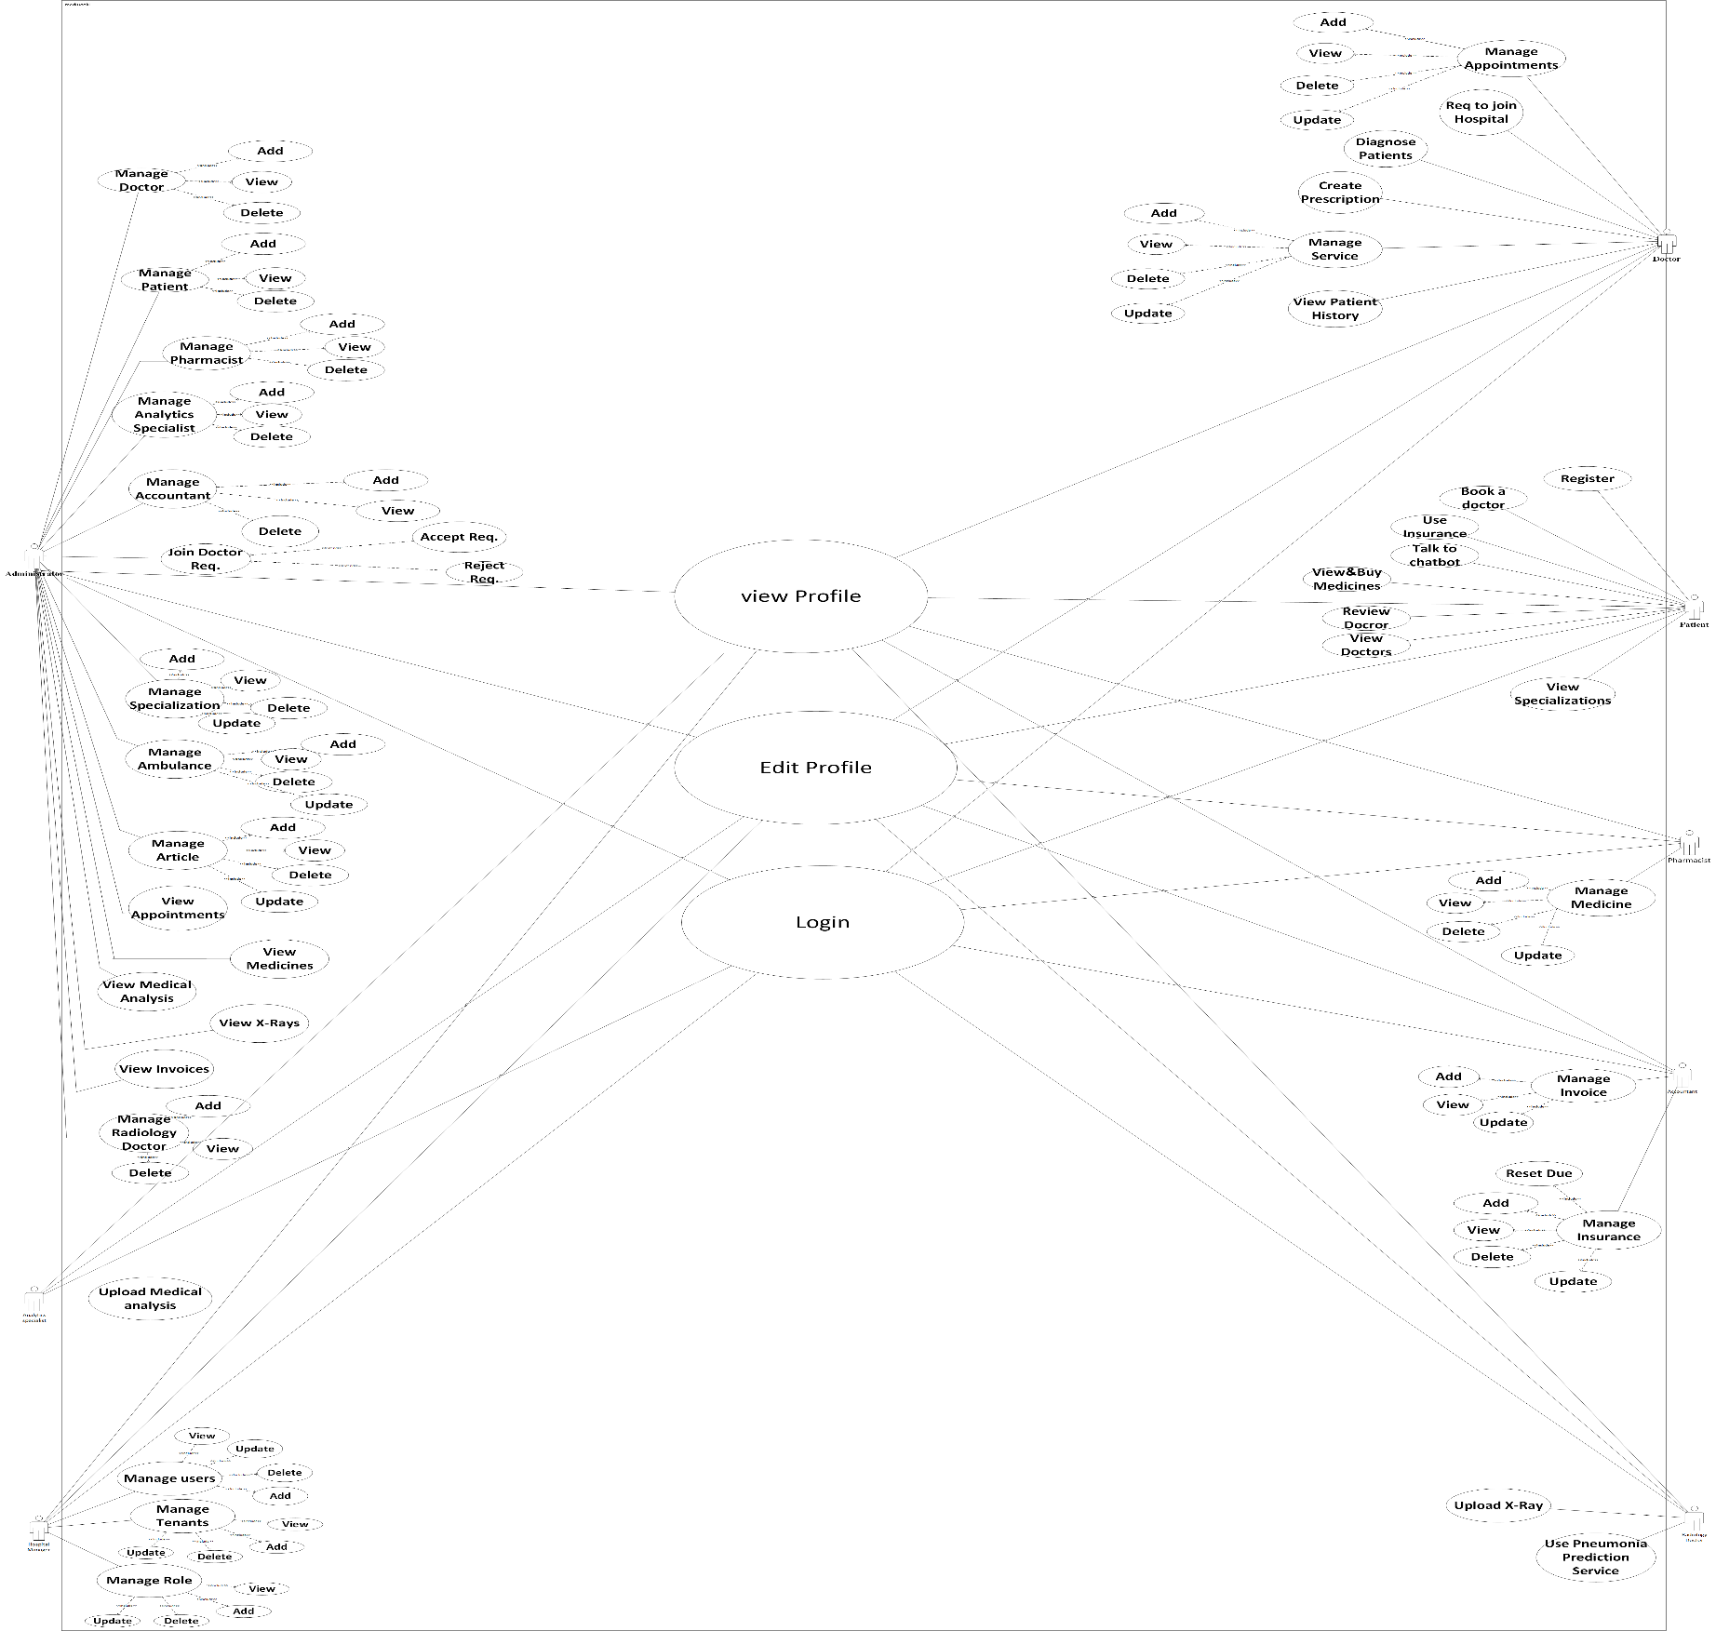

Figure 1: Use Case Diagram

* + 1. Use Case Scenarios:

Use case: Login

**Diagram** :

System User

Login

**Scenario:**

|  |  |
| --- | --- |
| **Log in to the system** | |
| **Actor who initiates the use case** | System User |
| **Pre-condition** | The actor already has an account |
| **Basic path** | -The system user enters user ID and Password in the custom field.  -click on the login button.  -the system validation the entered username and  Password and logs the user into the system. |
| **Post condition** | The actor entered his account successfully |
| **Alternative Paths** | If the system user enters invalid ID or Password, the system shall display an appropriate error message and returns them back to the first in the series of operation |
| **Actor who benefits from the use case** | System User |

Use case: Edit profile

**Diagram** :

System User

Edit profile

Scenario:

|  |  |
| --- | --- |
| Edit profile | |
| **Actor who initiates the use case** | System User |
| **Pre-condition** | The actor must be logged in to the system and has permission. |
| **Basic path** | By click on edit profile in user profile can edit his data such as their name, age, profile picture, email, and password from the form opened. |
| **Post condition** | The actor can edit this profile. |
| **Alternative Paths** | If the system user enters invalid or wrong data, the system shall display an appropriate error message and returns them back to the first in the series of operation |
| **Actor who benefits from the use case** | System User |

Use case: Add Doctor

**Diagram** :

Administrator

Add Doctor

Scenario:

|  |  |
| --- | --- |
| Add Doctor | |
| **Actor who initiates the use case** | Administrator |
| **Pre-condition** | The administrator had signed in to his profile (system), has permeation and the doctor give his data to the administrator. |
| **Basic path** | When the administrator login, he can add the Doctor to the website database and give him an account to make the doctor can do many functions. |
| **Post condition** | The doctor is added and has an account. |
| **Alternative Paths** | If the Administrator enters invalid doctor data, the system shall display an appropriate error message and returns them back to the first in the series of operation |
| **Actor who benefits from the use case** | Administrator |

Use case:  Delete Doctor

**Diagram:**

Administrator

Delete Doctor

Scenario:

|  |  |
| --- | --- |
| Delete Doctor | |
| **Actor who initiates the use case** | Administrator |
| **Pre-condition** | The administrator had signed in to his profile (system), has permeation and the doctor give his data to the administrator |
| **Basic path** | When the administrator login, he can Delete the Doctor from the website database by click on delete button on the doctor row. |
| **Post condition** | The administrator deletes all the doctors |
| **Alternative Paths** | If the Administrator in specific doctor page he can also delete doctor by click on delete button on the page. |
| **Actor who benefits from the use case** | Administrator |

Use case:  Accept Join Requests

**Diagram:**

Administrator

**Accept Join Requests**

Scenario:

|  |  |
| --- | --- |
| **Accept Join Requests** | |
| **Actor who initiates the use case** | Administrator |
| **Pre-condition** | -The system is allowed to accept doctor join request  -The admin must be log in system  -The admin has permission to do this |
| **Basic path** | The system is available to accept doctors' requests by the admin, and requests for the doctor to join the site to work on it |
| **Post condition** | Admin accepts doctor join request |
| **Alternative Paths** | If the doctor is already existing, the system shall display an appropriate error message. |
| **Actor who benefits from the use case** | Administrator |

Use case:  Add Specialization

**Diagram:**

Administrator

**Add Specialization**

Scenario:

|  |  |
| --- | --- |
| **Add Specialization** | |
| **Actor who initiates the use case** | Administrator |
| **Pre-condition** | Admin had signed into his profile (system) and has a permeation |
| **Basic path** | When the admin login, he can add a specialization to the website database, and make patient can access to view it |
| **Post condition** | specialization is added |
| **Alternative Paths** | If the Administrator enters invalid Specialization data, the system shall display an appropriate error message and returns them back to the first in the series of operation |
| **Actor who benefits from the use case** | Administrator |

Use case:  Add Ambulance

**Diagram:**

Administrator

**Add Ambulance**

Scenario:

|  |  |
| --- | --- |
| **Add Ambulance** | |
| **Actor who initiates the use case** | Administrator |
| **Pre-condition** | Admin had signed into his profile (system) and has a permeation |
| **Basic path** | When the admin login, he can add an Ambulance to the website database, and make patient can access to view it |
| **Post condition** | Ambulance is added |
| **Alternative Paths** | If the Administrator enters invalid or wrong Ambulance data, the system shall display an appropriate error message and returns them back to the first in the series of operation |
| **Actor who benefits from the use case** | Administrator |

Use case:  Add Insurance

**Diagram:**

Administrator

**Add Insurance**

Scenario:

|  |  |
| --- | --- |
| **Add Insurance** | |
| **Actor who initiates the use case** | Accountant |
| **Pre-condition** | Accountant had signed into his profile (system) and has a permeation |
| **Basic path** | When the accountant login, he can add Insurance to the website database, and make patient can access to view it |
| **Post condition** | Insurance is added |
| **Alternative Paths** | If the Accountant enters invalid Insurance data, the system shall display an appropriate error message and returns them back to the first in the series of operation |
| **Actor who benefits from the use case** | Accountant |

Use case:  View Appointments

**Diagram:**

Administrator

**View Appointments**

Scenario:

|  |  |
| --- | --- |
| **View Appointments** | |
| **Actor who initiates the use case** | Administrator |
| **Pre-condition** | The user had login into his profile (system) and has permission |
| **Basic path** | When the User login, he can view appointment details like “name, date and some other info |
| **Post condition** | User view details about all filtered the appointment |
| **Alternative Paths** | If the required Appointments is not found, the system should display not found message |
| **Actor who benefits from the use case** | Administrator |

Use case:  Add Medicine

**Diagram:**

Pharmacist

**Add Medicine**

Scenario:

|  |  |
| --- | --- |
| **Add Medicine** | |
| **Actor who initiates the use case** | Pharmacist |
| **Pre-condition** | The pharmacist must log in system and verified to add pharmacist. |
| **Basic path** | Adding Medicineis behaviour done by a pharmacist. When the pharmacist adds a medicine, He’ll add details for the medicine such as the name and image etc. |
| **Post condition** | The medicine will be saved to database. |
| **Alternative Paths** | If the Pharmacist enters invalid or wrong Medicine data, the system shall display an appropriate error message and returns them back to the first in the series of operation |
| **Actor who benefits from the use case** | Pharmacist |

Use case:  Upload Medical Analysis

**Diagram:**

Analytics specialist

**Upload Medical Analysis**

Scenario:

|  |  |
| --- | --- |
| **Upload Medical Analysis** | |
| **Actor who initiates the use case** | Analytics specialist. |
| **Pre-condition** | The Analytics specialist must log in system and type of medical analysis is exist |
| **Basic path** | After Analytics specialist finish medical analysis, he uploads result of medical analysis as file on system |
| **Post condition** | The medical analysis result will be saved to database |
| **Alternative Paths** | If the Analytics specialist enters empty Medical Analysis, the system shall display an appropriate error message and returns them back to the first in the series of operation |
| **Actor who benefits from the use case** | Analytics specialist. |

Use case:  Upload X-Rays

**Diagram:**

Radiology doctor.

**Upload X-Rays**

Scenario:

|  |  |
| --- | --- |
| **Upload X-Rays** | |
| **Actor who initiates the use case** | Radiology doctor. |
| **Pre-condition** | The Radiology doctor must log in system and type of x-ray is exist |
| **Basic path** | After Radiology doctor finish x-ray, he uploads result of x-ray as file on system |
| **Post condition** | The x-ray result will be saved to database |
| **Alternative Paths** | If the Radiology doctor enters empty X-Rays, the system shall display an appropriate error message and returns them back to the first in the series of operation |
| **Actor who benefits from the use case** | Radiology doctor. |

Use case:  Add Role

**Diagram:**

The Hospital Manager

**Add Role**

Scenario:

|  |  |
| --- | --- |
| **Add Role** | |
| **Actor who initiates the use case** | The Hospital Manager |
| **Pre-condition** | The system is allowed to add roles |
| **Basic path** | The Hospital Manager is available to add roles and describe the privilege for each user. The role is the validities that the user takes, whoever (Admin, Pharmacist, Doctor, Analytics Specialist, Radiology Doctor, Accountant or Patient) to perform certain tasks |
| **Post condition** | Role is created successfully |
| **Alternative Paths** | If the Hospital Manager enters invalid or wrong role data, the system shall display an appropriate error message and returns them back to the first in the series of operation |
| **Actor who benefits from the use case** | The Hospital Manager |

Use case:  Add User

**Diagram:**

The Hospital Manager

**Add User**

Scenario:

|  |  |
| --- | --- |
| **Add User** | |
| **Actor who initiates the use case** | The Hospital Manager |
| **Pre-condition** | -The system is allowed to add users  -The Hospital Manager must be logged in the system  -User hasn’t been created yet. |
| **Basic path** | The Hospital Manager is available to add user and describe his privileges |
| **Post condition** | User is added successfully |
| **Alternative Paths** | If the Hospital Manager enters invalid or wrong User data, the system shall display an appropriate error message and returns them back to the first in the series of operation |
| **Actor who benefits from the use case** | The Hospital Manager |

Use case:  Add Invoice

**Diagram:**

Accountant

**Add Invoice**

Scenario:

|  |  |
| --- | --- |
| **Add Invoice** | |
| **Actor who initiates the use case** | Accountant |
| **Pre-condition** | -The system is allowed to create invoices  -The accountant must be logged in the system  -Patients and Doctors have been created. |
| **Basic path** | Accountant must add invoices and manage the financial part of the hospital |
| **Post condition** | Invoice is added successfully |
| **Alternative Paths** | If the accountant enters invalid or wrong invoice data, the system shall display an appropriate error message and returns them back to the first in the series of operation |
| **Actor who benefits from the use case** | Accountant |

Use case:  Patient Diagnosis

**Diagram:**

Doctor

**Patient Diagnosis**

Scenario:

|  |  |
| --- | --- |
| **Patient Diagnosis** | |
| **Actor who initiates the use case** | Doctor |
| **Pre-condition** | -The system is allowed to add diagnosis  -The Doctor must be logged in the system  -Patient , Radiology Doctor ,Analytics Specialist and Doctors have been created.  -The Doctor should view patient history. |
| **Basic path** | Doctor must add patient diagnosis and can send them to the specialist. |
| **Post condition** | Diagnosis is added successfully |
| **Alternative Paths** | If the doctor enters invalid or wrong Diagnosis data, the system shall display an appropriate error message and returns them back to the first in the series of operation |
| **Actor who benefits from the use case** | Doctor |

Use case:  Create Prescription

**Diagram:**

Doctor

**Create Prescription**

Scenario:

|  |  |
| --- | --- |
| **Create Prescription** | |
| **Actor who initiates the use case** | Doctor |
| **Pre-condition** | -The system is allowed to add prescription  -The Doctor must be logged in the system  -Patients and Doctors have been created.  -Patient Diagnosis has been created |
| **Basic path** | Doctor must create prescription after diagnose patient and add it in patient profile. |
| **Post condition** | Prescription is added successfully |
| **Alternative Paths** | If the doctor enters invalid or wrong Prescription data, the system shall display an appropriate error message and returns them back to the first in the series of operation |
| **Actor who benefits from the use case** | Doctor |

Use case:  Add Service

**Diagram:**

Doctor

**Add Service**

Scenario:

|  |  |
| --- | --- |
| **Add Service** | |
| **Actor who initiates the use case** | Doctor |
| **Pre-condition** | -The system is allowed to add service.  -The Doctor must be logged in the system  -The Doctor has been created |
| **Basic path** | By click on add service button will open form the doctor type service details and click submit then the service is available for patient. |
| **Post condition** | Service is added successfully |
| **Alternative Paths** | If the doctor enters invalid or wrong service data, the system shall display an appropriate error message and returns them back to the first in the series of operation |
| **Actor who benefits from the use case** | Doctor |

Use case:  View Patient History

**Diagram:**

Doctor

**View Patient History**

Scenario:

|  |  |
| --- | --- |
| **View Patient History** | |
| **Actor who initiates the use case** | Doctor |
| **Pre-condition** | -The system is allowed to view patient history.  -The Doctor must be logged in the system  -The Doctor and patient have been created |
| **Basic path** | After open specific patient profile doctor can view patient history to help doctor in diagnoses |
| **Post condition** | List of patient’s history is viewed successfully |
| **Alternative Paths** | If the required Patient History is not found, the system should display not found message |
| **Actor who benefits from the use case** | Doctor |

Use case:  View Specialization

**Diagram:**

Patient, Administrator, Hospital manager

**View Specialization**

Scenario:

|  |  |
| --- | --- |
| **View Specialization** | |
| **Actor who initiates the use case** | Patient, Administrator, Hospital manager |
| **Pre-condition** | User had login to his profile (system) and has permission |
| **Basic path** | When user login, he can filter and view specialization details like “name” |
| **Post condition** | User view details about all filtered the specializations |
| **Alternative Paths** | If the required Specialization is not found, admin should add Specialization to view his details |
| **Actor who benefits from the use case** | Patient, Administrator, Hospital manager |

Use case:  Register

**Diagram:**

Patient

**Register**

Scenario:

|  |  |
| --- | --- |
| **Register** | |
| **Actor who initiates the use case** | Patient |
| **Pre-condition** | Patient don’t have an account |
| **Basic path** | By click on register Button on navbar will open the registration form the user type his data in every field and by click on submit button the account is created and user can login now. |
| **Post condition** | User register successfully and can login into the system |
| **Alternative Paths** | If the system user enters invalid ID or not strong Password or invalid user data, the system shall display an appropriate error message and returns them back to the first in the series of operation |
| **Actor who benefits from the use case** | Patient |

Use case:  Book a doctor

**Diagram:**

Patient

**Book a doctor**

Scenario:

|  |  |
| --- | --- |
| **Book a doctor** | |
| **Actor who initiates the use case** | Patient |
| **Pre-condition** | Patient have an account and login into the system |
| **Basic path** | When user login, he can book a doctor and make an appointment based on specialty |
| **Post condition** | Appointment is made |
| **Alternative Paths** | If the doctor isn’t available the system should display error message |
| **Actor who benefits from the use case** | Patient |

Use case:  View Doctors

**Diagram:**

Patient

**View Doctors**

Scenario:

|  |  |
| --- | --- |
| **View Doctors** | |
| **Actor who initiates the use case** | Administrator, Hospital manager |
| **Pre-condition** | User had login into his profile (system) and has permission |
| **Basic path** | When User login, he can filter and view doctor details like “name, specialty and some another info |
| **Post condition** | System User view details about all filtered the doctors |
| **Alternative Paths** | If the required doctor is not found, the system should display not found message |
| **Actor who benefits from the use case** | Administrator, Hospital manager |

Use case:  Use medical Insurance

**Diagram:**

Patient

**Use medical Insurance**

Scenario:

|  |  |
| --- | --- |
| **Use medical Insurance** | |
| **Actor who initiates the use case** | Patient |
| **Pre-condition** | User logged in to his profile (system) and has permission |
| **Basic path** | When user login, he can use medical insurance to have a discount on price of medicines |
| **Post condition** | User dispends the medicine from the system |
| **Alternative Paths** | If patient did not add insurance the system should ask user to add insurance |
| **Actor who benefits from the use case** | Patient |

Use case:  Talk to chatbot

**Diagram:**

Patient

**Talk to chatbot**

Scenario:

|  |  |
| --- | --- |
| **Talk to chatbot** | |
| **Actor who initiates the use case** | Patient |
| **Pre-condition** | User logged in to his profile (system) and has permission |
| **Basic path** | By click on chatbot icon chat will open and patient can type any question and bot will respond with the answer |
| **Post condition** | User talk to chatbot and be guided by it |
| **Alternative Paths** | If the user typed a wrong question, the system should ask the user to type another one |
| **Actor who benefits from the use case** | Patient |

Use case: View medical Analysis

**Diagram:**

Doctor

**View medical Analysis**

Scenario:

|  |  |
| --- | --- |
| **View medical Analysis** | |
| **Actor who initiates the use case** | Doctor |
| **Pre-condition** | User logged in to his profile (system) and has permission |
| **Basic path** | When User login, he can view medical analysis details |
| **Post condition** | User view details about all filtered the medical analysis |
| **Alternative Paths** | If the required medical Analysisis not found, the system should display not found message |
| **Actor who benefits from the use case** | Doctor |

Use case: Add Tenant

**Diagram:**

The Hospital Manager

**Add Tenant**

Scenario:

|  |  |
| --- | --- |
| **Add Tenant** | |
| **Actor who initiates the use case** | The Hospital Manager |
| **Pre-condition** | The system is allowed to add Tenant |
| **Basic path** | The Hospital Manager is available to add Tenant and describe the Tenant data for each Tenant like its domain, DB name and branch or tenant name. |
| **Post condition** | Tenant is created successfully |
| **Alternative Paths** | If the Hospital Manager enters invalid or wrong Tenant data, the system shall display an appropriate error message. |
| **Actor who benefits from the use case** | The Hospital Manager |

* 1. Activity Diagrams

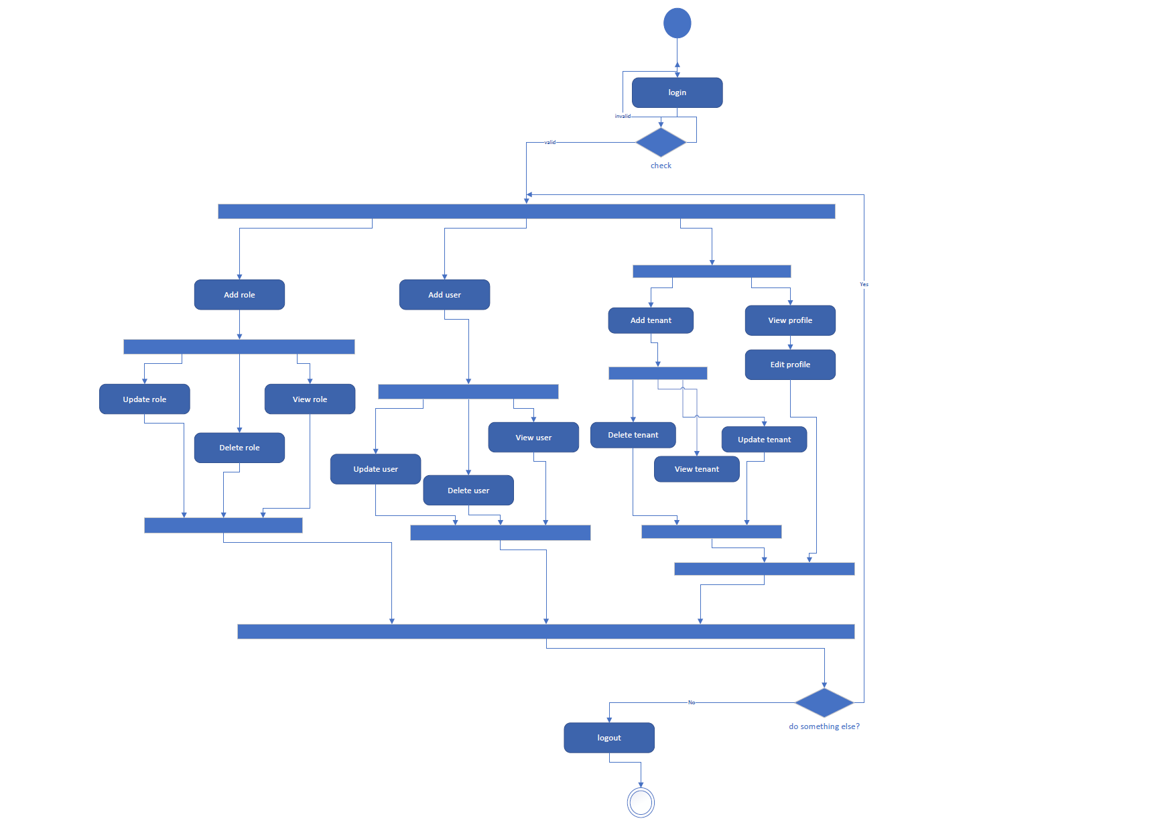

Figure 2: Hospital Manager Activity Diagram

Figure 3: Hospital Manager Activity Diagram

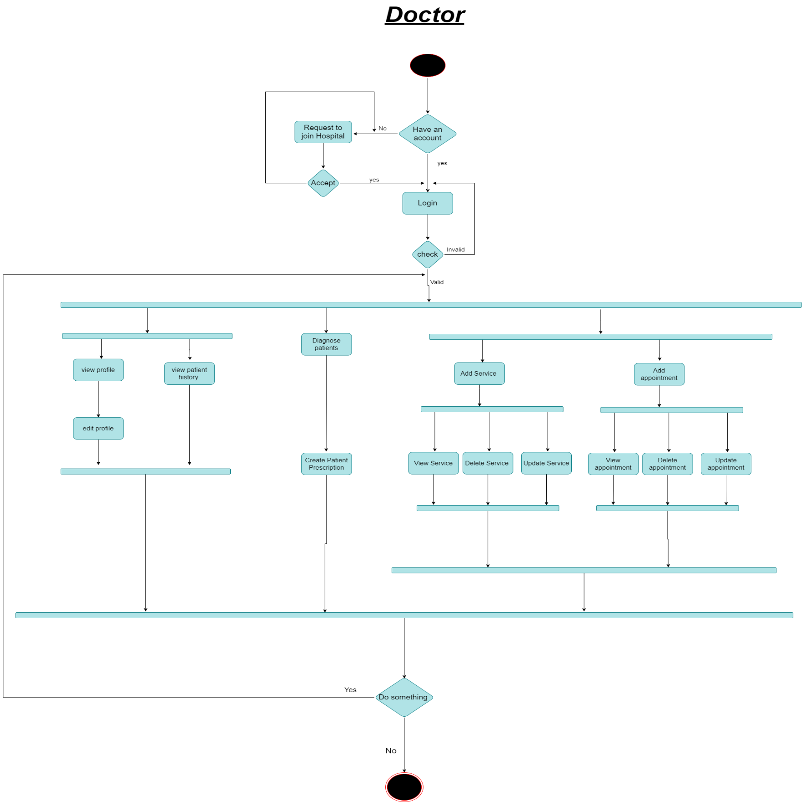

Figure 4: Doctor Activity Diagram

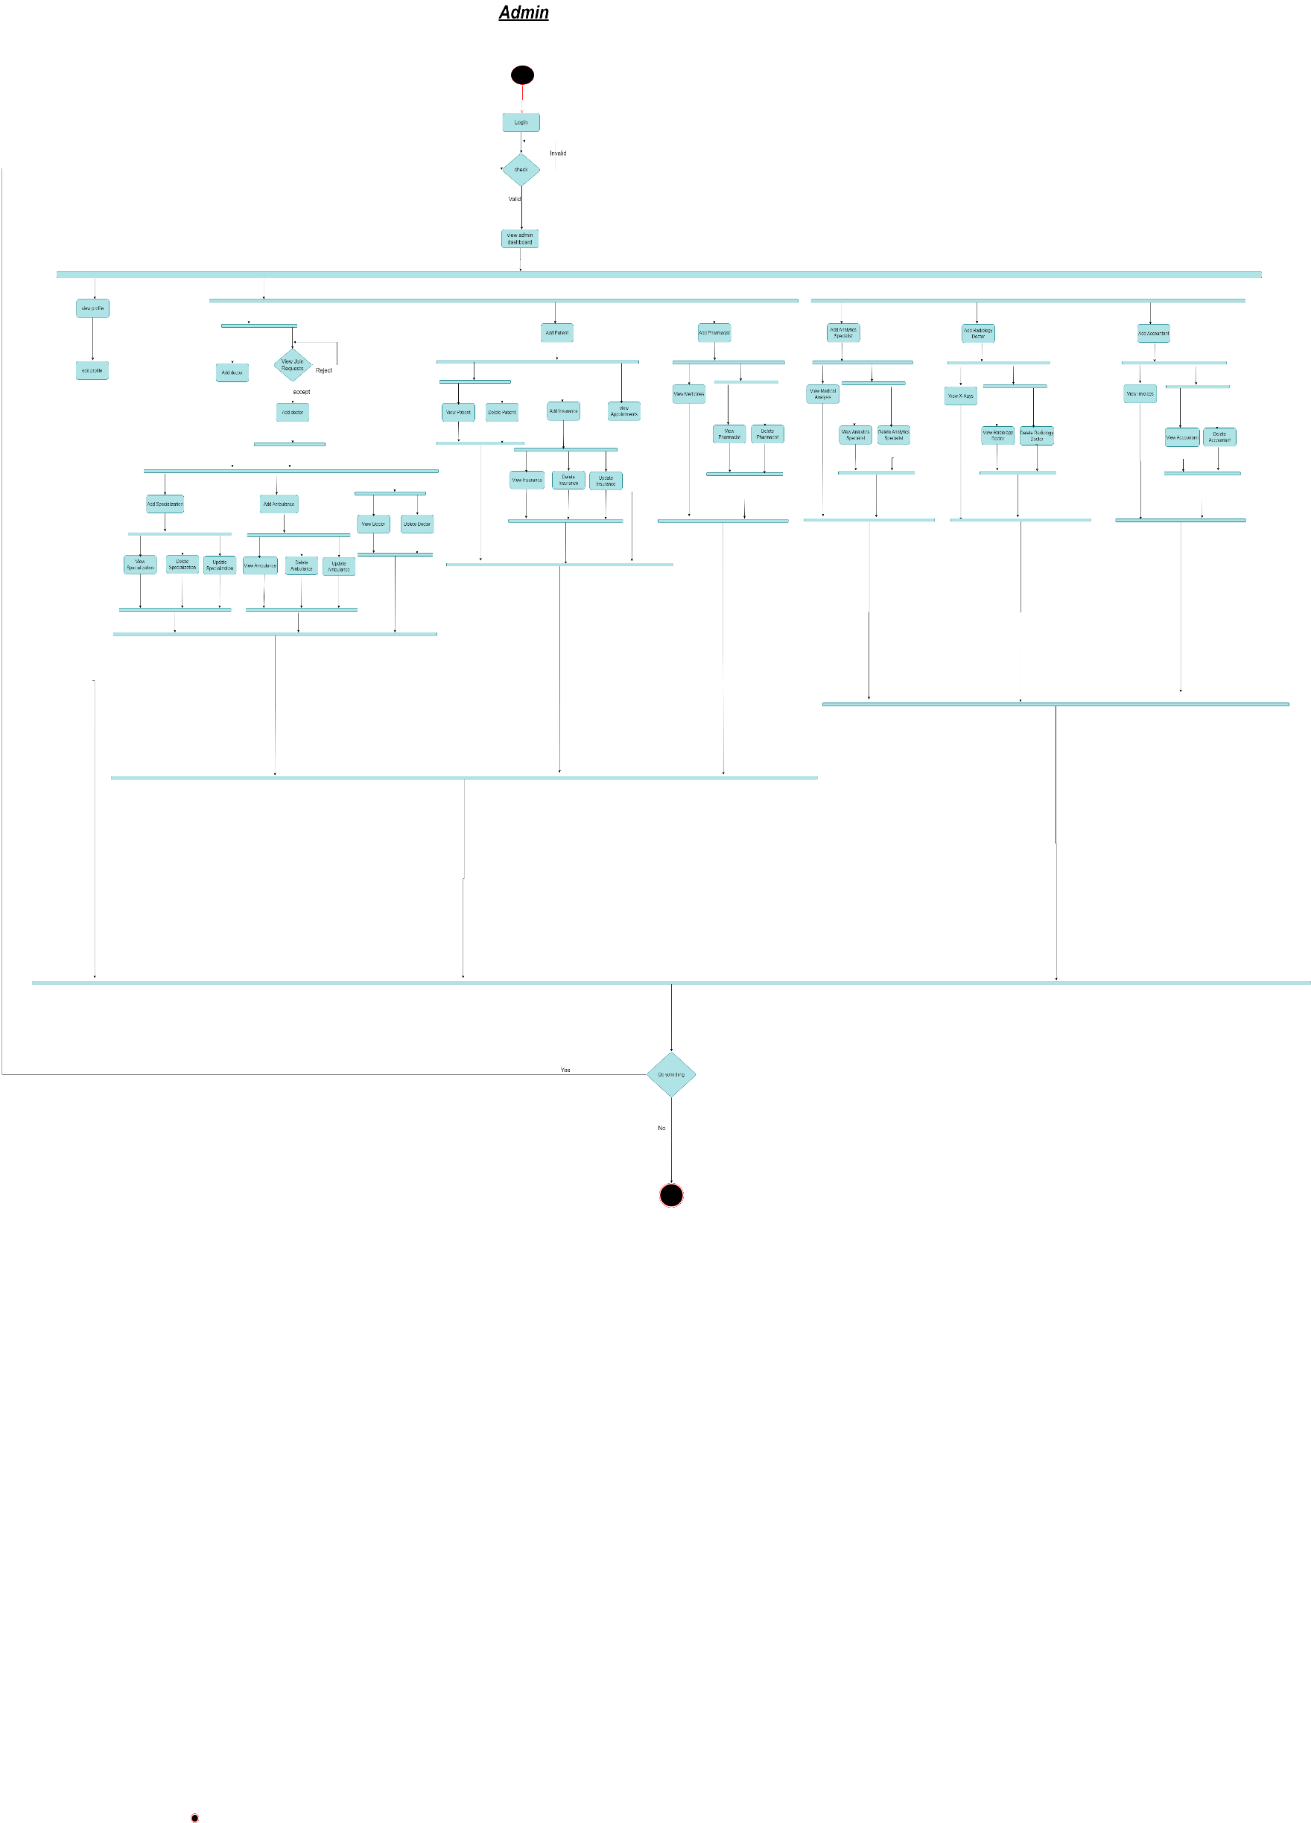

Figure 5: Admin Activity Diagram

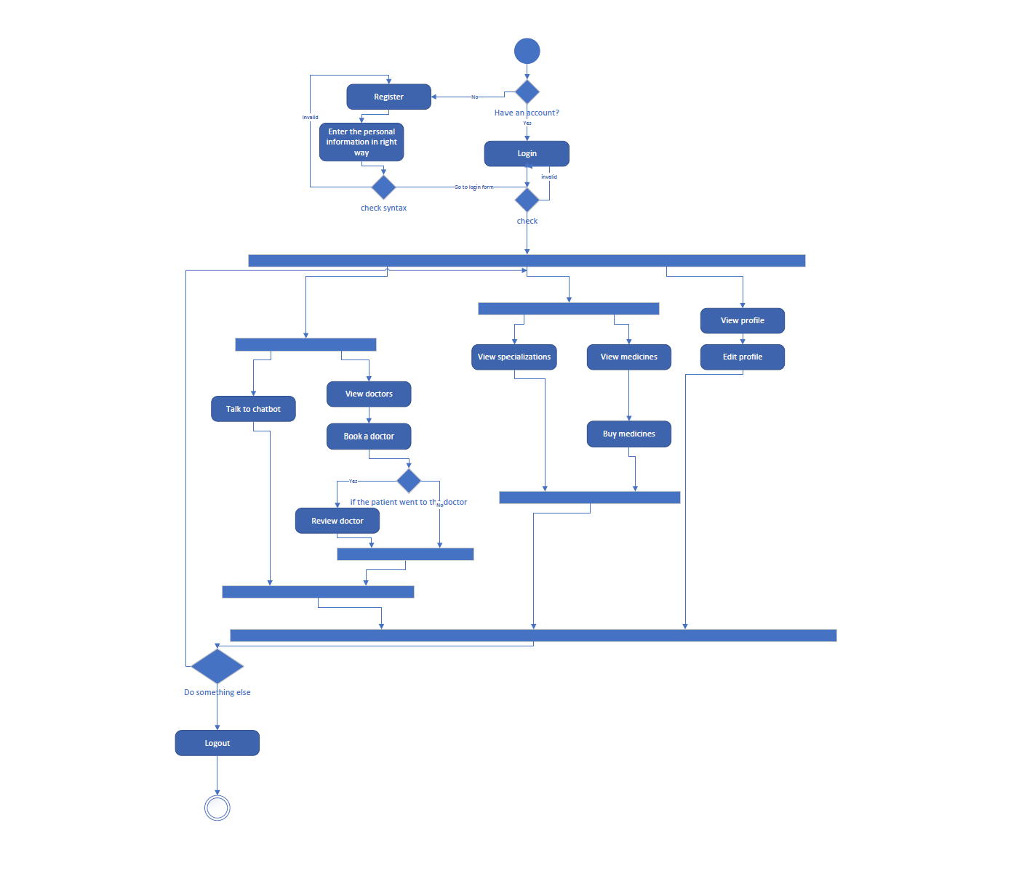

Figure 6: Patient Activity Diagram

Figure 7: Analysis Specialist Activity Diagram

Figure 8: Radiology Doctor Activity Diagram

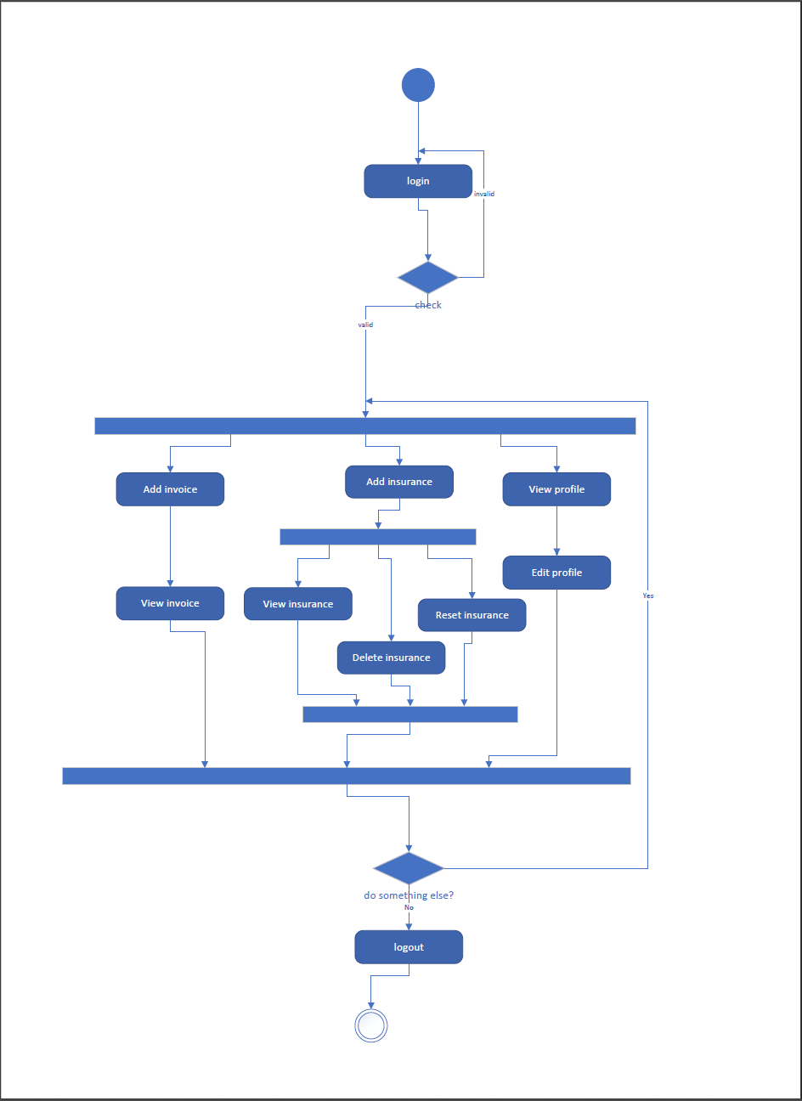

Figure 9: Pharmacy Activity Diagram

Figure 10: Accountant Activity Diagram

1. Software Design

4. 1. Design of database (Class Diagram)
      1. Version 1: -

Figure 11: Class Diagram V1

* + 1. Version 2:Timeline

       Description automatically generated

Figure 12: Class Diagram V2

* 1. 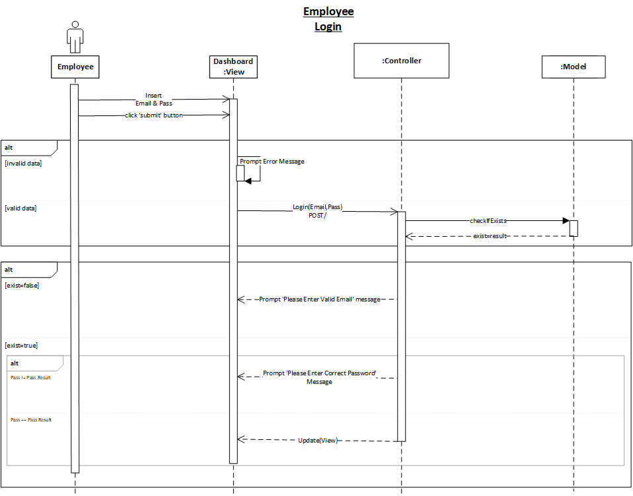Sequence Diagram

Figure 13: Employee Login

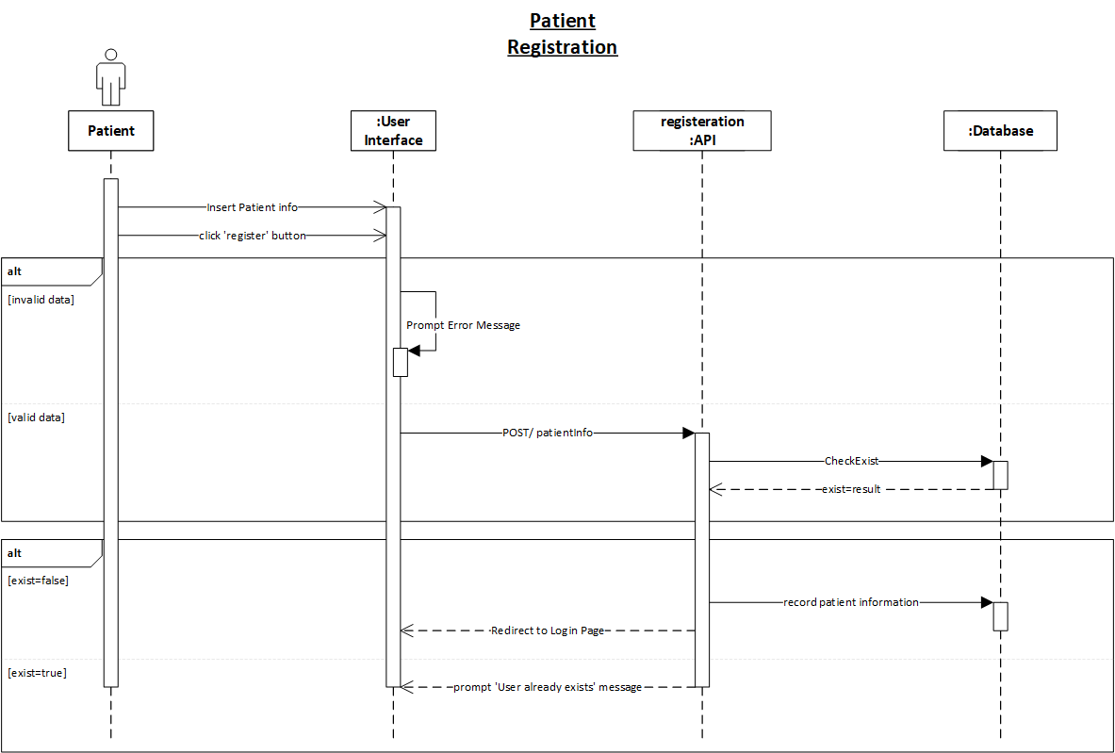

Figure 14: Patient Registration

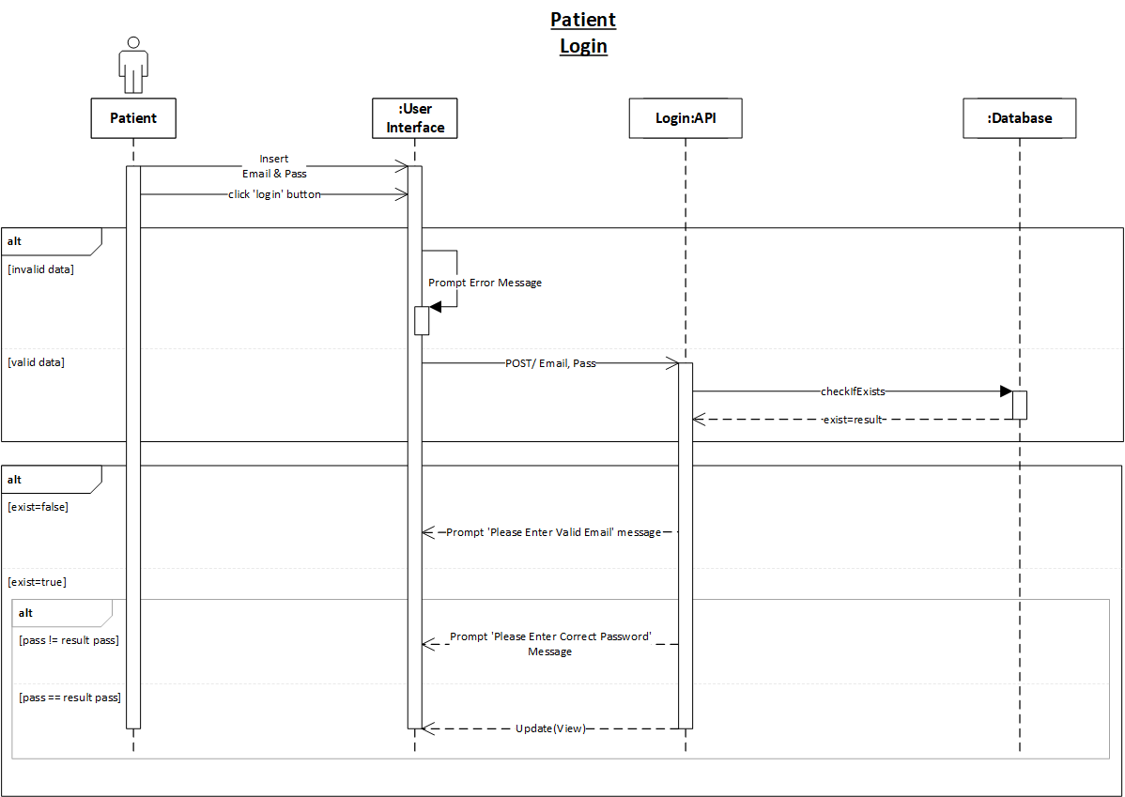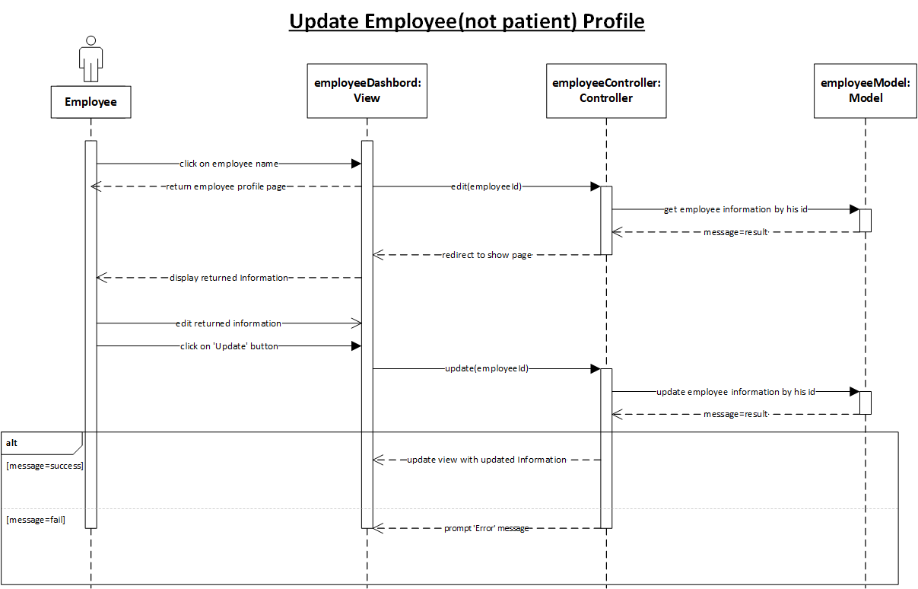

Figure 15: Update Employee Profile

Figure 16: Patient Login

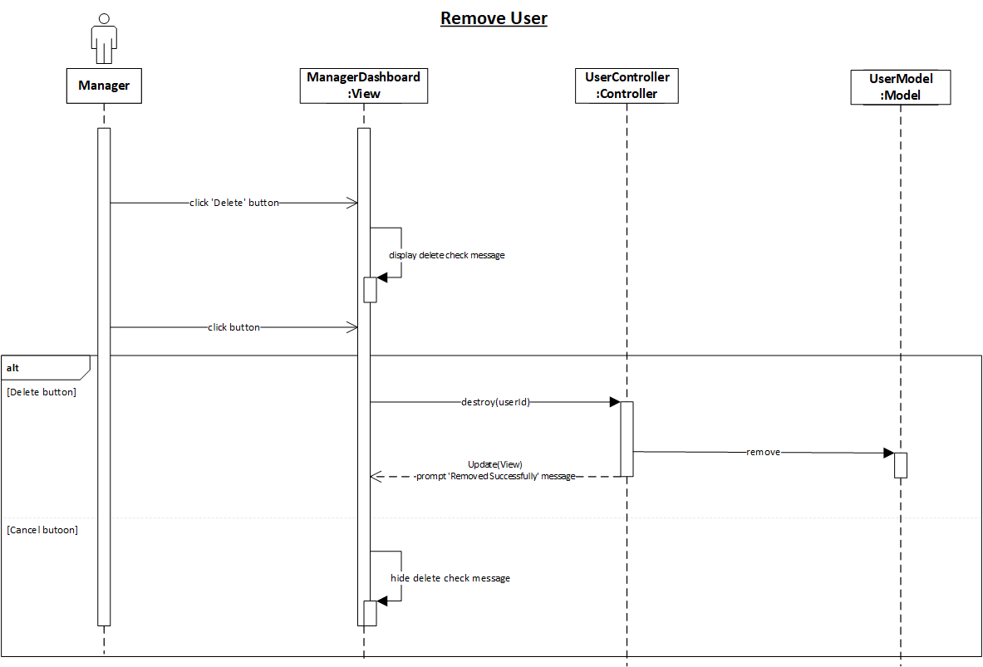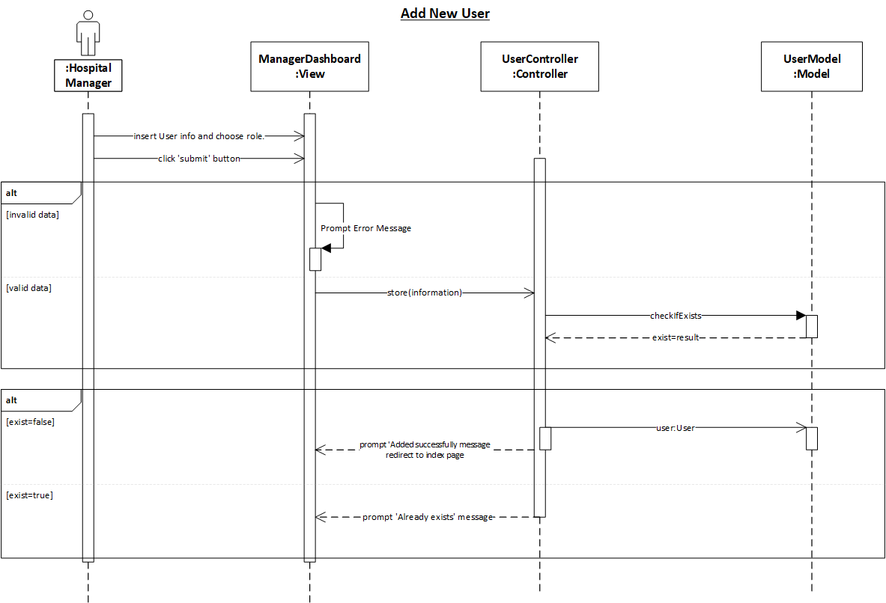

Figure 17: Hospital Manager Remove User

Figure 18: Hospital Manager Add User

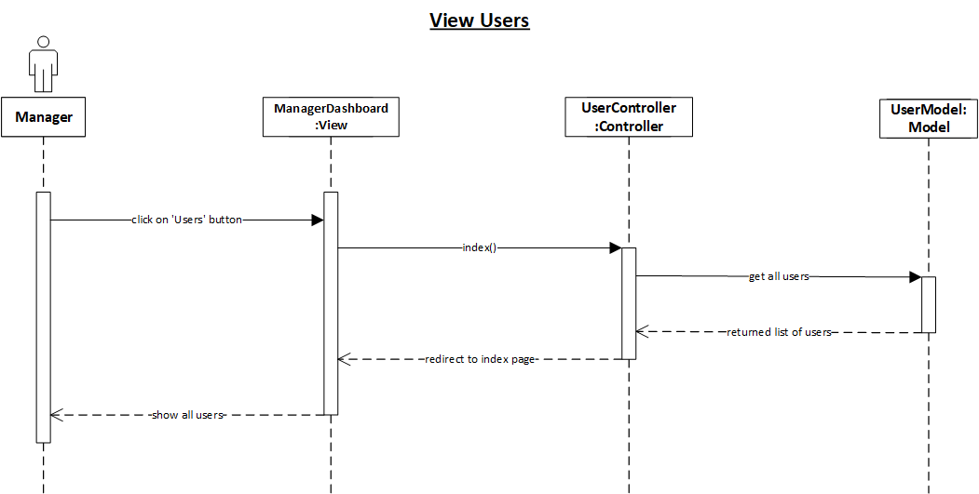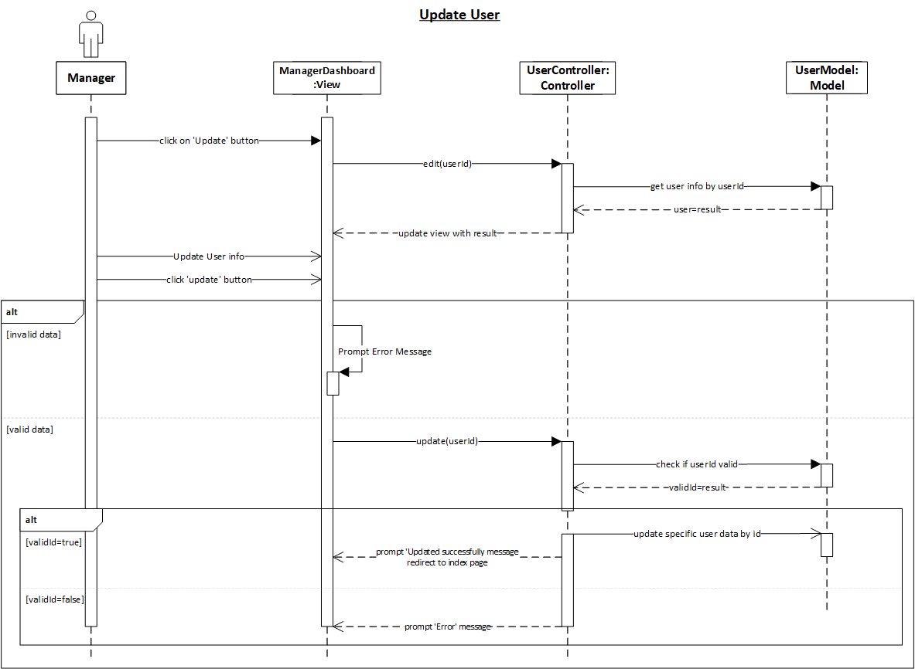

Figure 19: Hospital Manager View Users

Figure 20:Hospital Manager Update User

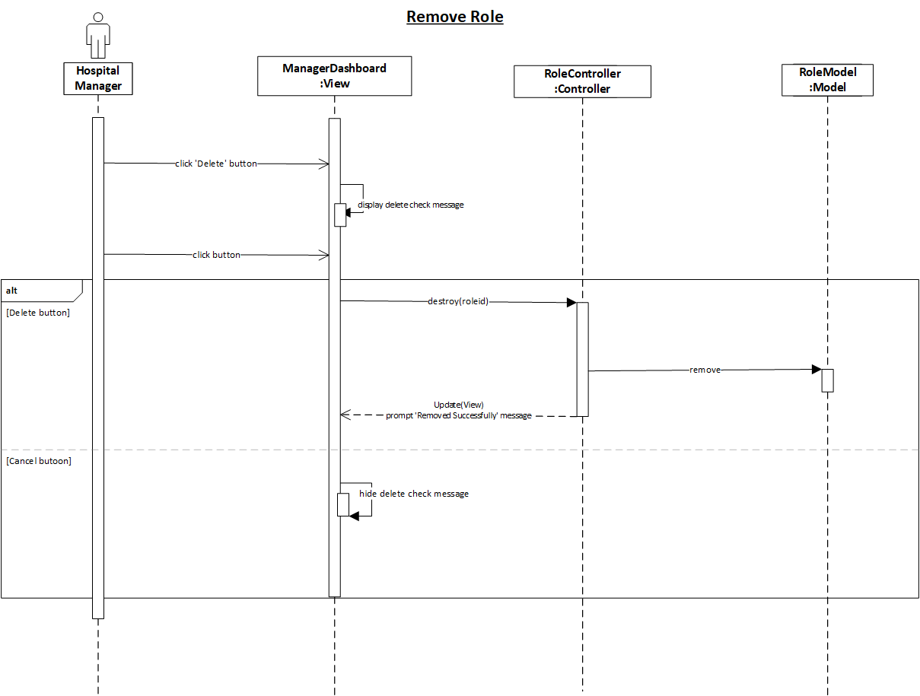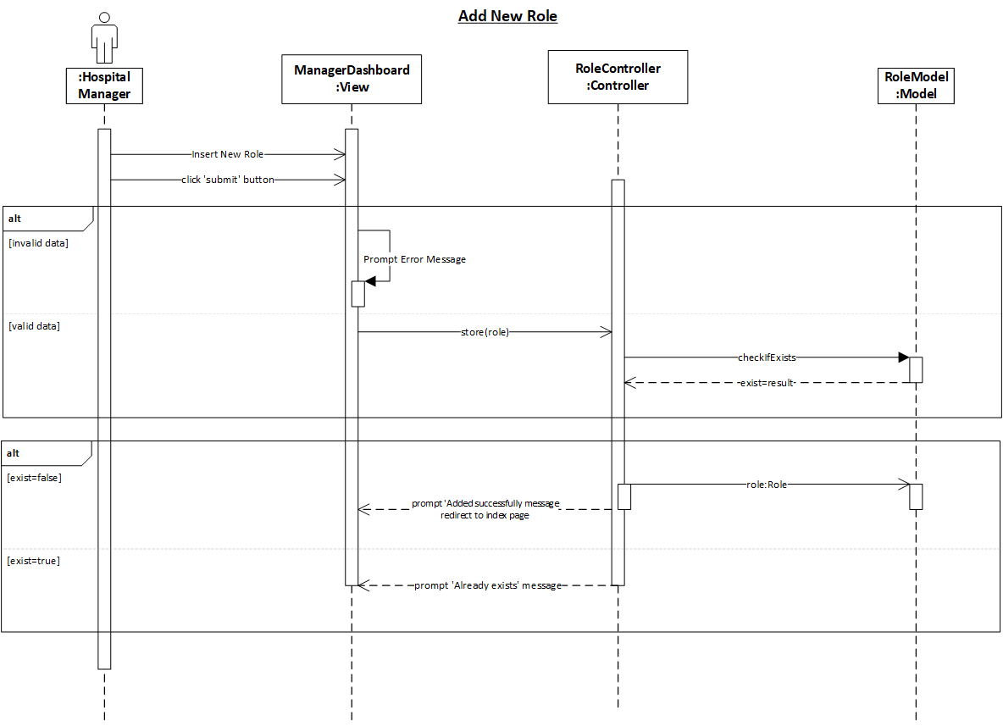

Figure 21: Hospital Manager Remove Role

Figure 22: Hospital Manager Add Role

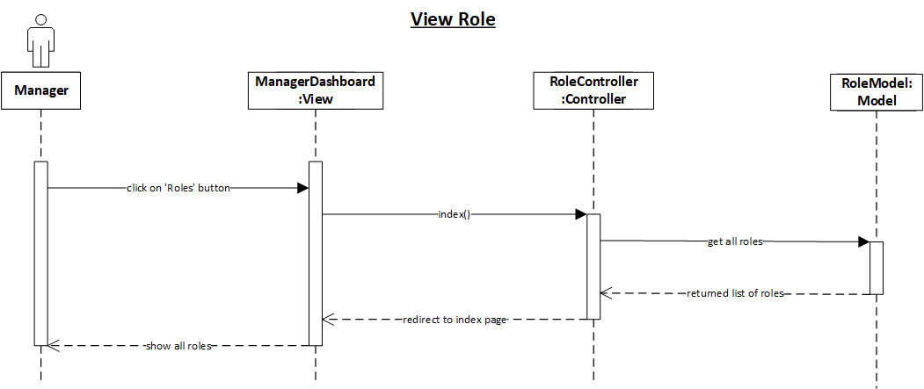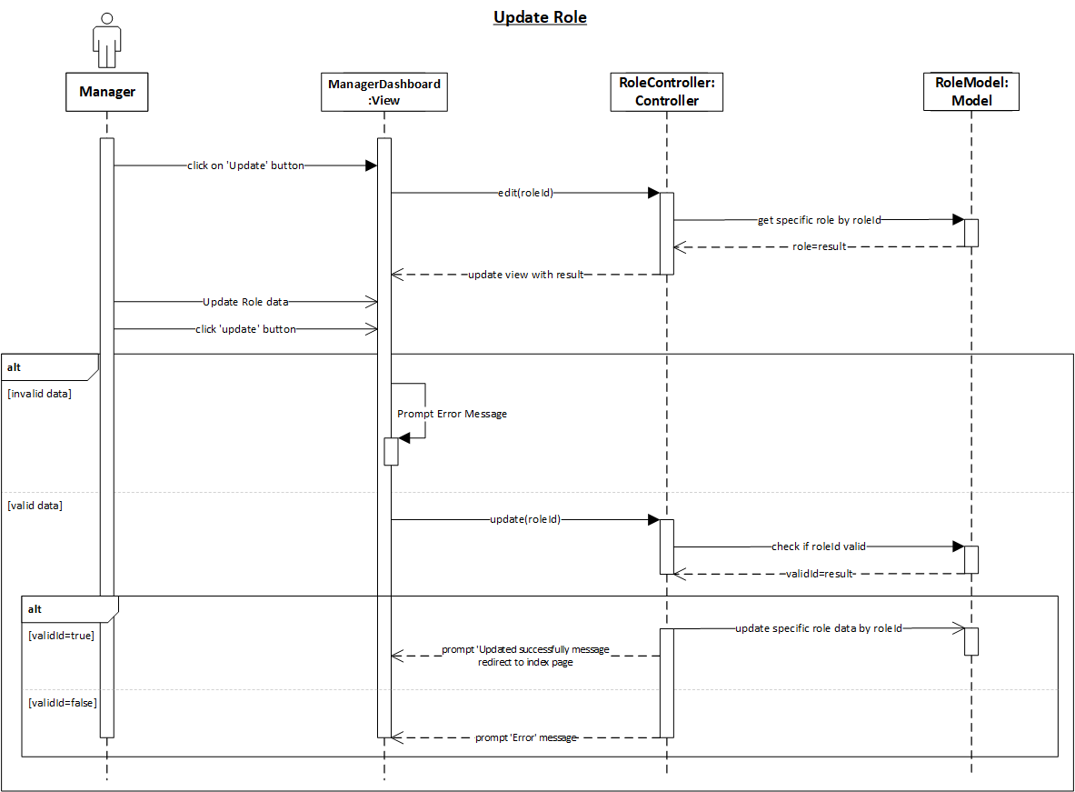

Figure 23: Hospital Manager View Role

Figure 24: Hospital Manager Update Role

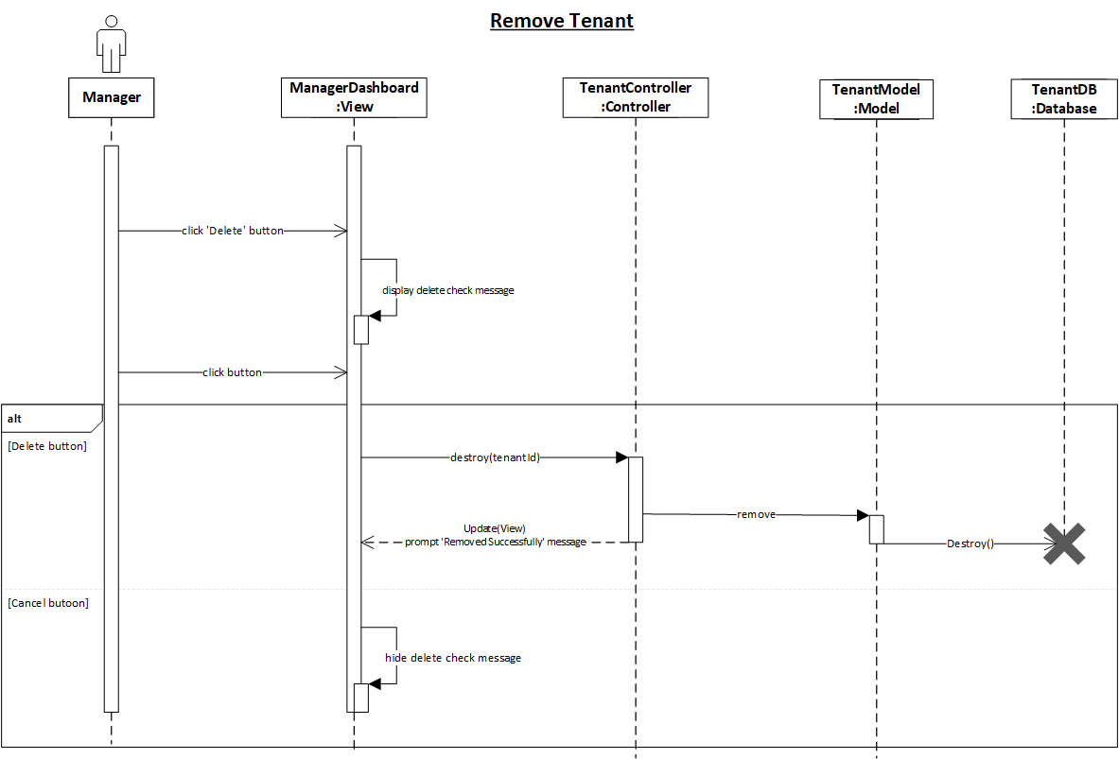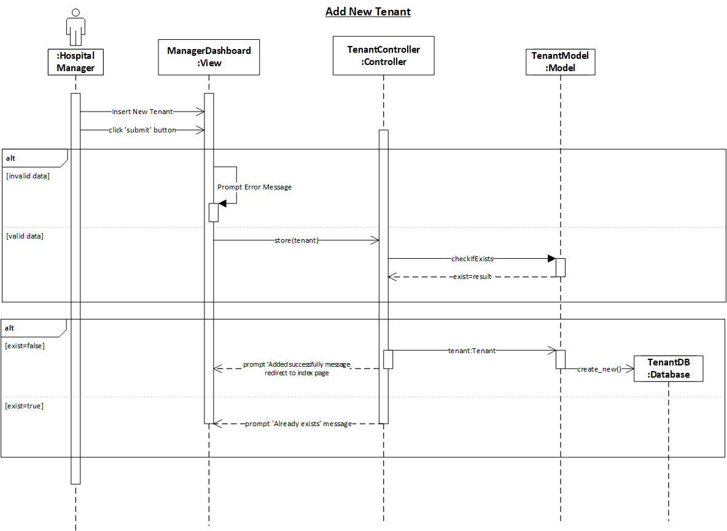

Figure 25: Hospital Manager Remove Tenant

Figure 26: Hospital Manager Add Tenant

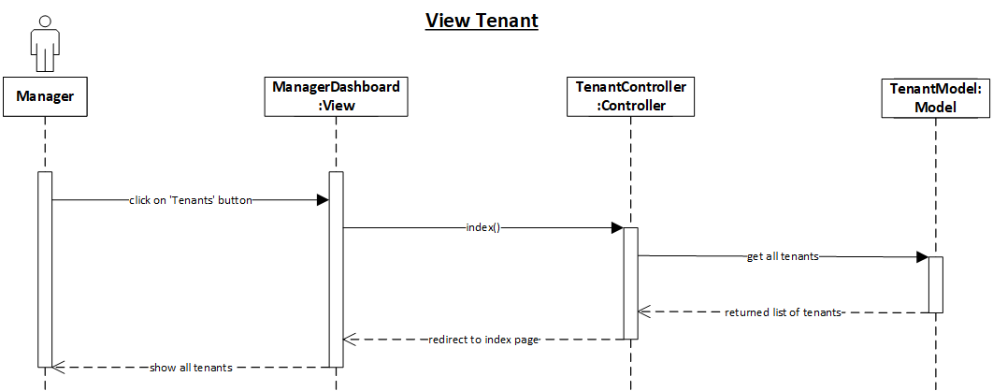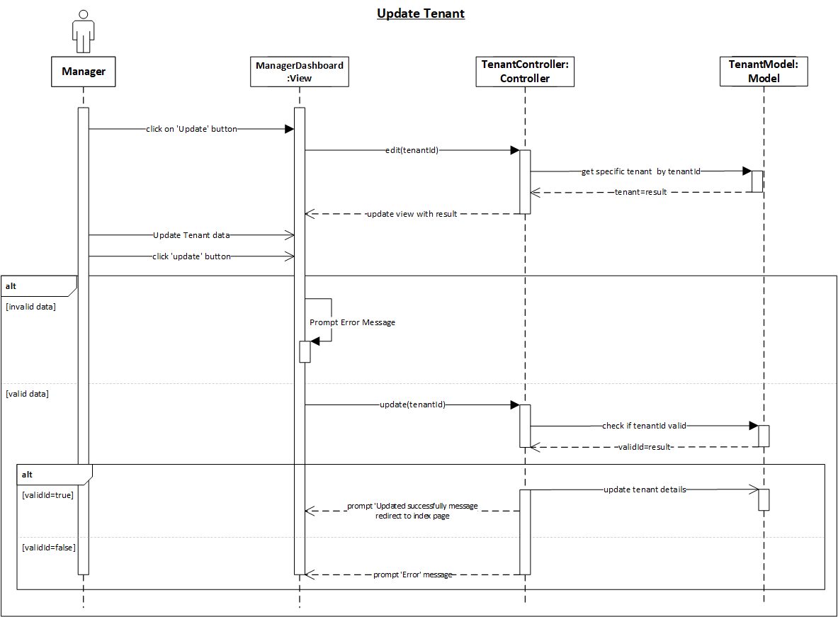

Figure 27: Hospital Manager View Tenant

Figure 28: Hospital Manager Update Tenant

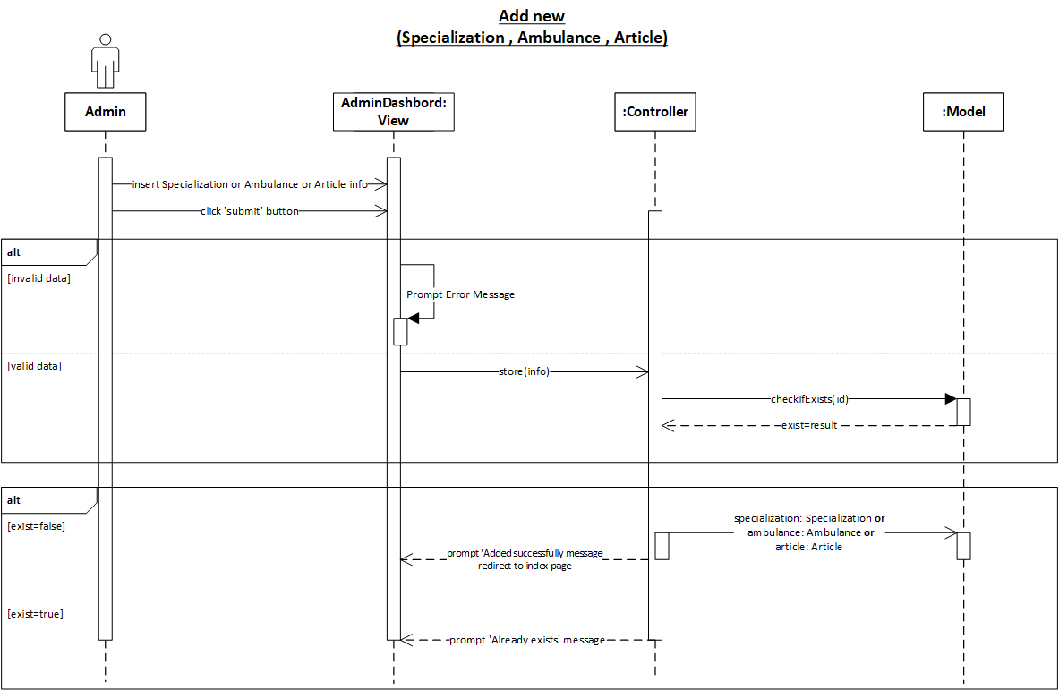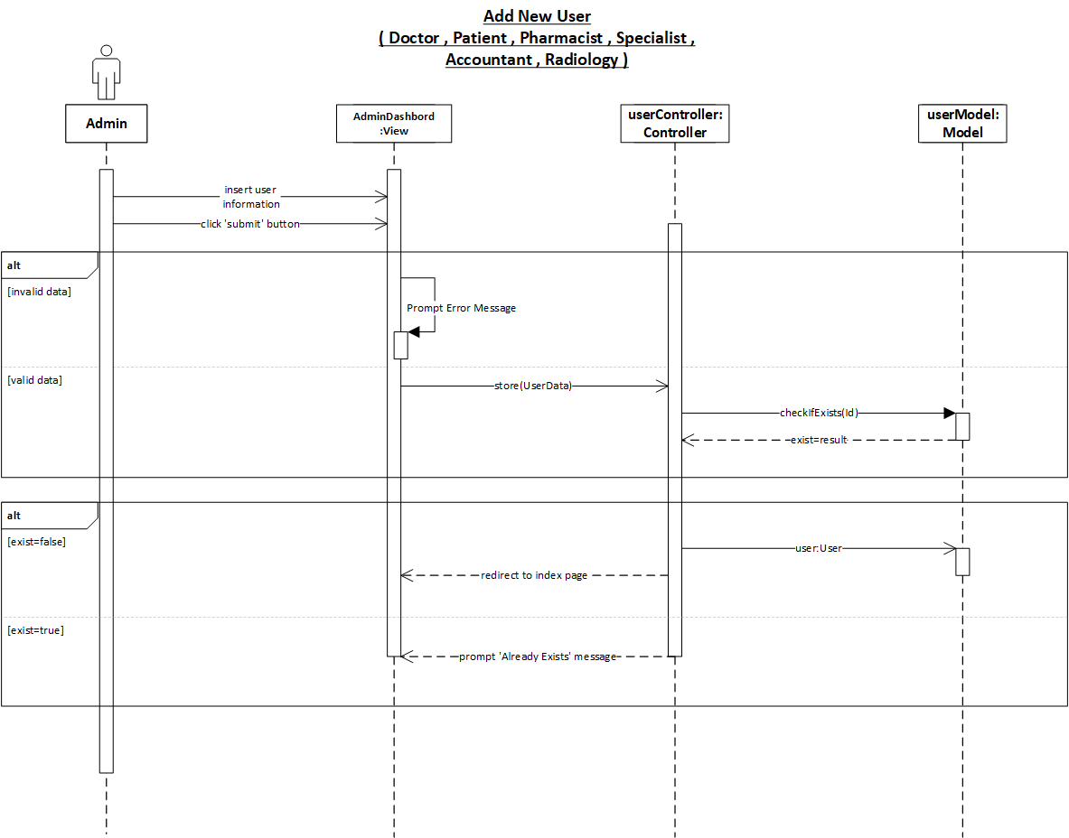

Figure 29: Admin Add Specialization / Ambulance / Article

Figure 30: Admin Add User ( Doctor , Patient , Pharmacist , Specialist , Accountant , Radiology )

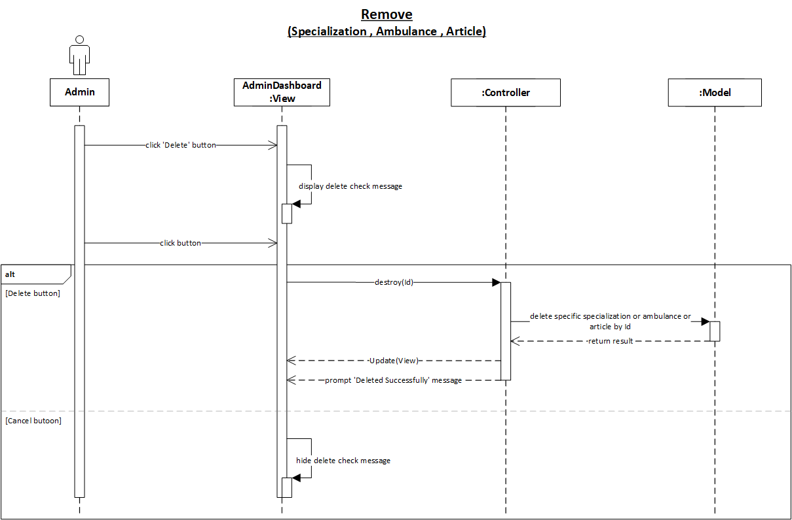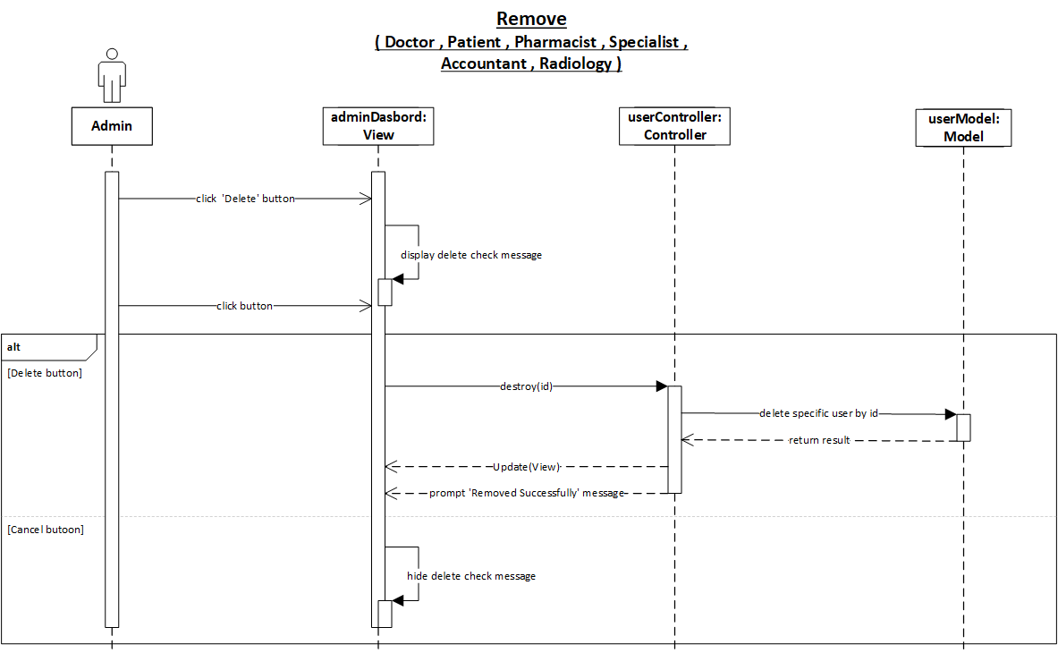

Figure 31: Admin Remove Specialization / Ambulance / Article

Figure 32: Admin Remove User ( Doctor , Patient , Pharmacist , Specialist , Accountant , Radiology )

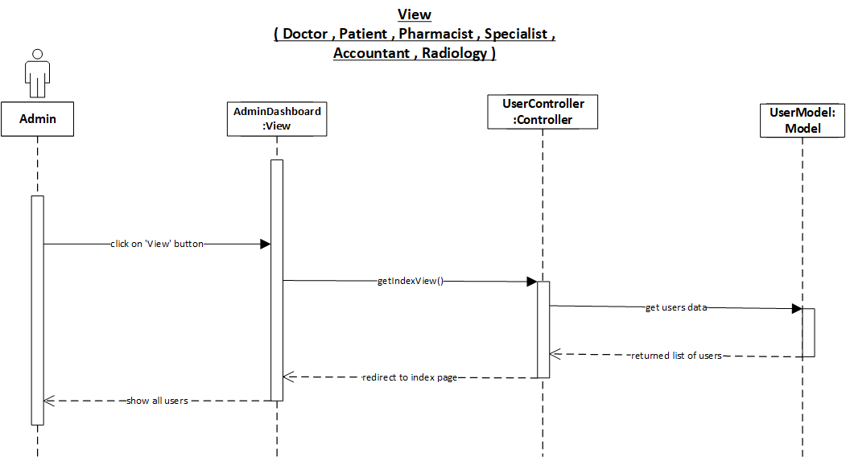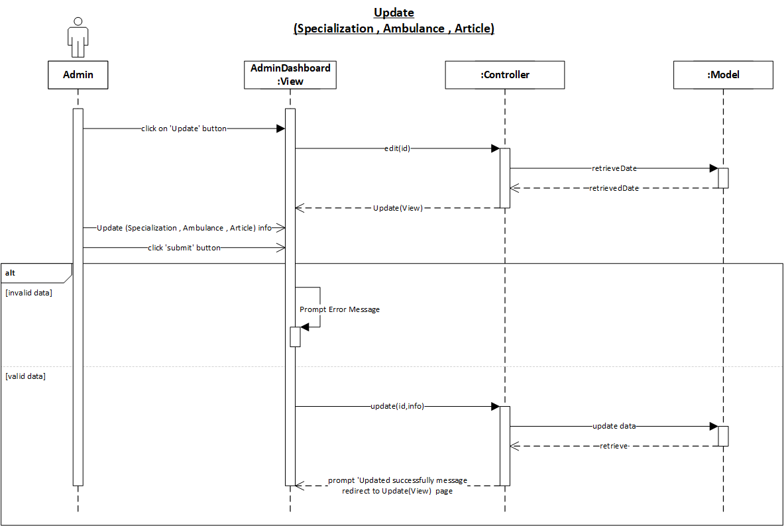

Figure 33: Admin View User ( Doctor , Patient , Pharmacist , Specialist , Accountant , Radiology )

Figure 34: Admin Update Specialization / Ambulance / Article

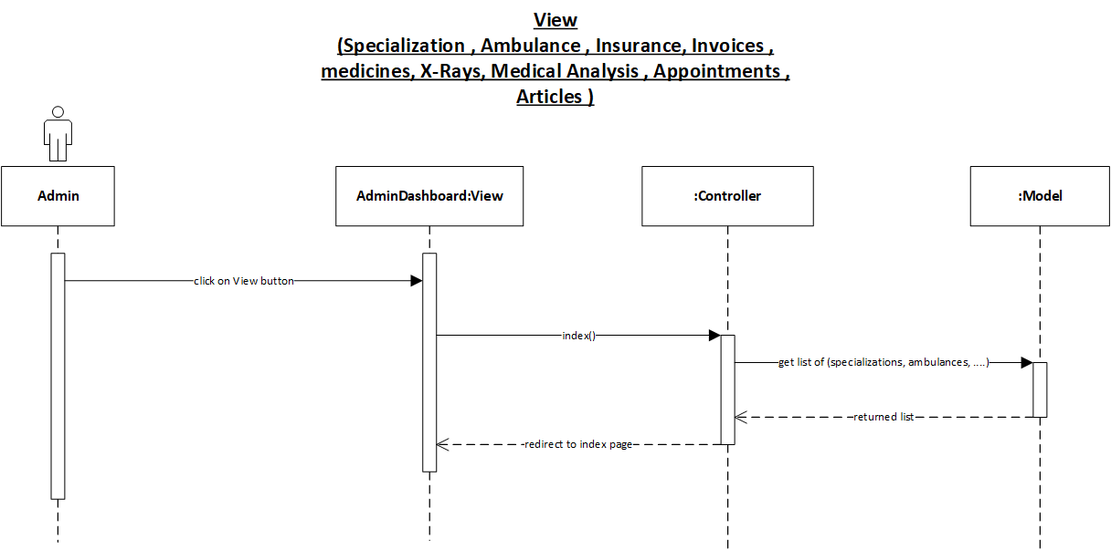

Figure 35: Admin View Something

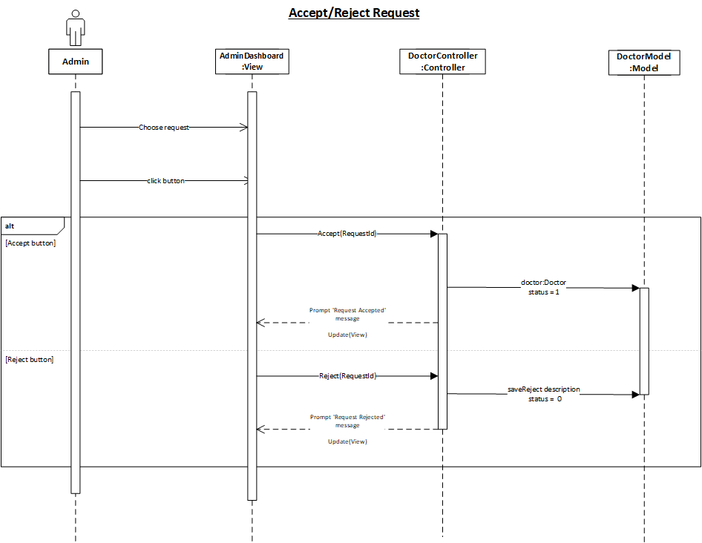

Figure 36: Admin Accept/Reject Request

Figure 37: Doctor Add New Appointment

Figure 38: Doctor Add New Service

Figure 39: Doctor Delete Appointment

Figure 40: Doctor Delete Service

Figure 41: Doctor Diagnose Patient

Figure 42: Doctor Create Prescription

Figure 43: Doctor Join Request

Figure 44: Doctor Update Appointment

Figure 45: Doctor Update Service

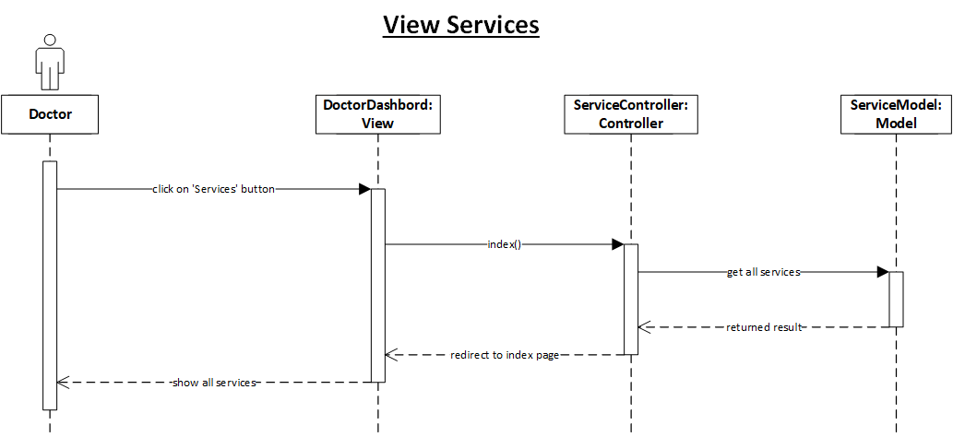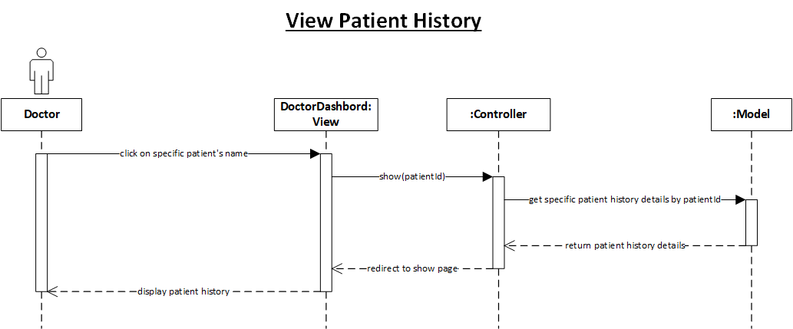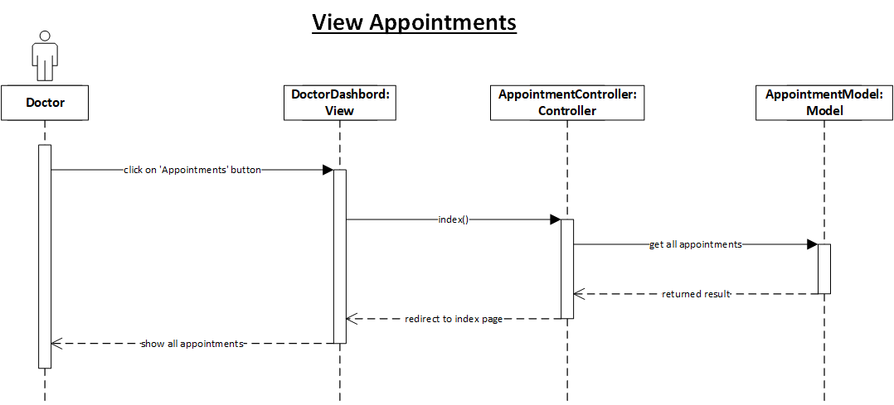

Figure 46: Doctor View Patient History

Figure 47: Doctor View Services

Figure 48: Doctor View Appointments

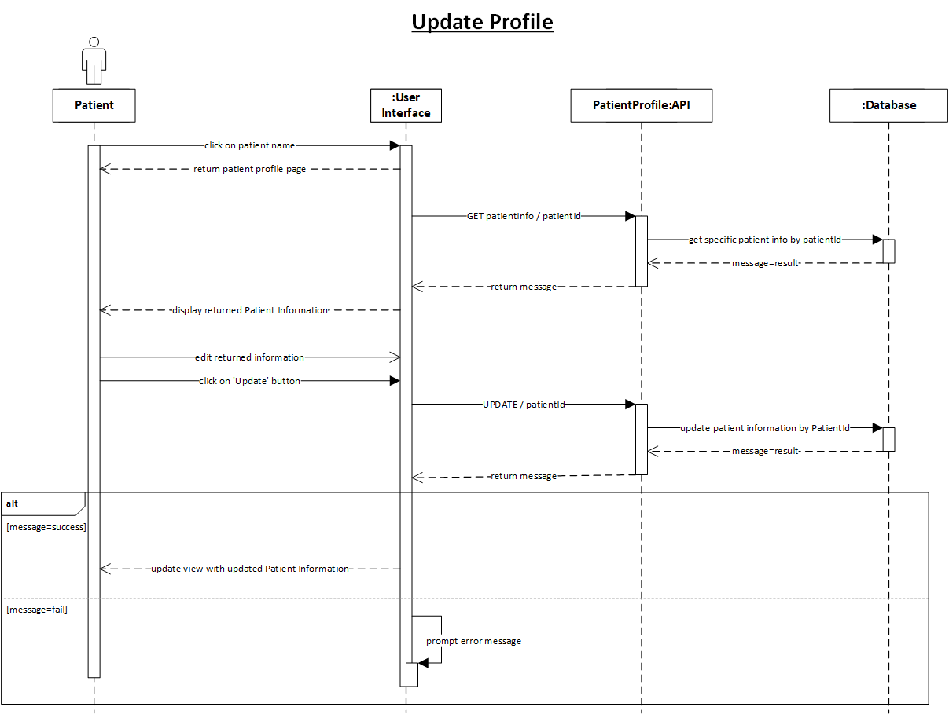

Figure 49: Patient Update Profile

Figure 50: Patient talk to chatbot

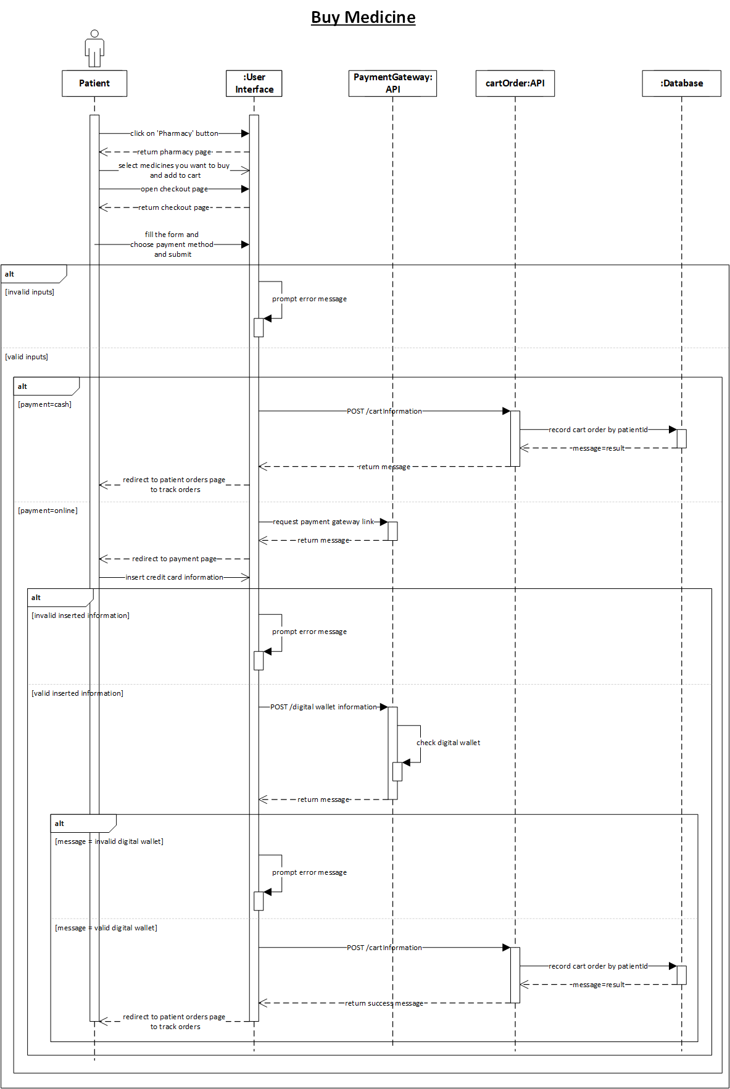

Figure 51: Patient Buy Medicine

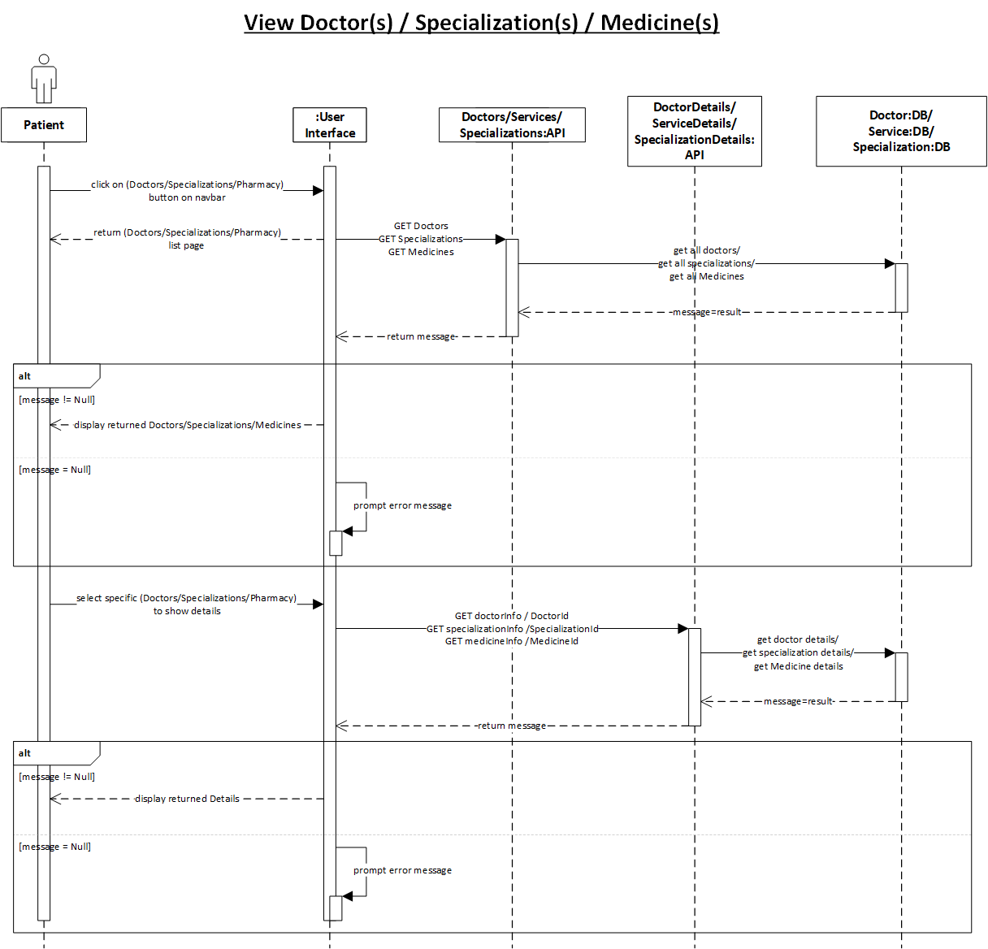

Figure 52: Patient View Doctor_Specialization_Medicine

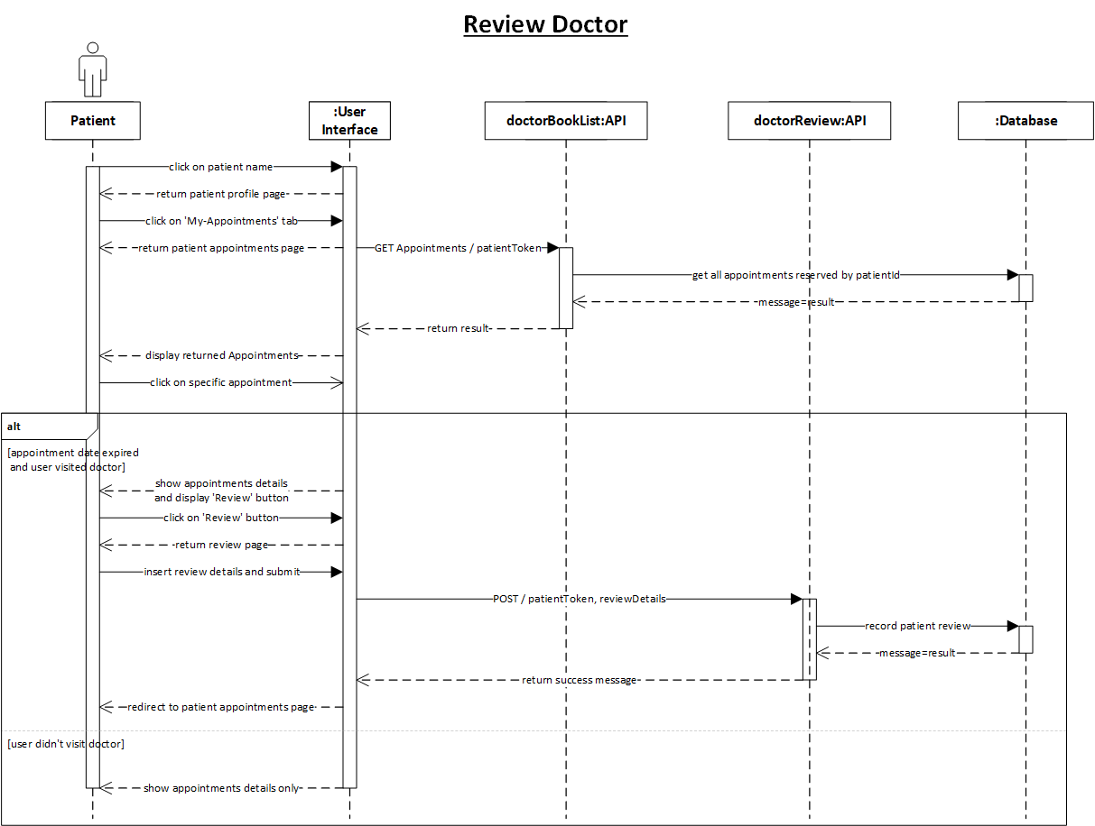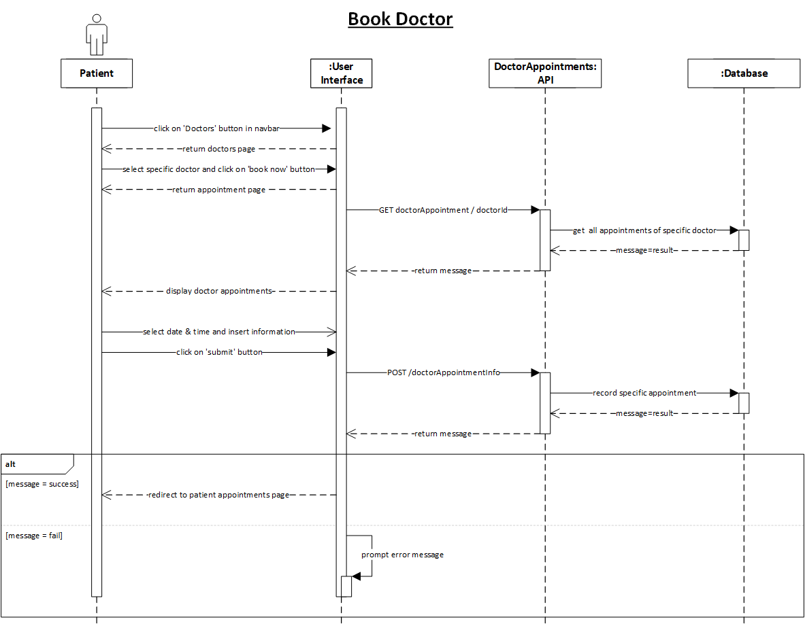

Figure 53: Patient Book Doctor

Figure 54: Patient Review Doctor

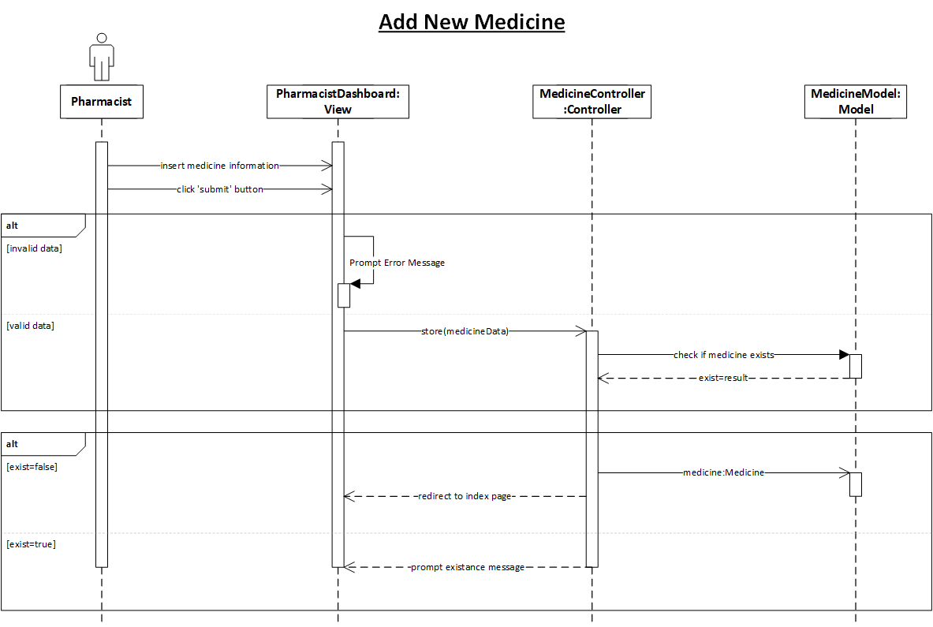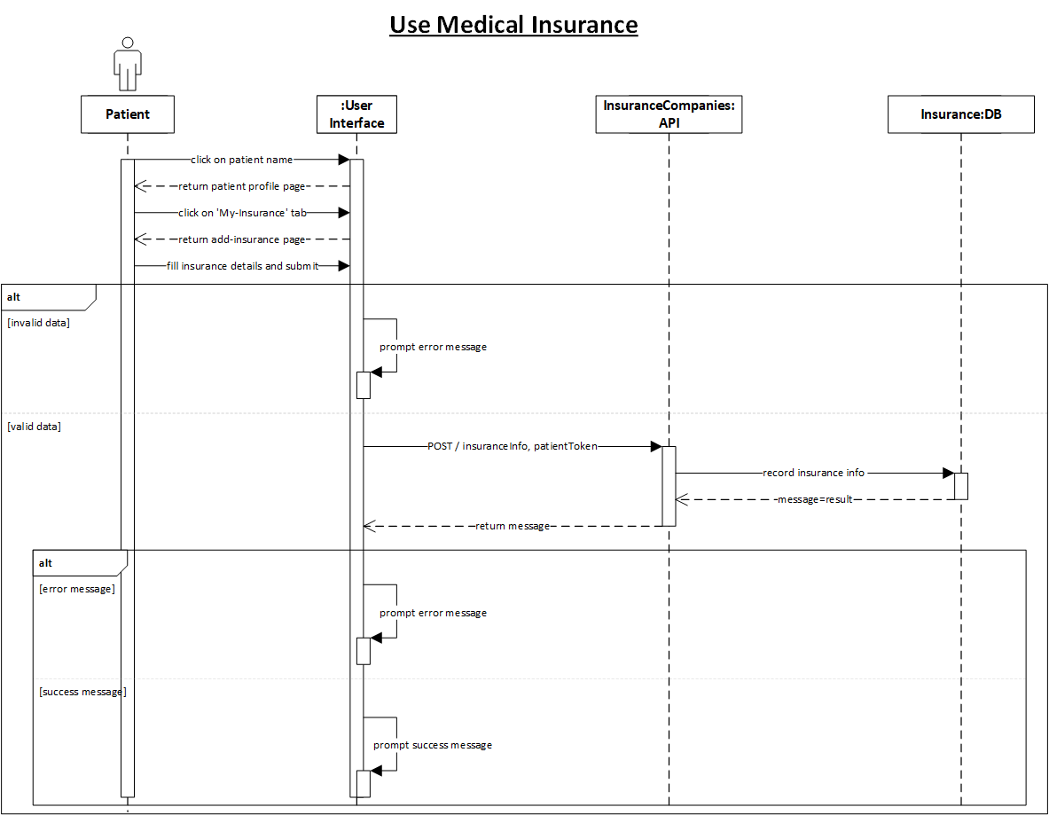

Figure 55: Pharmacist Add Medicine

Figure 56: Patient use Medical Insurance

Figure 57: Pharmacist Update Medicine

Figure 58: Pharmacist Delete Medicine

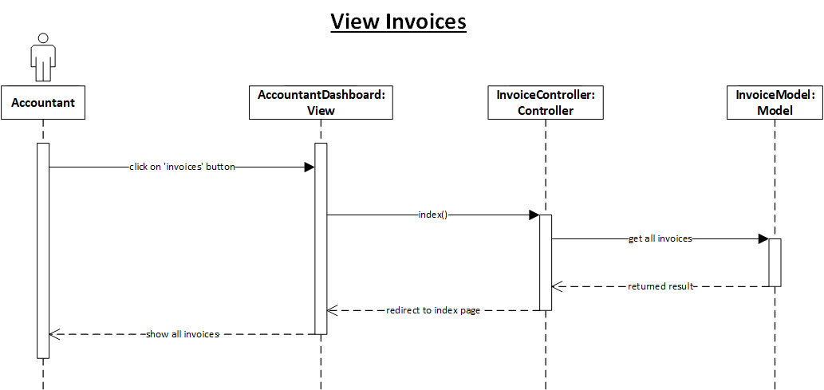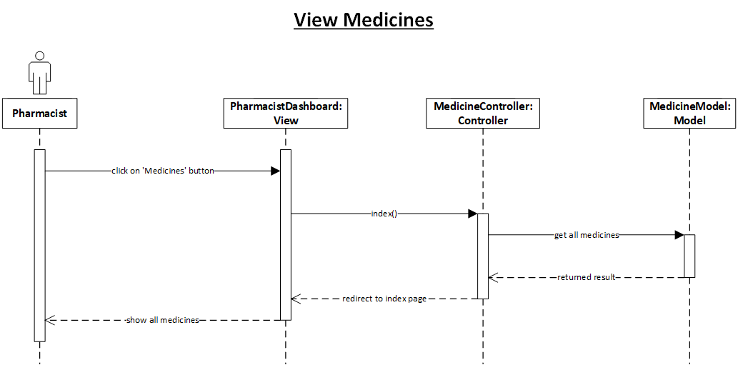

Figure 59: Accountant View Invoices

Figure 60: Pharmacist View Medicines

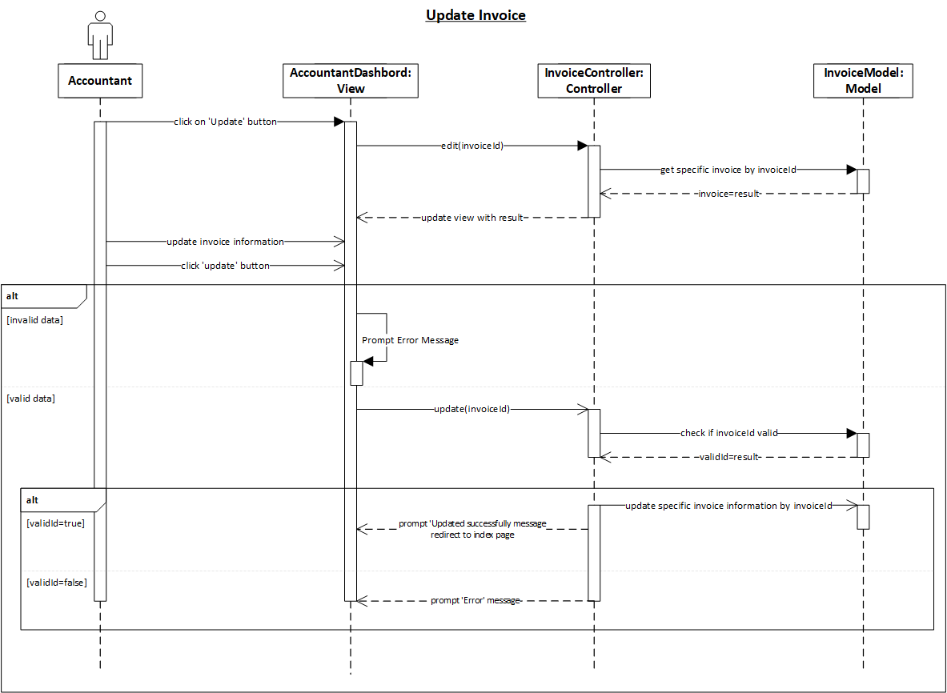

Figure 61: Accountant Update Invoice

Figure 62: Accountant Add New Invoice

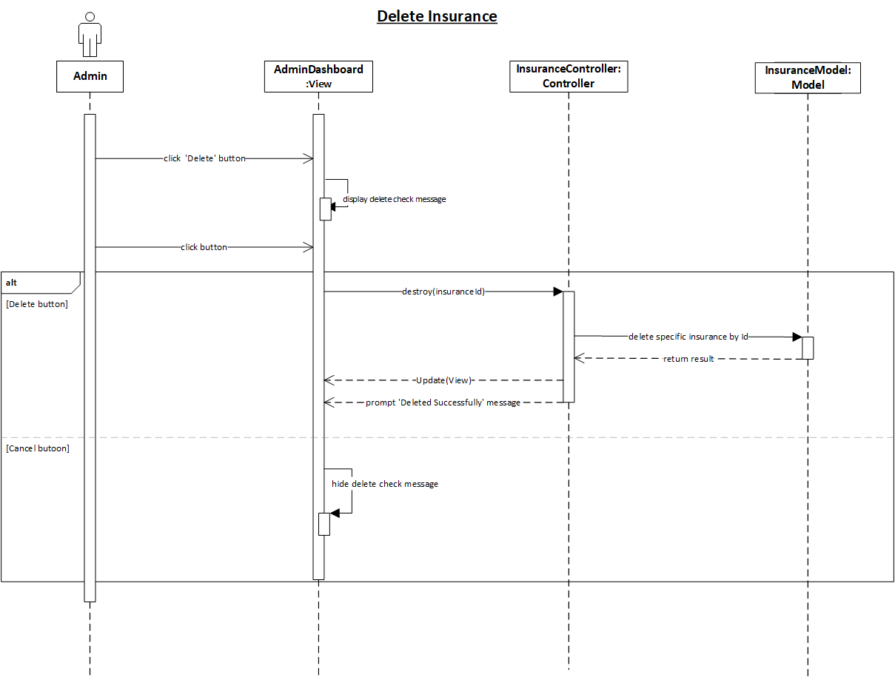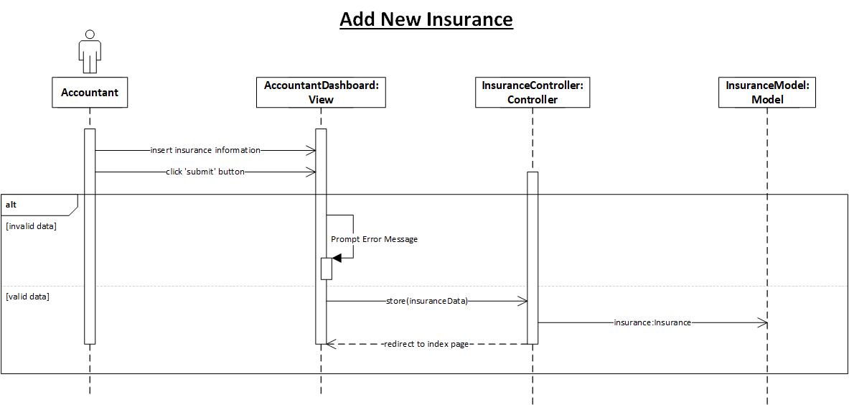

Figure 63: Accountant Delete Insurance

Figure 64: Accountant Add Insurance

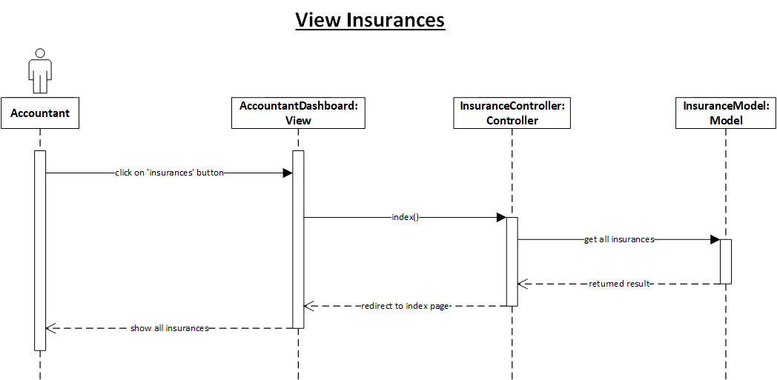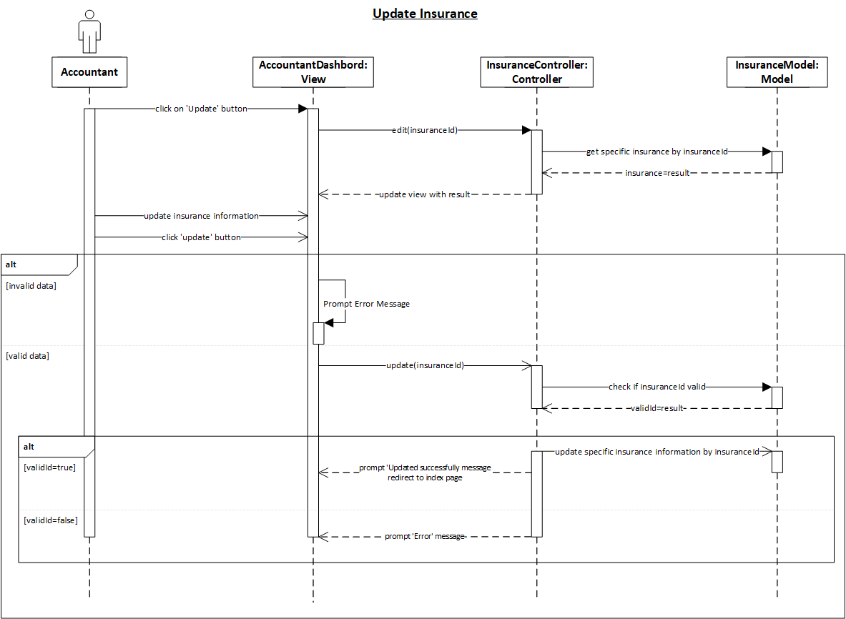

Figure 65: Accountant View Insurances

Figure 66: Accountant Update Insurance

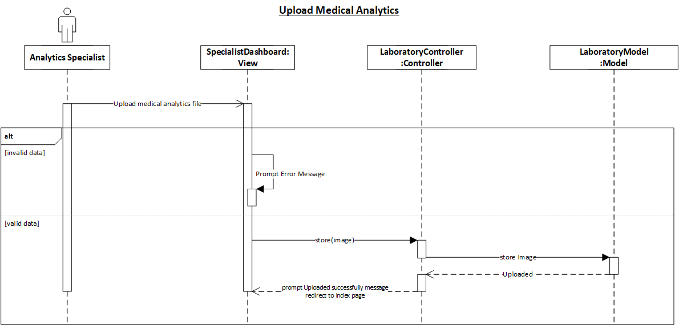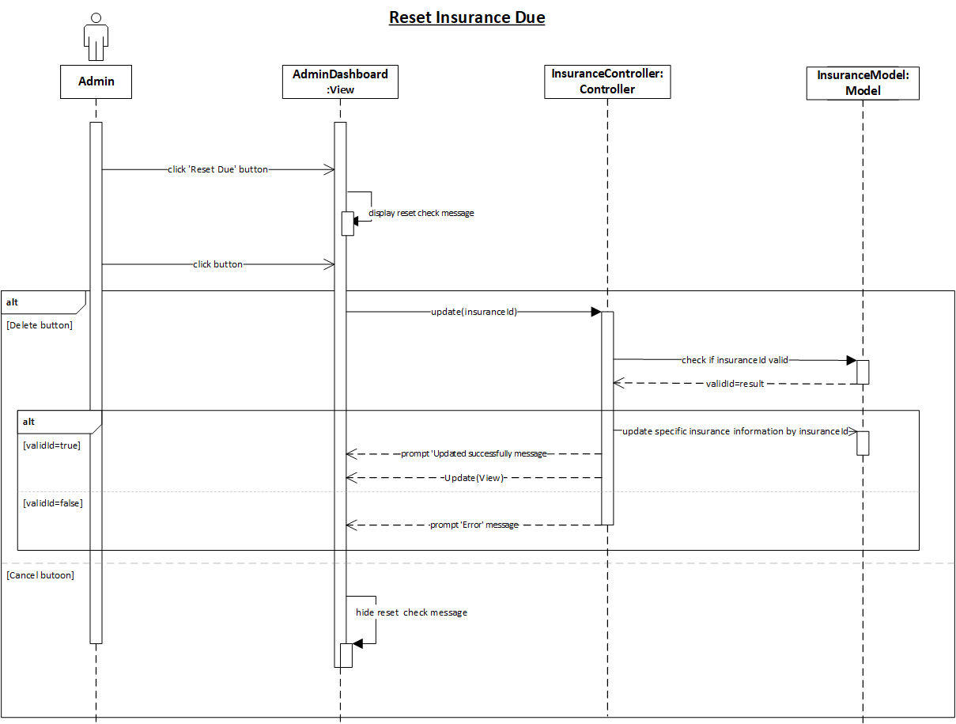

Figure 67: Analytics specialist upload medical analysis

Figure 68: Accountant Reset Insurance Due

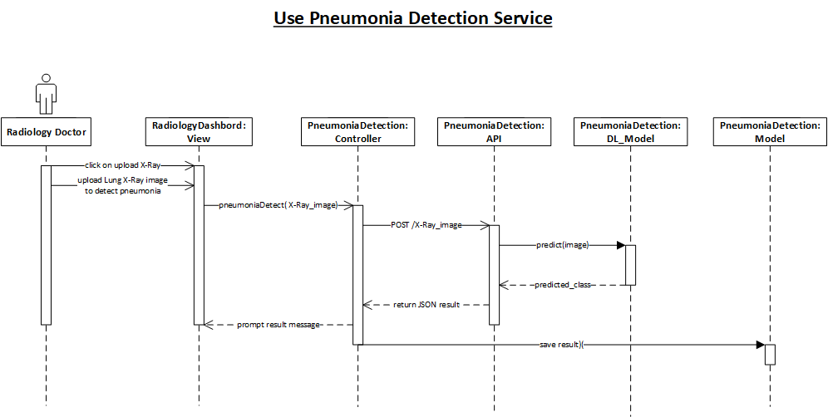

Figure 69: Radiology use Pneumonia Detection Service

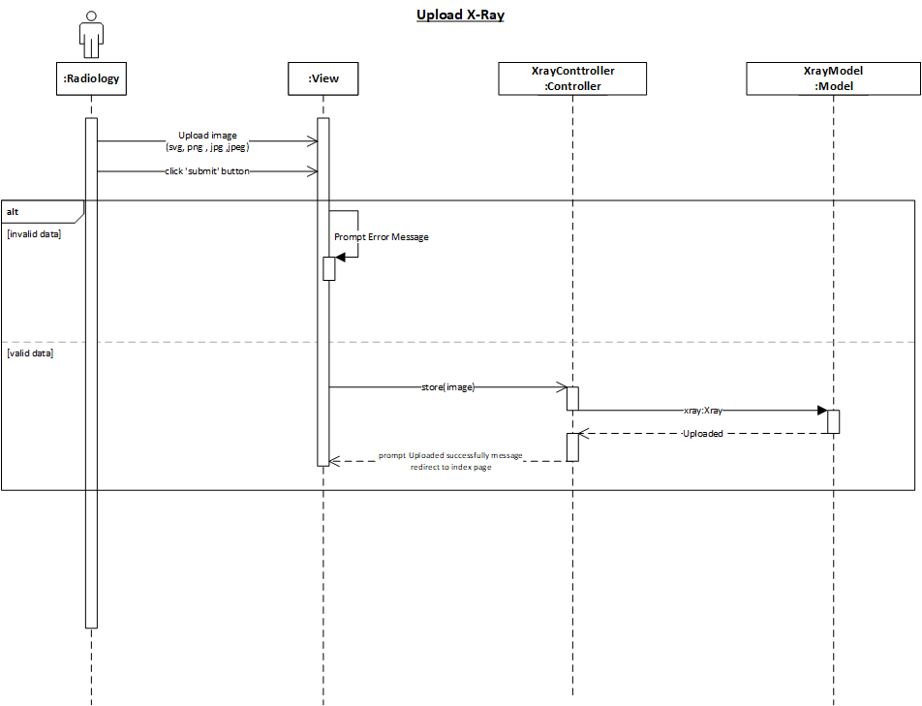

Figure 70: Radiology Upload X-Ray

* 1. System architecture

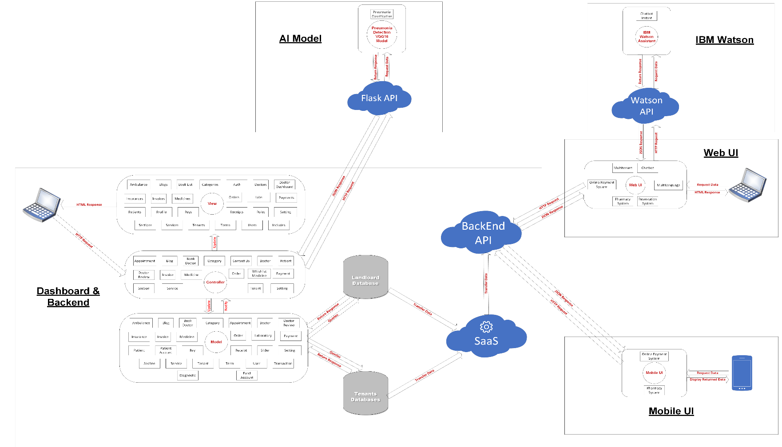

Figure 71: System Architecture

1. Implementation


5. 1. Description of Implementation

Implementation is the realization of a technical specification or algorithm as a software component or program. It involves the careful conversion of a program's design or design into some executable program code using any preferred programming language. Design can be implemented in different ways depending on the developer's priorities. In this work, many factors were taken into consideration during implementation.

The implementation of the hospital system involved creating a dedicated website to display available services and enable users to book appointments with doctors. Additionally, users could place purchase orders for available medicines and access informative articles about health. The website also included various sections, and an insurance feature was implemented to provide discounts on medicine purchases. To facilitate mobile access and medicine purchases, a mobile application was developed.

For the website's front-end, we used Angular, a framework that leverages TypeScript, HTML, and SCSS. The back-end was implemented using the PHP programming language with the Laravel framework. MySQL was chosen as the database management system for storing data. APIs were utilized to connect the front-end and back-end, enabling data retrieval and presentation to users. The mobile application was developed using the Flutter programming language, which also utilized APIs to connect to the back-end. Hosting the website was necessary for users to access its services.

* 1. Programming language and technology

The hospital system consists of two primary components: the front-end and the back-end, each employing different programming languages and technologies.

For the front-end, Angular framework was used, employing scripting languages such as JavaScript, TypeScript, and SCSS to support the creation of HTML.

The back-end was implemented using the PHP programming language, the Laravel framework. The MySQL database served as the data storage utilizing system. APIs were used to establish a connection between the front-end and back-end, enabling data retrieval and display to users.

On the mobile application side, Flutter framework was used, employing object-oriented client-optimized programming language such as Dart for mobile application development. It served as the client, allowing the creation of input and output forms. The mobile application also utilized the MySQL database as the back-end data storage system.

By utilizing these programming languages and technologies, we were able to develop a comprehensive hospital system with a website and a mobile application, providing users with easy access to services and medicine purchases.

* + 1. The factors that influenced the choice of Angular
* **Reusability**. Components of similar nature are well encapsulated, in other words, self-sufficient. Developers can reuse them across different parts of an application. This is particularly useful in enterprise-scope projects where different systems may have many similar elements like search boxes, date pickers, sorting lists, etc.
* **Readability**. Encapsulation also ensures that new developers – who’ve been recently onboarded to a project – can read code better and eventually reach their plateau of productivity faster.
* **Unit-test friendly**. The independent nature of components simplifies unit tests, and [quality assurance](https://www.altexsoft.com/whitepapers/quality-assurance-quality-control-and-testing-the-basics-of-software-quality-management/) procedures aimed at verifying the performance of the smallest parts of the application, units.
* **Maintainability**. Components that are easily decoupled from each other can be easily replaced with better implementations. Your engineering team will be more efficient in maintaining and updating the code within the iterative development workflow.
  + 1. The factors that influenced the choice of PHP
* **Speed**: Being a compiled language, it is very fast, and speed is important in database application.
* **Environment**: It can run in windows.
* **Efficient**: The final code tends to be compact and runs quickly.
* **Portability**: If compiled, it can be executed in different machines with alteration of source code.
* **Maintainability**: To ensure maintainability, this program is broken into modules and each module is assigned a specific function. This will make maintenance of the system easier.
* **Security**: it has proper backups, quality control mechanism for all modules and unauthorized access to sensitive data is prohibited.
* PHP supports full **object-oriented programming** giving us more control over the graphic user interface
* PHP supports all the new **AJAX and CSS**. It makes the graphic user interface friendly.
  + 1. Why MySql database was chosen?
* MYSQL maintains a high level of security.
* MYSQL database ensures maximum data throughput (i.e., accepting of data with
* MYSQL database has a very high data storage capacity limit, several Nano byte and terabytes.
* MYSQL is multiplatform working on all platforms, Linux, Os X and mobile platform.
* MYSQL together with built-in front end (client) and back end (DB server) such as MYSQL workbench or PhpMyAdmin has several data management and administrative services.
* MYSQL has data backup and recovery management services.
* MYSQL is an open sources application.
* MYSQL can be installed as a cluster server- this makes it possible for two or more MYSQL database servers to be united as a common server in a cluster server.
  + 1. Why did we use Flutter in Mobile App
* **Reduced Development Time:** The requirements for Flutter application development are much lower. So, the positive outcome is that there are no additional maintenance charges. Flutter makes it possible to create larger apps that use unique features.
* **Native-like Performance:** This is one of the Flutter advantages that stands out the most. Flutter works with Skia, a graphics engine which enables quick and well optimized development. It also is indistinguishable from native apps as it doesn’t rely on interpreters or intermediary code representations.
* **Powerful community:** According to [statista](https://www.statista.com/statistics/869224/worldwide-software-developer-working-hours/), Flutter has become one of the most popular frameworks and a first choice by developers globally. Over 40 percent of software developers have chosen Flutter over the course of the last three years. The following chart shows the growing interest in Flutter in comparison with other cross-platform app tools.
* **Hot Reload Feature:** The ability to hot reload is one of the main benefits of using Flutter. This is for effective cross-platform development so it can complement the nature of Flutter. This feature’s function speeds up application development.
  1. Part of Implementation

1. Testing
2. 1. Unit Testing

Sgsdgsdgsdg

* 1. Integrated Testing

Sdsbgsfbdfbdfbdf

* 1. Additional Testing

Sdvgsdgsdgdsgds

1. Conclusion & Future Work
2. 1. Conclusion

From the beginning, our first and last mission and goal was to make it easier for all those involved in the health field, from patients to doctors and administrators, and all hospital departments. So we made three things that are divided into web app, mobile app, and dashboard, each one serving a specific category on the following approach:

* The Web App serves patients and doctors, so the doctor can apply to join the hospital, and the patient can book an examination and see all doctors and specialties, and he can also buy medicines, and he can add his medical insurance, and he can track all his transactions with the hospital, evaluate doctors, and the most important part is the presence of chat pot that helps the user on the site.
* As for the dashboard, it is divided into two parts. A part serves doctors by detecting patients and viewing all his bills and accounts. He can also add a service to his personal account, and he can see patients’ reservations. He can also see patient reviews. The second part is for administrators, and this is the main control panel in which he can add a branch to the hospital. Also, adding specialties and managing doctors’ accounts, and he can accept or reject the doctor, manage patients, manage services, and there is a special part for accounting services and billing, and the largest and most important part is the detection of pneumonia, which is in the radiology section, and also the pharmacy and its medicines can be controlled, and patients’ requests from the pharmacy can be controlled and ambulances managed .
* As for the mobile app, it serves patients by purchasing medicines and paying online.
  1. Future Work

What we mentioned previously is what was actually done. As for our recommendation how to enhance the project if we are given the right resources, we want to connect smart watches to our system, and from them we track the user’s health status such as heartbeat and such things, so we process this data and suggestion The patient should visit the specialist doctor in case of something abnormal. Also, we will not stop at detecting pneumonia, but we will use artificial intelligence to detect more diseases to make it easier for doctors and help them with modern technologies, for example Alzheimer’s Disease Detection using Deep Learning